Week 2

# Section 1. Comparisons and Conditionals

## Exercise 1: Comparison Operators

### Understanding the Task:

This exercise asked us to explore and practice **comparison operators**. We were expected to check how values or variables compare using operators like **==, !=, >, <, >=, and <=.** The main goal was to understand how these comparisons return either True or False.

### Source Code:

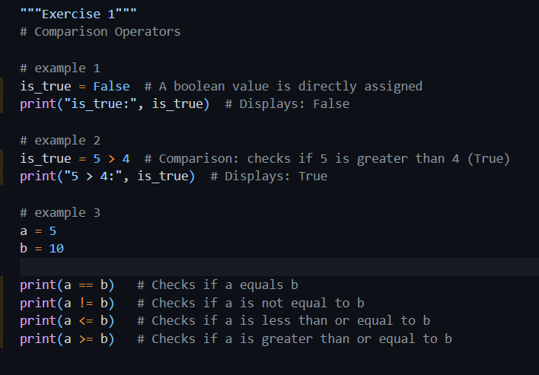

### Explanation

This exercise introduces **comparison operators** like ==, !=, <, >, <=, >=. In this exercise, I explored how Python compares values. I first set a variable to False just to see how Boolean values work. Then I checked if 5 is greater than 4, and I noticed it returned True because the condition was correct. After that, I created two variables, a and b, with values 5 and 10. I used comparison operators like ==, !=, <=, and >= to compare them. This helped me understand how to check if two values are equal, not equal, or how they relate in terms of size.

The comparisons are:

* a == b: Is a equal to b? (No → False)
* a != b: Is a not equal to b? (Yes → True)
* a <= b: Is a less than or equal to b? (Yes → True)
* a >= b: Is a greater than or equal to b? (No → False)

### Output

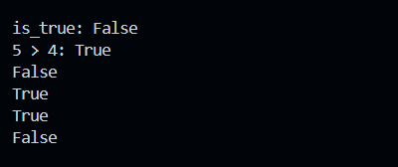

## Exercise 2: Logical Operators

### Understanding the Task

In this exercise, I was supposed to work with **logical operators**. These include **and**, **or**, and **not**. I needed to check how they behave when used with different conditions and see what kind of Boolean result they give, either True or False. The goal was to understand how we can combine multiple conditions using logic.

### Source Code

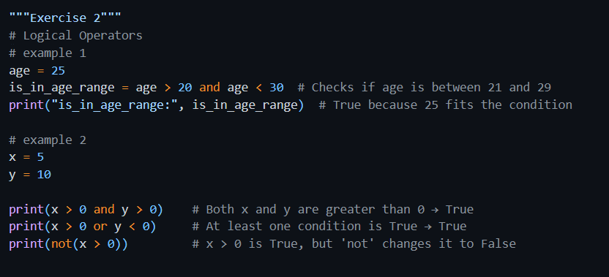

### Explanation

Here, I learned how to combine multiple conditions using logical operators. I started by checking if a person's age was between 20 and 30 using the **and** operator. It returned True because both sides of the condition were correct. Then I tested other expressions using and, or, and not with two numbers. I saw that and only returns True if both conditions are true, while or only needs one condition to be true. The **not** operator reversed the result. These examples helped me clearly understand how I can combine or negate conditions when writing logic.

* We check if someone's age is between 21 and 29 by using and. Both sides must be true.
* x and y are numbers. We test combinations of conditions:
  + x > 0 and y > 0: Are both positive? → Yes.
  + x > 0 or y < 0: Is either positive or y negative? → Yes (since x > 0 is True).
  + not(x > 0): This means “is it NOT true that x is greater than 0?” → No, x is 5, so x > 0 is True, and not(True) is False.

### Output

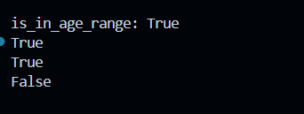

## Exercise 3: if – Conditionals

### Understanding the Task

In this task, I explored the basic use of **if statements** in Python. I had to check if a certain condition is true and then update a variable or display a message accordingly. The main idea was to learn how decisions are made in a program based on conditions.

### Source Code

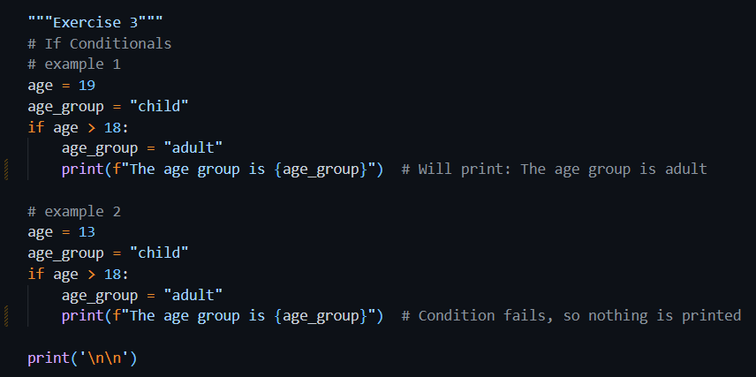

### Explanation

### In this part, I used an if statement to check someone's age group. I assumed the person was a child, but then used if age > 18 to see if they were actually an adult. If they were, I updated the label and printed it. When I tested it with age 19, it printed "adult". But when I tested with age 13, nothing printed because the condition wasn’t true. I learned that if statements only run their block when the condition is true, otherwise, they skip it.

### Output

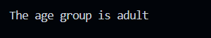

## Exercise 4: if – else Conditionals

### Understanding the Task

This task was about using the **if-else** structure. I had to write code where the program chooses between two possible actions, one if a condition is true, and another if it's false.

### Source Code

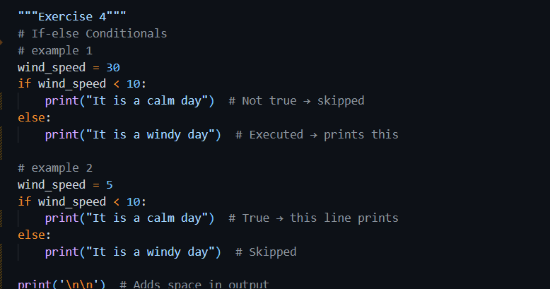

### Explanation

* In the first example, wind_speed was 30, which is not less than 10, so it printed "It is a windy day".
* In the second example, windspeed was 5, which is less than 10, so it printed "It is a calm day".

### Output

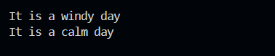

## Exercise 5: if – elif - else Conditionals

### Understanding the Task

In this exercise, I practiced using **if-Elif-else** blocks to handle multiple conditions in a clean way. This helped in writing better decision-based logic where the program chooses the right option from several possibilities.

### Source Code

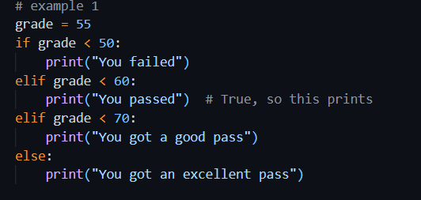

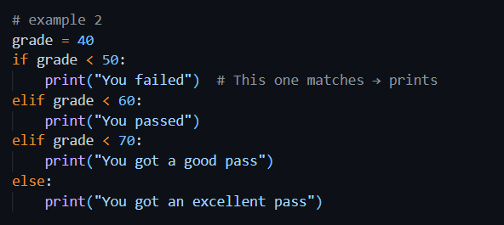

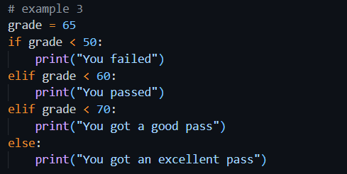

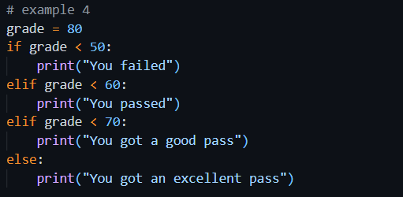

### Explanation

* Four different grades were tested.
* The code checked each grade and printed a message:
  + Below 50 → “You failed”
  + Between 50–59 → “You passed”
  + Between 60–69 → “You got a good pass”
  + 70 and above → “You got an excellent pass”
* Each elif allows checking in sequence, and only one block runs depending on the value.

### Output

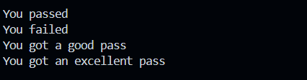

## Exercise 6: Compare Temperatures

### Understanding the Task

This task was about comparing two temperature values. I had to check if they were equal or different and show the appropriate message using an if-else structure.

### Source Code

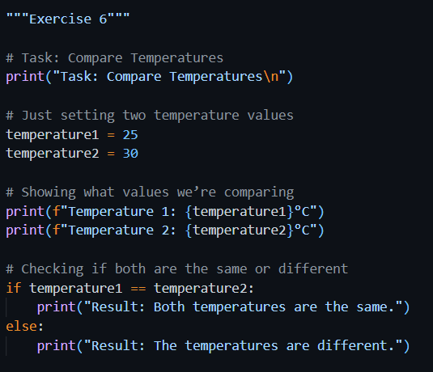

### Explanation

* The two temperatures were set to 25 and 30.
* The program displayed both values.
* Then it compared them: since 25 ≠ 30, it printed “The temperatures are different”.

### Output

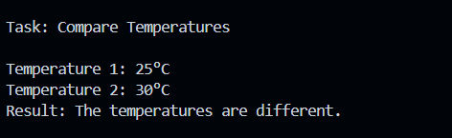

# Section 2. Python Lists

### Understanding the Task

I was asked to practice how Python lists work. Specifically:

* I had to **create a list** of cities.
* Then I **accessed specific elements** in the list using indexes and slicing.
* After that, I **modified the list** by changing one value and adding another.
* Finally, I had to **create, access, and manipulate another list** of colors, check its length, and use conditions and slicing to work with it.

These tasks helped me understand how flexible and powerful Python lists are.

## Exercise 1: Creating a list

* I created different types of lists to explore how Python handles numbers, text, empty lists, and mixed types.
* I also created a list named city_list with "Glasgow", "London", and "Edinburgh" as requested.

### Exercise 2: Accessing List Elements

* I learned that I can get a specific item by its position using an index.
* I used slicing to get a portion of the list.
* I also printed the **third item** and the **last two items** from city_list using slicing.

### Exercise 3: Modifying Lists

* I replaced the first item in string_list from "apple" to "pear".
* I added a new item to the end of the list using .append().
* I also updated the city_list by adding "Manchester" and changing "London" to "Birmingham".

### Exercise 4: Summary Task

* I created a list called colours and printed it.
* I accessed the second color and printed it.
* I changed the first color, counted how many colors were in the list using len(), and printed that.
* I checked whether "red" was in the list and printed a message accordingly.
* I used slicing to make a new list with just the second and third colors.

### Output

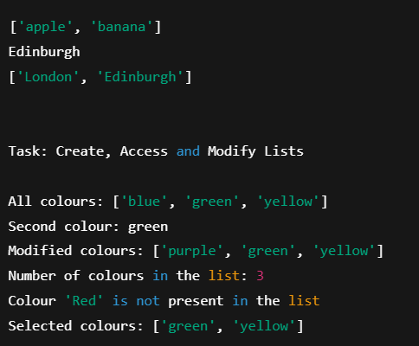

# Section 2. Python Loops

### Understanding the Task (In My Words)

In this exercise, I practiced how to use loops in Python to repeat tasks automatically. I worked with both while loops and for loops. I also learned how to control the flow of loops using special keywords like break (to stop the loop early) and continue (to skip part of a loop). After that, I applied my learning to some mini-projects like printing even numbers, summing up squares of numbers, and creating a countdown. These tasks helped me build a strong foundation in writing repetitive logic efficiently

### Explanation of the Code (Step by Step)

#### Exercise 1: While Loop

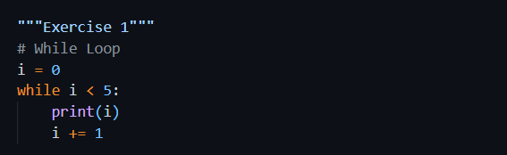

* I used a while loop to print numbers from 0 to 4.
* The loop kept running as long as i was less than 5.
* Each time, I printed i and increased it by 1.

#### Exercise 2: For Loop

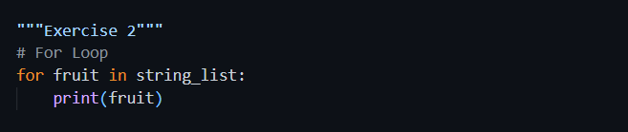

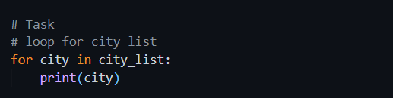

* I used a for loop to print items from two different lists: string_list and city_list.
* It went through each element one by one and printed them.

#### Exercise 3: Loop Keywords

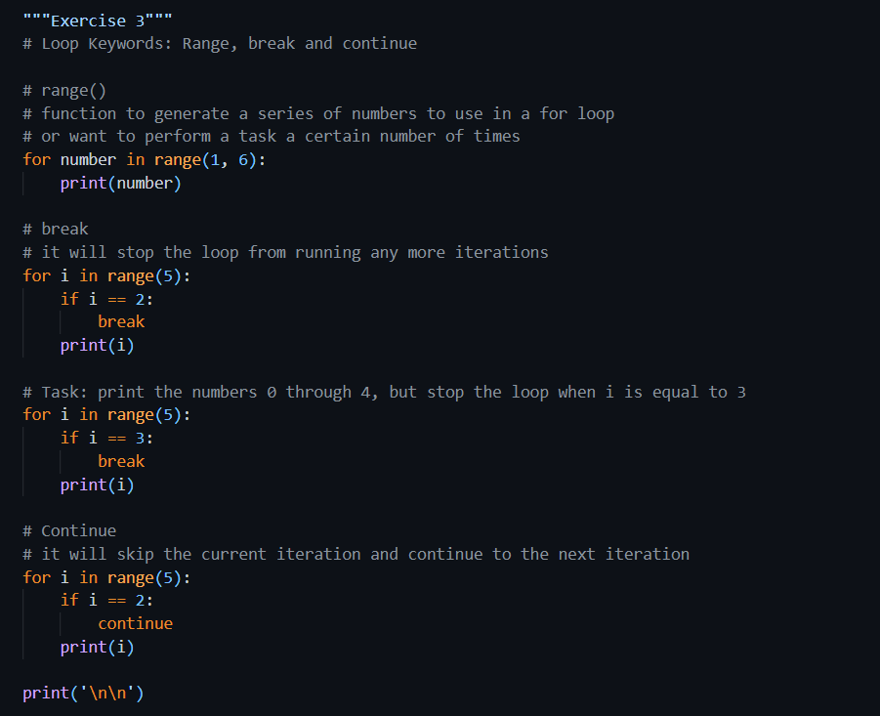

* I used range(1, 6) to print numbers from 1 to 5.
* Then I used break to stop the loop early when i became 2.
* I also wrote a custom task to stop when i == 3.
* Lastly, I used continue to skip printing the number 2 but printed everything else.

#### Exercise 4: Summary Tasks

1. **Even Numbers**:

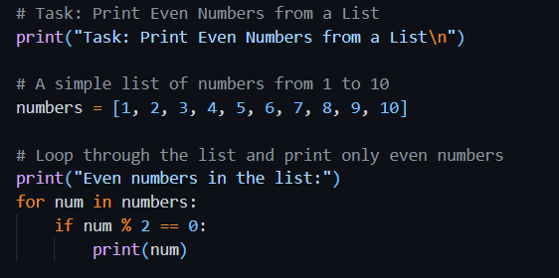

* + I created a list from 1 to 10.
  + I used the modulo operator % to check if a number was even.
  + If yes, I printed it.

##### Output

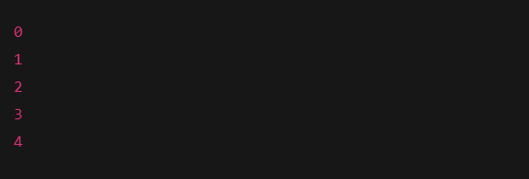

1. **Sum of Squares**:

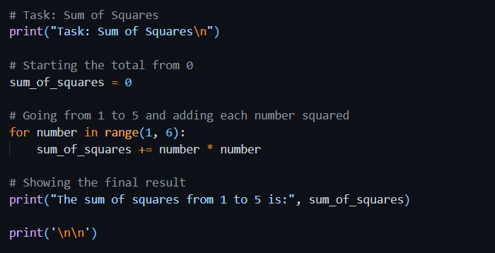

* + I used a loop to go from 1 to 5.
  + I squared each number and added it to a total.
  + I printed the final sum, which came out as 55.

1. **Countdown**:

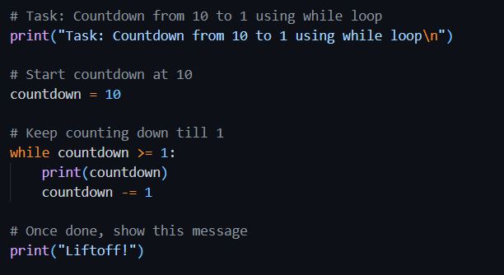

* + I used a while loop that started from 10.
  + It printed each number down to 1.
  + Then, it printed “Liftoff!” to end the countdown.

Week 3

# Section 1. Functions and Scope

## Exercise 1: Functions in Python

### Understanding the Task

In this task, I learned how functions work in Python and how they help make code more reusable and organized. I explored different aspects like how to define a basic function, pass parameters to it, and use keyword arguments. I also practiced using default parameter values and learned how to return results from a function. Each small sub-topic helped me understand how functions behave in different scenarios and how we can control the inputs and outputs more efficiently. This exercise gave me a solid understanding of writing clean, functional code.

#### Creating Functions

##### Source Code

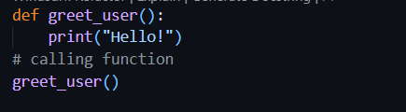

##### Explanation

Here, I created a simple function called greet_user() that prints a greeting. I called the function after defining it to run the print statement. This shows how basic functions are defined and called in Python.

##### Output

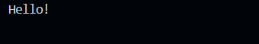

#### Function Parameters

##### Source Code 1

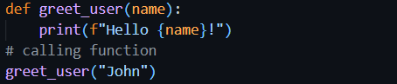

##### Output 1

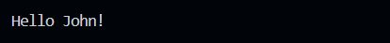

##### Source Code 2

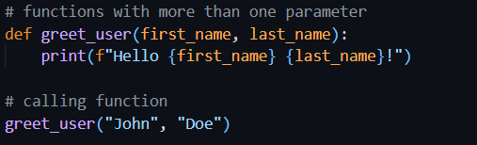

##### Output 2

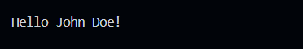

##### Explanation

This version of the function takes a parameter called name. When I call greet_user("John"), it prints "Hello John!". This shows how to pass input (variables) into a function and use it inside.

#### Keyword Arguments

##### Source Code

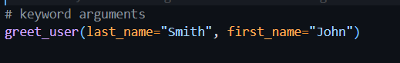

##### Explanation

In this example, I called the same function using keyword arguments. I passed values by naming the parameters directly. This allows the arguments to be passed on in any order, which makes the code more readable.

##### Output

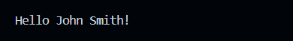

#### Default Values

##### Source Code

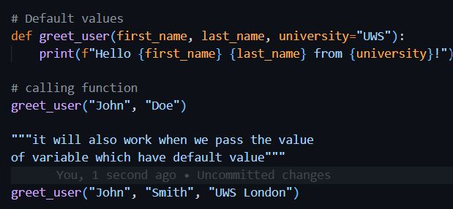

##### Explanation

This function has a default value for the university parameter. If I don’t pass the value for it, it uses "UWS" by default. But I can also override it by giving a custom value like "UWS London". This is useful when some arguments usually have a common value.

##### Output

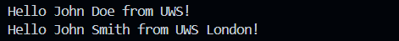

#### Return

##### Source Code

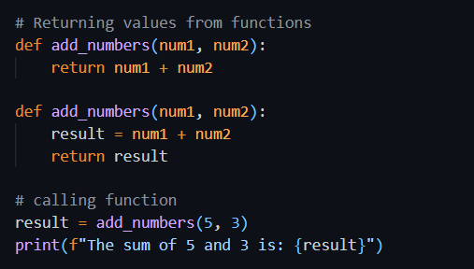

##### Output

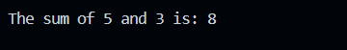

##### Source Code

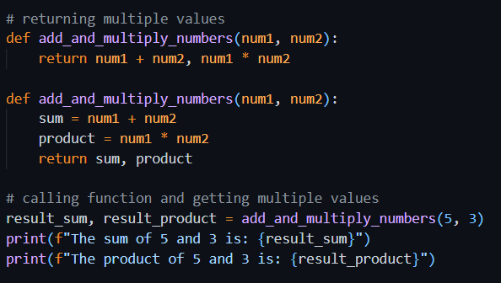

##### Output

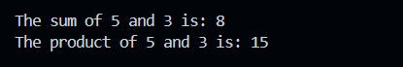

##### Explanation

In this part, I created a function called add_numbers() that takes two numbers and returns their sum. Instead of printing the result inside the function, it sends the result back using the return keyword. I stored that value in a variable called result and printed it. This makes the function more flexible since I can use the result anywhere else in the program too.

## Task: Greet each friend in the list

### Understanding the Task

In this task, I had to create a function that takes a list of friends' names and greets each one by printing a message. The main goal was to use a for loop to go through a list and apply the same action (printing a greeting) to every item.

### Source Code

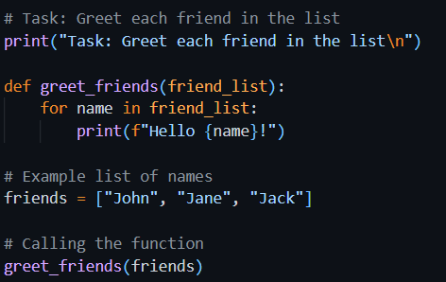

### Explanation

I defined a function greet_friends() that accepts one argument, a list of names. Inside the function, I used a for loop to iterate through the list and print "Hello" followed by each friend's name. When I called the function with a sample list like ["John", "Jane", "Jack"], it printed a greeting for each one. This is a good example of using functions and loops together.

### Output

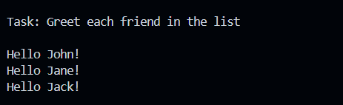

## Task: Calculate Tax Based on Income and Tax Rate

### Understanding the Task

In this task, I had to write a program that calculates tax based on a given income and tax rate. It starts by testing the function with fixed values, and then allows the user to enter their own income and tax rate multiple times. The goal was to use functions, input/output, loops, and basic arithmetic.

### Source Code

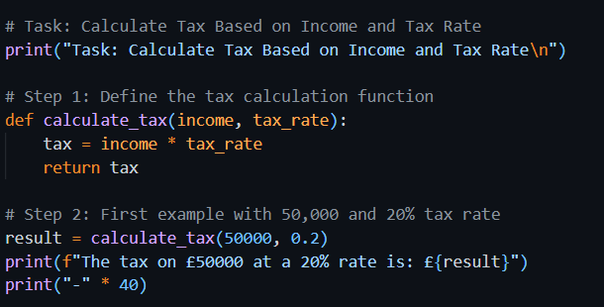

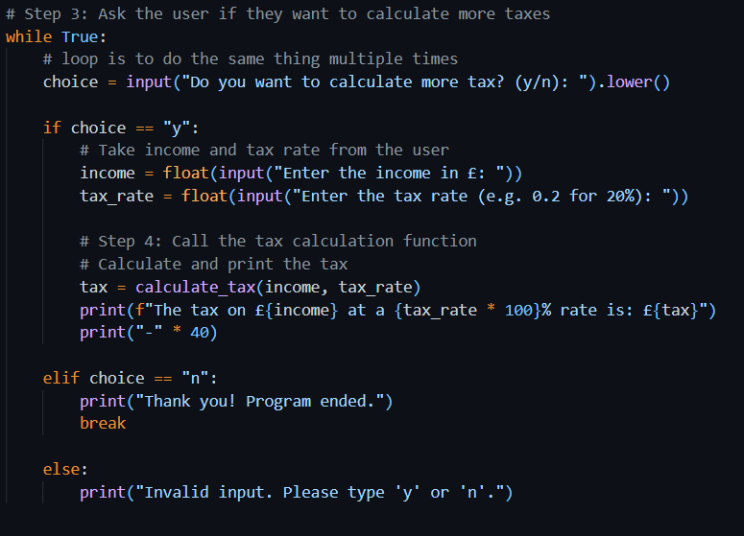

### Explanation

* First, I created a function called calculate_tax that multiplies income by tax rate and returns the result.
* I tested the function with £50,000 income and a 20% tax rate, and it correctly returned the tax.
* Then I used a while loop to allow the user to calculate tax as many times as they want.
* If the user enters 'y', it asks for income and tax rate, then prints the calculated tax using the same function.
* If the user types 'n', the program ends with a thank-you message.
* It also handles invalid inputs like any character other than 'y' or 'n'.

### Output

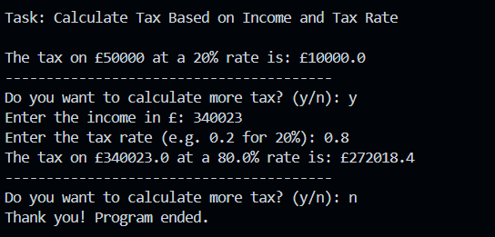

## Task: Compound Interest Calculator Function

### Understanding the Task

This task was about writing a function that calculates compound interest over a number of years. The function needed to handle invalid inputs and print how the investment grows year by year. In the end, it returns the final value of the investment.

### Source Code

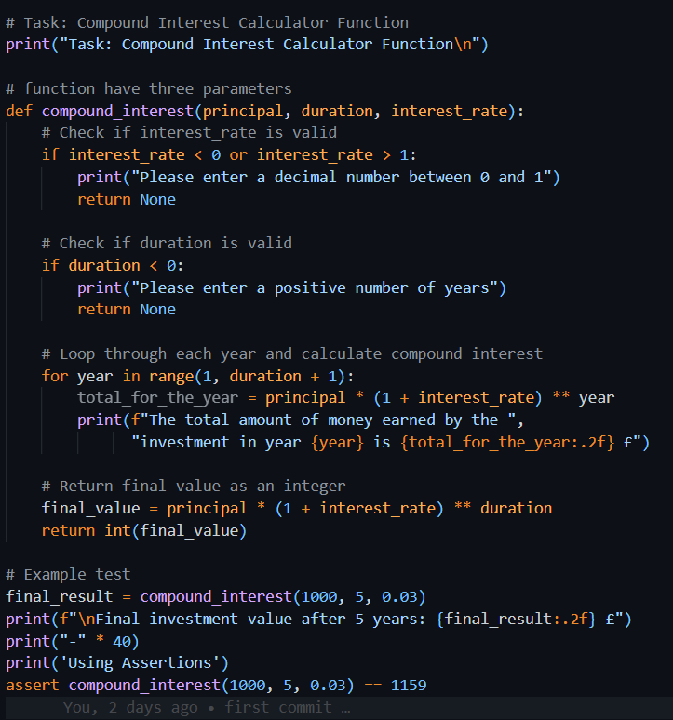

### Explanation

* The function compound_interest takes three parameters: principal, duration, and interest_rate.
* It first checks if the interest rate is between 0 and 1 and if the duration is positive. If not, it shows an error and exits early.
* Then, it uses a for loop to calculate and print the total amount at the end of each year using the compound interest formula:  
  (principal×(1+rate)year)(principal × (1 + rate) ^ year)(principal×(1+rate)year)
* Finally, it returns the total value at the end of the given duration, rounded to an integer.
* I tested the function with a £1000 investment for 5 years at 3% interest, and it correctly printed the values for each year and returned the final result.

### Output

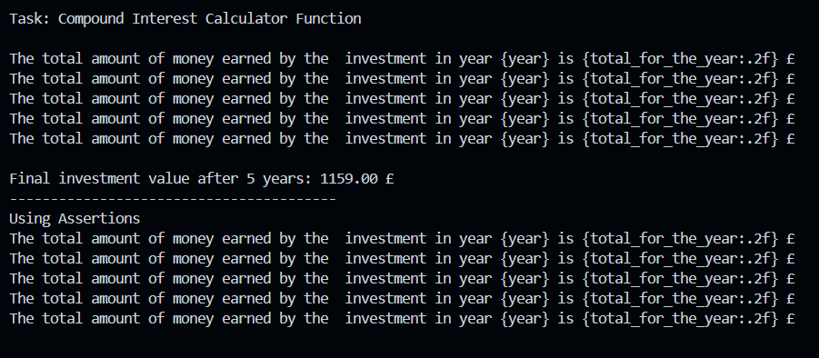

## Exercise 2: Variable Scope

### Understanding the Task

This task helped me understand how **variable scope** works in Python, especially in relation to functions. It showed the difference between variables defined inside a function (local scope) and those outside it (global scope).

### Source Code

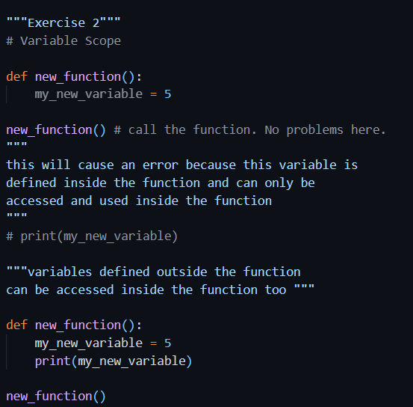

### Explanation

* In the first part, I defined a variable called my_new_variable **inside** a function and then tried to access it **outside** the function. This causes an error because the variable only exists within the function’s local scope.
* In the second part, I added a print() statement **inside** the function to access the same variable, and it worked perfectly. This proves that local variables can only be used within the function they’re defined in.
* The code also notes that **global variables** (defined outside the function) can still be accessed inside it — though this specific example doesn’t show that part in action.

### Output

#### Error

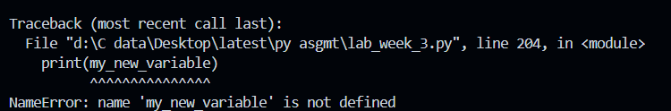

#### Corrected Code Output



# Section 2: Assertions and Errors

## Exercise 6: Assertions

### Understanding the Task

This task was about using assert statements in Python to automatically check if a function gives the expected result. Assertions are used mainly for testing.

### Source Code

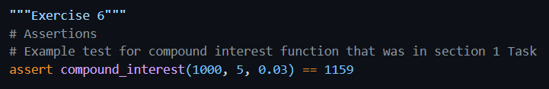

### Explanation

I used the assert keyword to test the output of the compound_interest function. If the result is not exactly 1159, the program will raise an error. Since the actual return value matches, the code runs without any issues.

### Output

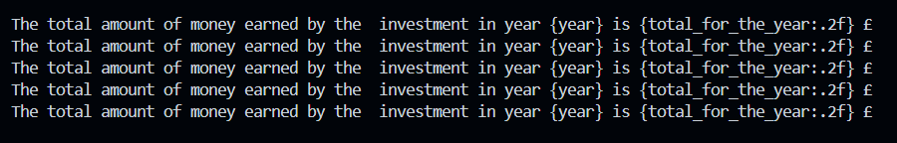

## Exercise 7: Identifying and Fixing Common Errors

### Understanding the Task

#### Syntax Error

Occurs when Python code is written incorrectly and doesn't follow the proper rules — e.g., a typo like pritn() instead of print().

##### Source Code 1 – Has Error

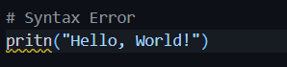

##### Output 1

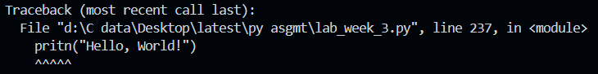

##### Source Code – Corrected

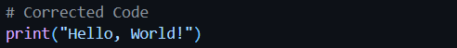

##### Output 2

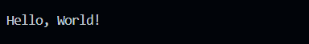

##### Explanation

The original line used pritn() which is incorrect. I fixed it by writing print("Hello, World!") correctly.

#### Name Error

Happens when you try to use a variable or function name that hasn’t been defined yet.

##### Source Code 1 - Has Error

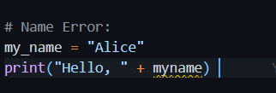

##### Output 1

##### 

##### Source Code 2 – Corrected Code

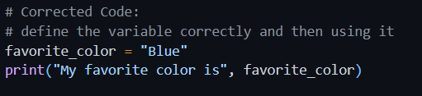

##### Output 2

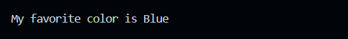

##### Explanation

Originally, myname was used without being defined. I fixed it by using a properly declared variable favorite_color and printed it correctly.

#### Value Error

Occurs when a function gets the right type of data but the value is not acceptable — like converting "abc" to an integer.

##### Source Code 1 – Has Error

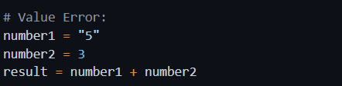

##### Output 1

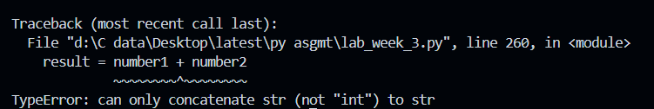

##### Source Code 2 – Corrected Code

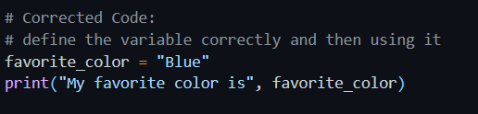

##### Output 2



##### Explanation

Python can’t add a string and an integer directly. I fixed it by converting "5" to int using int("5") before adding.

#### Index Error

Happens when you try to access an index in a list that doesn’t exist — like accessing index 3 in a 3-item list.

##### Source Code 1 – Has Error

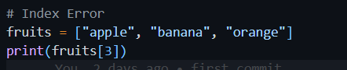

##### Output 1

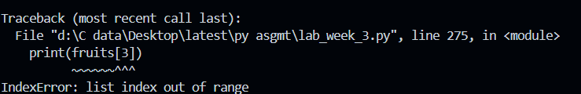

##### Source Code 2 – Corrected Code

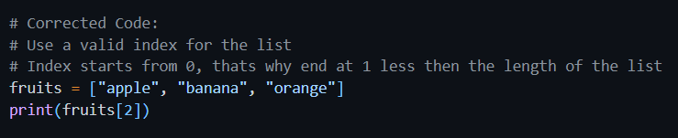

##### Output 2



##### Explanation

The list only had 3 elements (index 0 to 2), but index 3 was used. I corrected it by accessing index 2, which is valid.

##### Output

#### Indentation Error

Occurs when the code isn't properly spaced. Python uses indentation to know what code belongs in loops, functions, etc.

##### Source Code 1 – Has Error

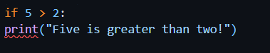

##### Output 1

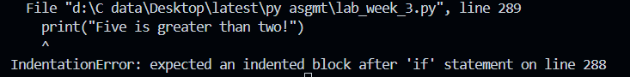

##### Source Code 2 – Corrected Code

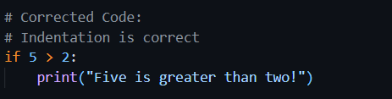

##### Output 2

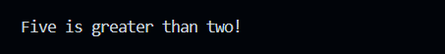

##### Explanation

Python expects code blocks to be indented. The original code wasn’t indented under if. I fixed it by indenting the print() line properly.

# Section 3. Larger scale python program

## Task: To-Do list manager:

### Understanding the Task

The purpose of this task was to create a simple **To-Do List application** using basic Python features like lists, functions, conditionals, and loops. The program should allow the user to manage their daily tasks by adding them, viewing the current list, removing any task, and exiting the program using a menu system.

The focus was on writing clean, functional code and understanding how to work with user input and list operations in Python.

### Source Code

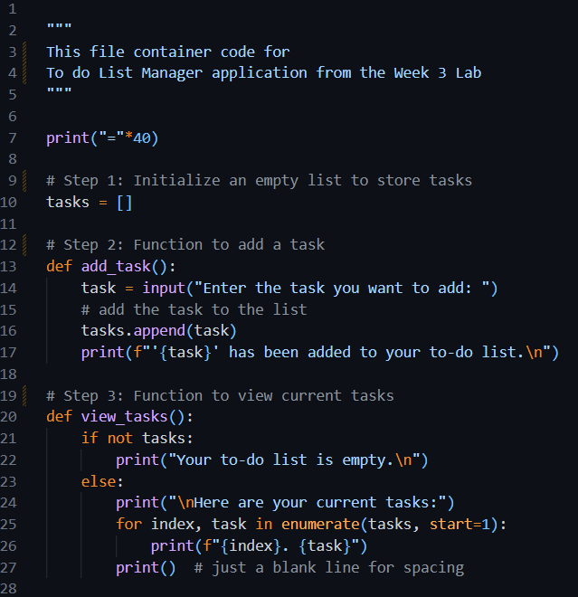

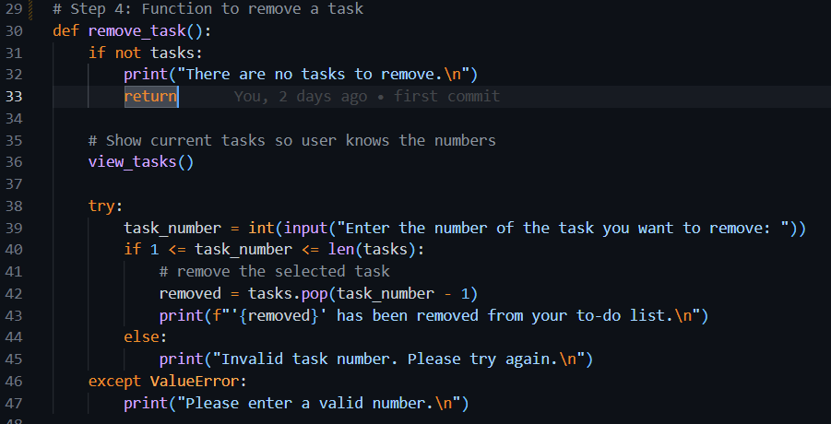

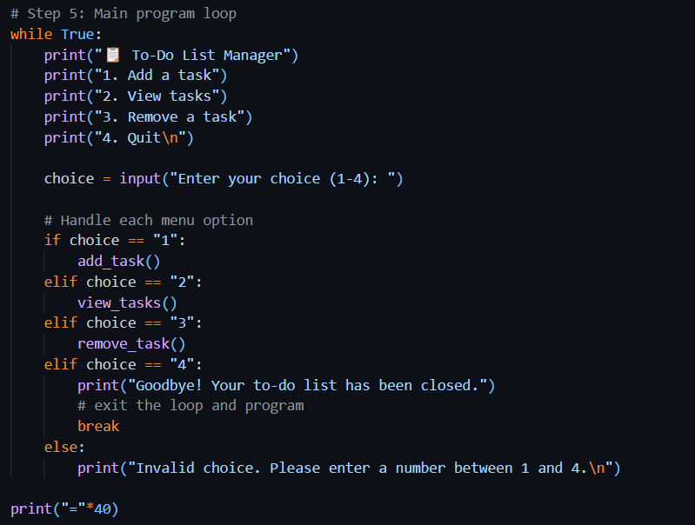

### Explanation

The program runs in a loop and offers four main options to the user:

#### 1. Initialize the Task List

At the top of the program, an empty list called tasks is created. This is where all the tasks entered by the user are stored.

#### 2. Adding a Task

The add_task() function asks the user to type in a task. Once entered, the task is added to the list, and a confirmation message is displayed.

#### 3. Viewing All Tasks

The view_tasks() function checks if the list is empty. If not, it shows all current tasks with numbers beside them for easy reference. This helps the user see what tasks they’ve added so far.

#### 4. Removing a Task

The remove_task() function lets the user delete a task by entering its number. The task list is displayed first so the user knows the correct number. The function also handles invalid input or if the list is empty.

#### 5. Menu and Loop

The program uses a while loop to repeatedly show the menu:

* 1 to Add a task
* 2 to View tasks
* 3 to Remove a task
* 4 to Quit

The user can perform any action, and the loop keeps running until the user selects the quit option.

### Output

###### Choice 1

Choosing 1 to add a task (one by one)

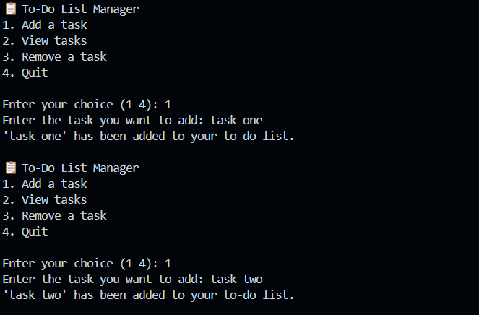

###### Choice 2

Choosing 2 to view tasks.

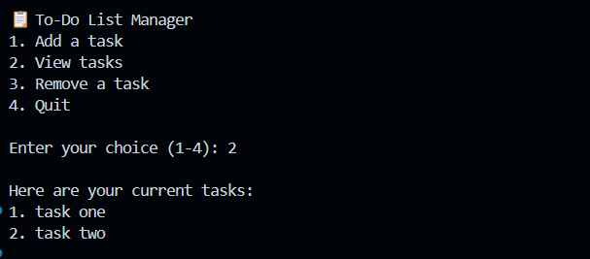

###### Choice 3

Choosing 3 to delete a task.

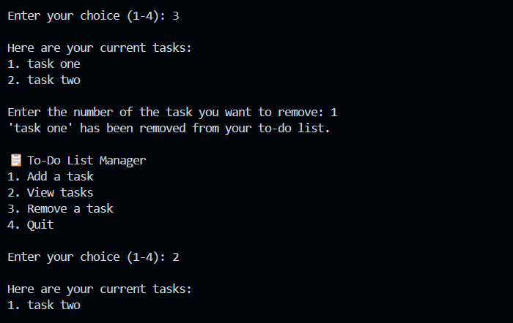

###### Choice 4

Quitting the program

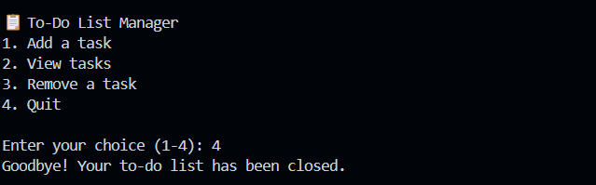

Week 4

# Section 1. Python Classes

## Exercise 1: Creating Classes and Initializing Objects

### Understanding the Task

In this exercise, I was asked to create Task class which will have task details. I was also asked to define a class called TaskList that holds a list of tasks which are the objects of Tasks from the Task class and stores the owner’s name. I learned how to use the __init__ method to initialize class attributes.

### Source Code

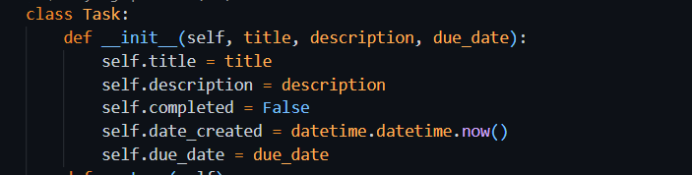

### Explanation

This class is used to represent a single task in a to-do list. When a new Task object is created, it automatically stores:

* **title**: The name or heading of the task
* **description**: A short explanation about what the task is
* **completed**: A boolean value that shows whether the task is done (initially set to False)
* **date_created**: The current date and time when the task is created
* **due_date**: The deadline for the task

This helps organize all the important details of one task inside a single object.

### Source Code

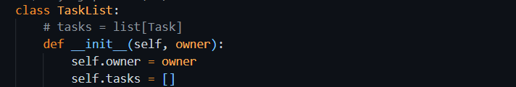

### Explanation

This class is used to manage a list of tasks for one user.

* **owner**: Stores the name of the person who owns the task list
* **tasks**: An empty list that will hold multiple Task objects

This class acts as a container for managing multiple tasks under one user.

#### Object Creation

For Task Class:



And for Task List class:

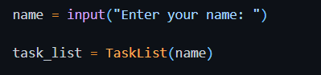

## Exercise 2: Adding Methods

### Understanding the Task

In this task, I was asked to expand the Task class by adding useful methods that allow interacting with task data. The goal was to practice writing instance methods for updating task attributes, such as marking it as complete, changing the title, or changing the due date. This helped me understand how to define custom behaviors inside a class.

### Source Code

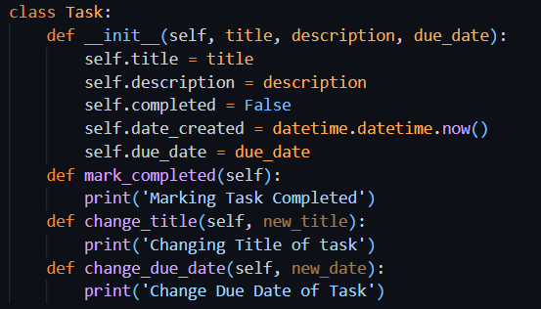

### Explanation

#### mark_completed() Method

* This method is intended to mark the task as completed.
* Currently, it just prints a message, but in a full version, it would update the completed status to True.

#### change_title(new_title) Method

* This method is designed to change the title of the task.
* It prints a message as a placeholder, but normally it would update the self.title.

#### change_due_date(new_date) Method

* This is meant to update the due date of the task.
* Right now, it prints a confirmation message, but ideally it would modify self.due_date.

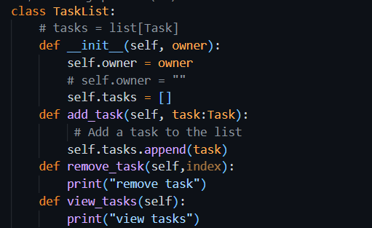

#### add_task(self, task: Task):

Adds a new Task object to the tasks list using the .append() method.

*remove_task(self, index):*

This function is meant to remove a task using a user-provided index. However, the actual deletion line (del self.tasks[index - 1]) is commented out. Instead, it only prints debug information like the task's position and name. This shows that the logic was still under development or being tested.

*view_tasks(self):*

Displays all tasks in the list. If the list is empty, it shows a message saying there are no tasks. Otherwise, it loops through the list and prints each task with a number.

This structure shows how methods can be added to a class to make it more dynamic and interactive.

## Task: Add logic to methods defined

In Task Class, I have implemented logic of functions e.g. mark_completed(), change_title(), change_due_date(). When any of these details will be required to be changed of specific task, these methods will be called respectively

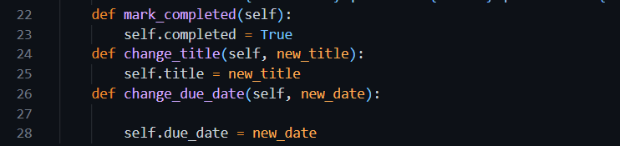

In TaskList Class, I have implemented logic of methods e.g. add_task(), view_tasks(), remove_task(). These methods will modify the tasks_list accordingly.

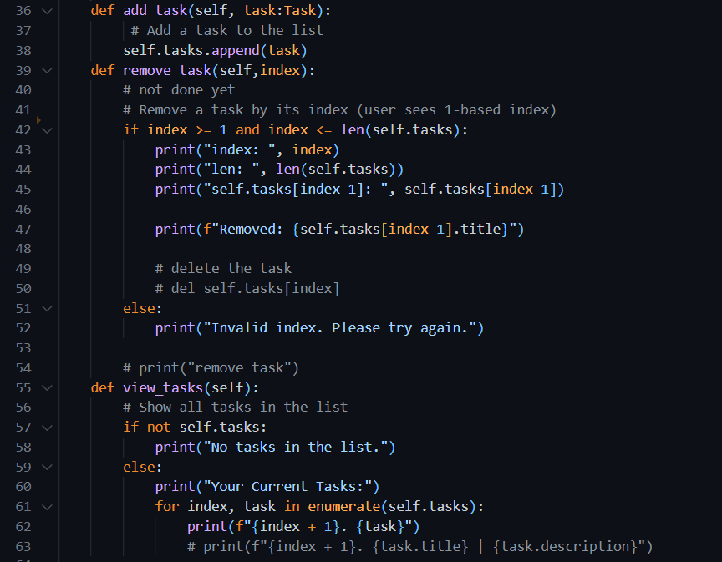

List_options() method will be calling for showing menu to the user and then calling the respective methods according to the choice.

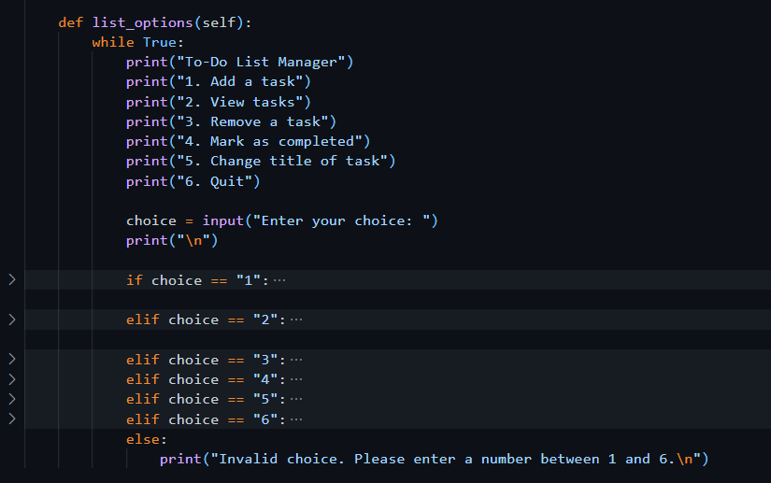

## Exercise 3: Testing the Functionality

Testing is done to check whether the code is working correctly or not.

### 

### Output

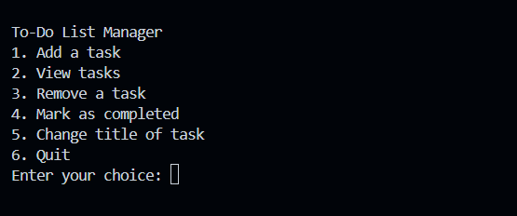

### Code

Choosing one option lets us add one new task to the list at a time. Its working correctly

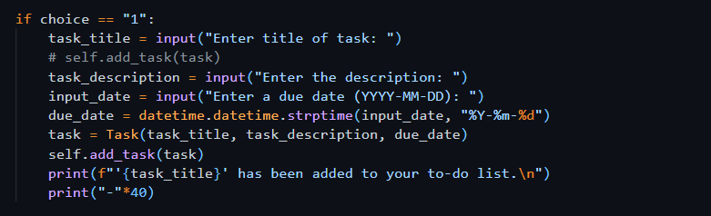

### Output

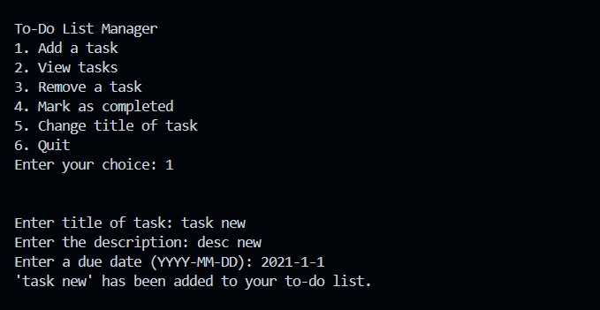

### Code

Choosing option 2 to view all the tasks. Its working correctly

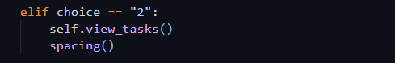

### Output

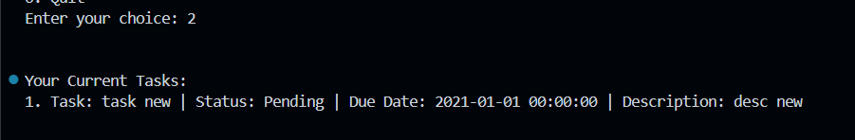

### Code

Choosing option 3 to delete the task

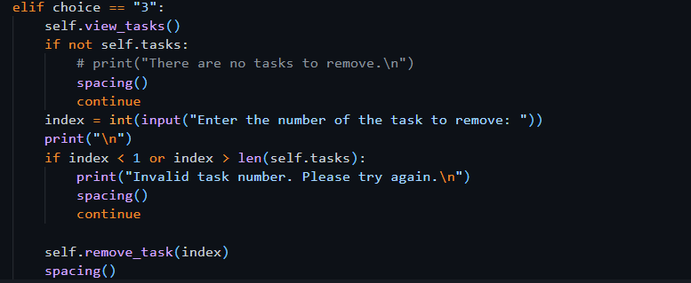

### Output

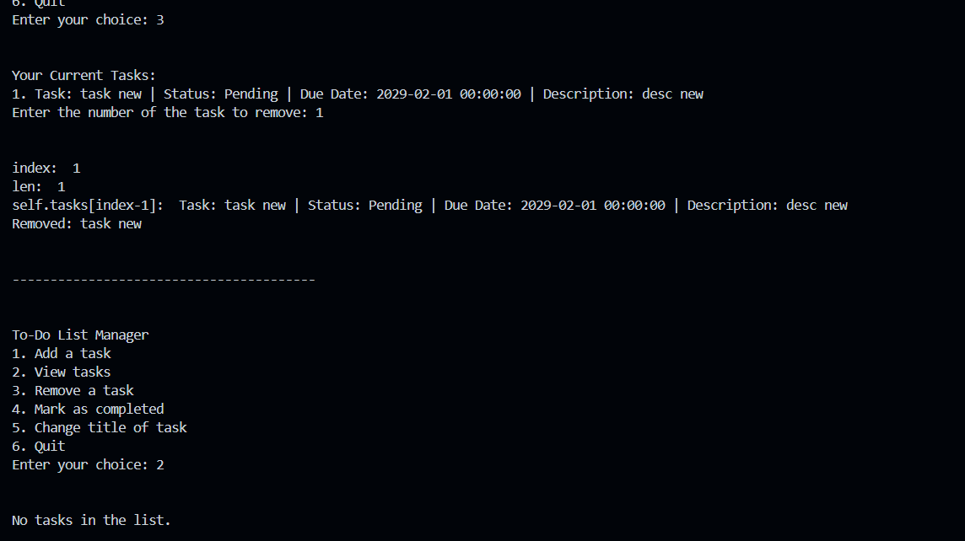

## Exercise 4: Composition

**Composition** is an object-oriented programming concept where one class is made up of or contains objects of another class.

### Source Code

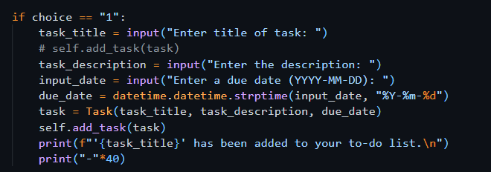

### Explanation

This code is taking title, desc and due date of a task as input from user. It then saves information using object of Task Class. It then adds that object to the Task List class using add_task() method. In this way TaskList can have many Tasks

## _str_ method

If we simply print the Task object , it will show something like



But we want to see the details of Task e.g. title, description, etc. For this purpose, we use _str_ method, which will convert the object into string and then will show it to user in readable format.



## Task: Change code in the Task Class

### Understanding the Task

‘**completed’** attribute is to be added to the class to mark the status of the task. First, it should be false to show that the task is not completed yet. There should be a function **mark_completed()** to update the status of the task. **change_title()** method will change the title of the respective task. All these details will be shown to the user by **_str_** method.

### Source Code

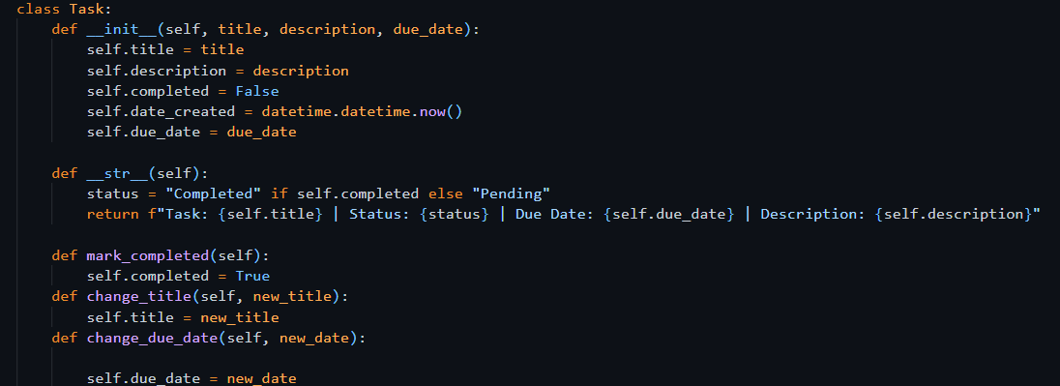

## Task: Update list_options() method

The options mark_completed(), change_title(), change_due_date() should be added to the menu items to show to the user to operate.

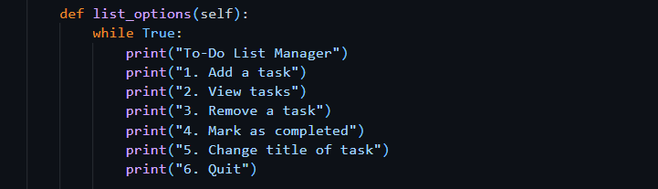

If Elif statements

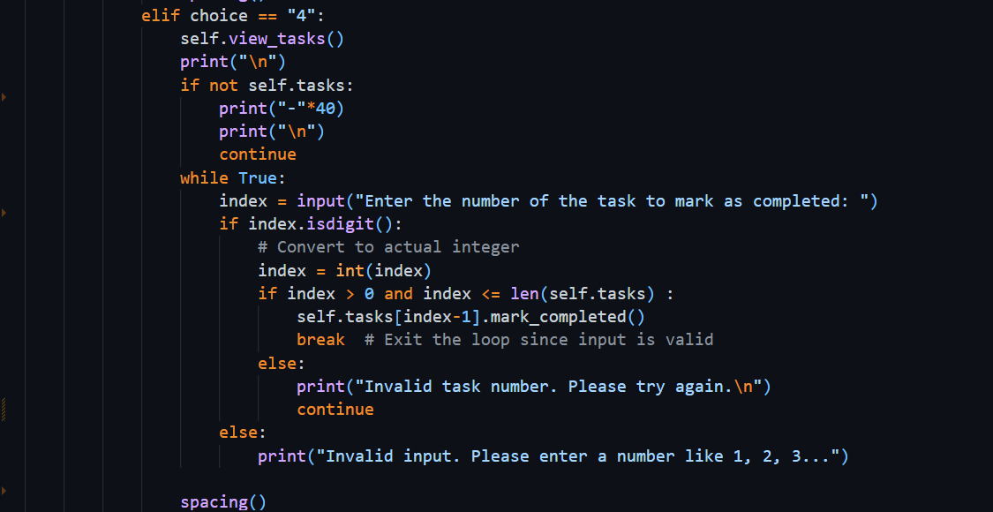

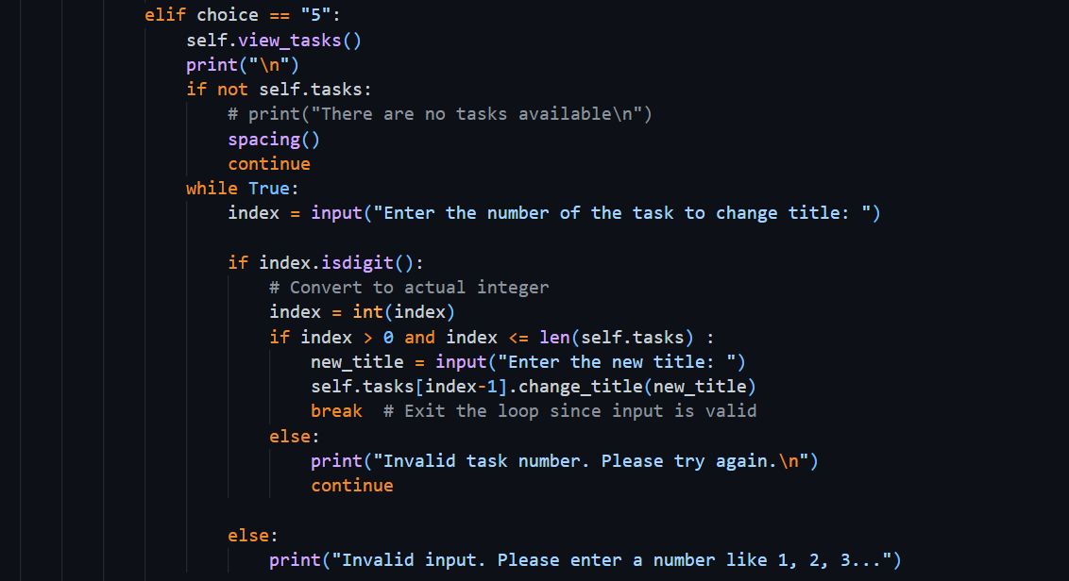

# Section 2. Python Libraries

Libraries are collections of functions and methods that allow you to perform actions, without having written the code yourself.

## Exercise 1: Adding Dates

### Understanding the Task

It is important for each task to have both the date it was created and the due date. To handle this, I used Python’s built-in **datetime** library. A method called **change_due_date** was also added so that the due date can be updated later if needed.

### Source Code

It is required to import the library, mostly at the top of the file.

**datetime** is the python library which is used to work with the dates and time. It lets us to :

* Get the current date and time
* Format dates in different ways
* Compare dates
* Add or subtract days, months, etc.
* Convert strings into date objects

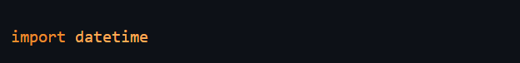

In this program, it is required to convert the string date (input from user) into datetime object and then save it to the Task. **strptime** also known as ‘String Parse Time’ is used to **convert a date string into a proper datetime object**, using a specific format. It takes 2 arguments, one is string and other is format, in which the string has to be converted.

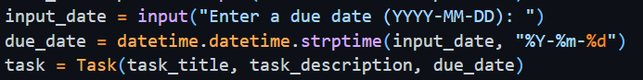

Or getting the present date and time



## Task: Add the due_date functionality

For changing due date of the task, I have created ‘change_due_date()’



Modification of If-else statements in list_options() method for changing due date

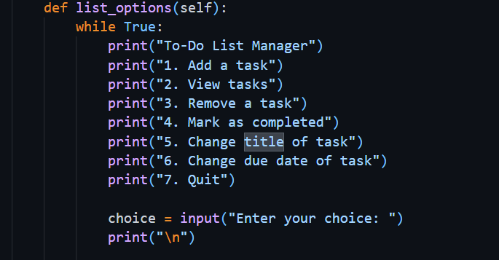

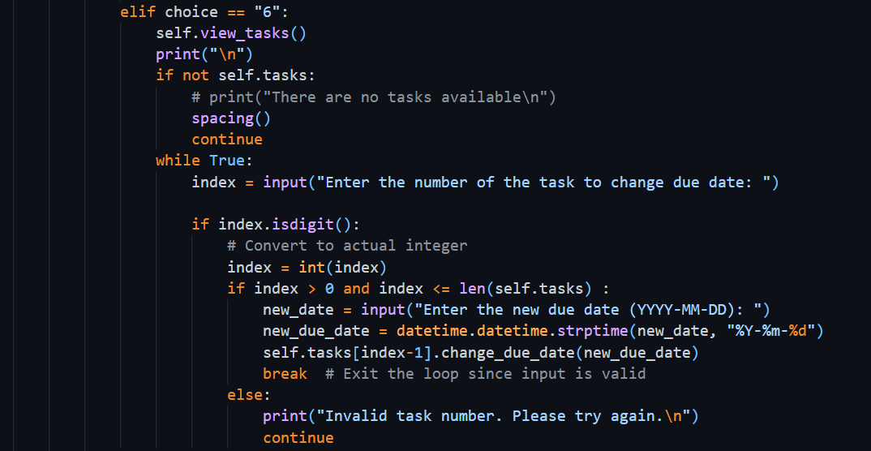

### Output

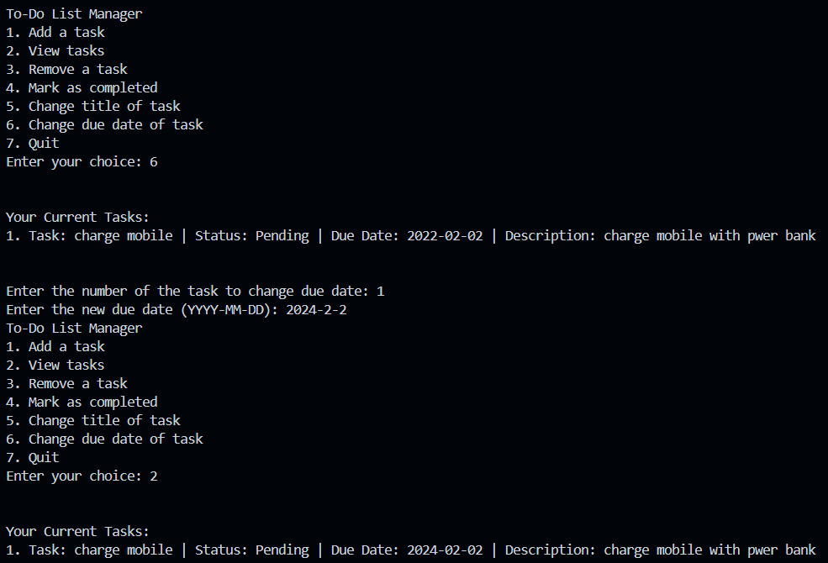

# Section 3. Modularizing the code

## Exercise 1: Restructuring

### Understanding the Task

In this task, I learned the importance of organizing code by splitting it into multiple files, which is called **modularization**. Instead of writing everything in one large script, I had to separate my code into different modules, each handling a specific part of the program.

I was asked to create a new folder called ToDoApp, then inside it:

* Create a main.py file to act as the **main.py entry point** of the application.
* Move the **Task** class into a new file called **task.py**.
* Move the **TaskList** class into another file called **task_list.py**.

This structure helps keep the code cleaner, easier to understand, and more manageable, especially as the program grows. I also had to handle importing properly.

### Explanation

To make the code more organized, I divided it into three separate Python files:

#### main.py

This file acts as the **entry point** of the program. It contains the user interface (menu), takes input from the user, and calls functions from other files. This is the file I run to start the application.

#### task.py

This module contains the **Task class**, which holds all the properties of a task, like title, description, due date, date created, and whether the task is completed. It also includes useful methods like:

* mark_completed()
* change_title()
* change_description()
* change_due_date()

#### task_list.py

This file contains the **TaskList class**, which manages a list of Task objects. It allows adding, removing, viewing, and checking overdue tasks.

### Output

* The program runs smoothly by calling everything from main.py, while the logic stays separated in task.py and task_list.py.
* The output remains the same as before — the user can add, view, update, or remove tasks using the menu.
* Code is now cleaner, easier to debug, and simpler to extend in the future.
* If I ever want to reuse the Task or TaskList classes in another project, I can do so without rewriting them.
* It follows a good programming habit of separating logic into modules, which is useful for teamwork and larger projects.

#### Import statement

When one file contents are being used in another file, it must be imported into the second file at the top, otherwise it will give error.

### Code

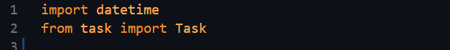

The second import statement says that I have imported Task class from task file. ‘task’ file is basically task.py file.

## Exercise 2: Main()

### Understanding the Task

In this task, I had to properly define a **main() function** that serves as the starting point of the program. The purpose was to cleanly separate the program's setup logic and make the code more structured.

Instead of writing everything directly at the bottom of the file, I placed the core startup code inside main() and then called it safely using:

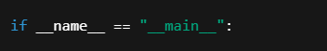

### Source Code

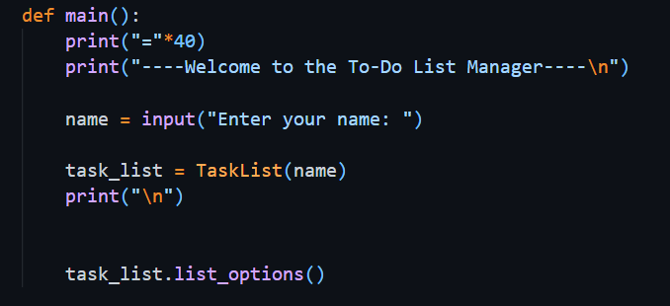

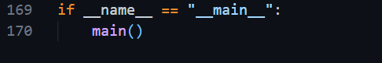

### Explanation

* Inside the main() function, I created an instance of TaskList, passing a name (e.g., "Ahmed").
* Then I called task_list.list_options() — this method displays the menu and lets the user interact with the to-do list.
* The condition if __name__ == "__main__" makes sure the app runs only when executed directly, not when imported.

This structure is helpful for testing, modularity, and professional coding practices.

## Task: Move Menu Logic to main() in main.py

### Understanding the Task

In this task, I was required to remove the list_options() method from the TaskList class and move its code into the main() function inside main.py. The purpose of this change is to make the code more modular and better structured.

Since the menu and user interaction part is not the responsibility of the TaskList class (which should only manage tasks), it makes more sense to place that logic in main.py, where the user runs the program.

### Explanation

Previously, the TaskList class included a method called list_options() that handled everything — from displaying the menu to taking user input and performing actions like adding or removing tasks. But that mixed two responsibilities into one class:

* Task management
* User interaction

To follow proper object-oriented design, I:

* Opened task_list.py and **copied the entire list_options() method’s content**
* Pasted the code inside the main() function in main.py
* Removed the list_options() method from TaskList class
* Deleted the line task_list.list_options() and replaced it with the actual menu logic now inside main()

Now, main.py handles the user interaction, and TaskList only manages the task-related functions. This separation improves the design and makes future updates (like replacing the menu with a GUI) much easier.

## Task: Using task_list object instead of self

### Understanding the Task

When I moved the menu logic from the TaskList class into the main() function in main.py, I had to replace all instances of self with task_list. This was necessary because I was no longer inside a class method. I was now working in a regular function (main()), where self is not available. The task_list object was already created earlier in main() to represent the user's task manager, so I used it to access tasklist class methods.

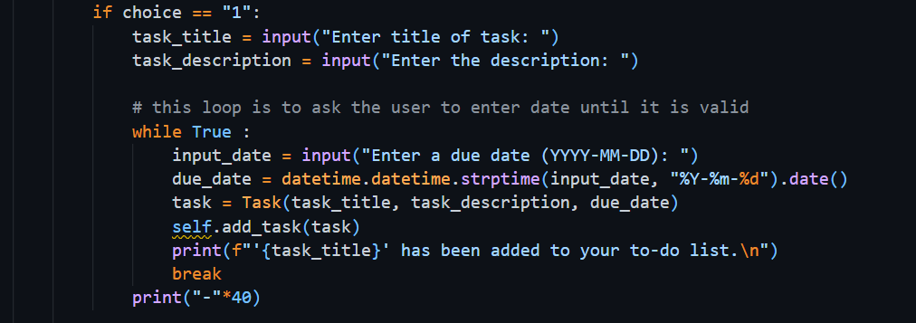

### Explanation

In the original list_options() method inside the TaskList class, all method calls used self, like this:

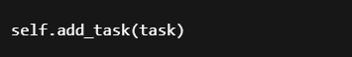

But after moving this logic to main.py, we’re no longer inside the TaskList class. So, we need to use the actual object created in main(), which is:



Now, to call methods on this object, I changed self to task_list, like:

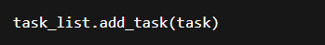

## Task: Add Helper function for test tasks

### Understanding the Task

In this task, I was asked to add a helper function named propagate_task_list() that would automatically fill the task list with some sample tasks when the program starts. The main reason for this was to make testing easier, so I wouldn’t have to manually add tasks every time I run the program.

The function takes a TaskList object and adds several tasks to it, with different due dates (some in the past, some in the future). Then it returns the updated task list back to the main program.

### Source Code

#### Definition

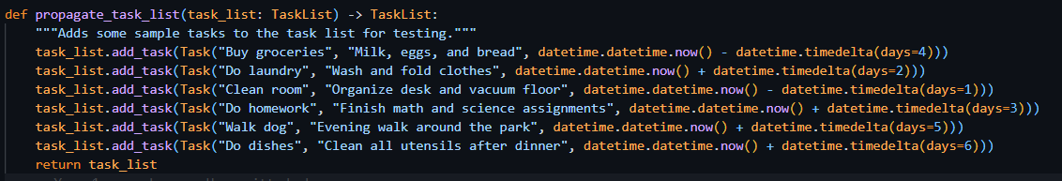

#### Usage

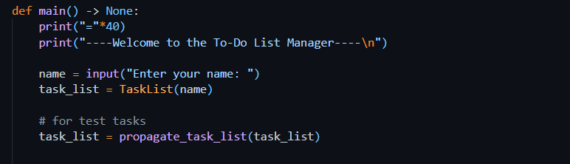

### Explanation

To complete this task, I followed these steps:

#### Defined the Function:

I copied the propagate_task_list() function into the top section of my main.py file, right above the main() function. Inside this function, I added six sample tasks with various due dates.

#### Called It in main():

Inside my main() function, after creating the task list object.

This made sure that every time I run the program, the task list already includes some tasks.

#### Testing Becomes Easier:

Now when I run the app, I can immediately test features like viewing tasks, marking them as completed, removing them, or checking overdue tasks, without entering tasks manually each time.

This step didn’t change how the app behaves for the user, but it made my development and testing process a lot faster and smoother.

### Output

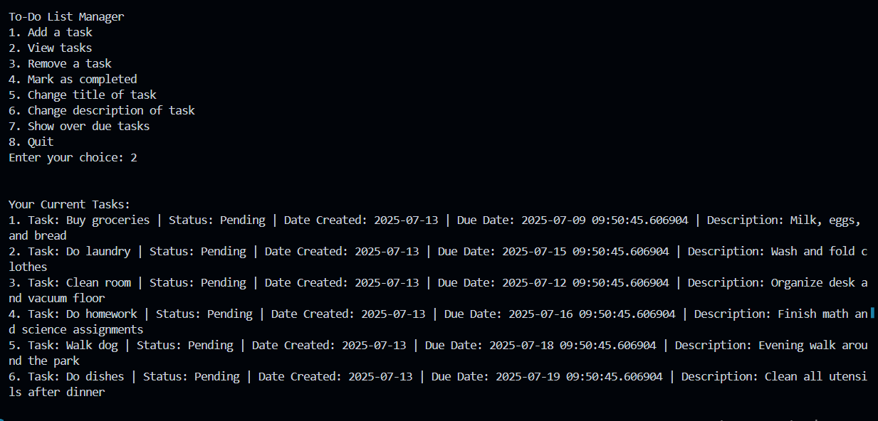

# Section 4. Type Checking and Documenting your Code

## Exercise 1: Type Checking

### Understanding the Task

In this exercise, I learned how to use **type hints** in Python to make my code cleaner, safer, and easier to understand. Although Python doesn't force you to declare variable types (like Java or C++), it's considered good practice to include them using the syntax variable_name: type.

Type hints help:

* Prevent bugs by catching type-related mistakes early.
* Improve code readability.
* Allow editors like VS Code to show helpful suggestions or warnings.

#### Type Hints for Method Parameters

This part showed me how to define what type of input (parameter) a method or function expects. For example:

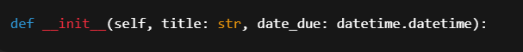

This means title should be a str and date_due should be a datetime object.  
It helps others (and me) understand what kind of values should be passed into the method.

Another example:

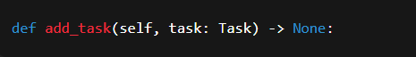

This method is expecting an object of type Task.

#### Type Hints for Return Values

“I also learned how to show what type of value a function returns by using the -> arrow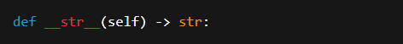

This means the __str__() method will return a string.  
It’s useful because when I call this method later, I’ll know exactly what kind of output to expect.

## Exercise 2: Docstrings and Comments

### Understanding the Task

In this task, I learned the importance of **documenting code** so that it becomes easier to understand — both for myself in the future and for others who may read it. I explored two main ways of doing this:

1. **Comments** – Used to explain parts of the code in plain language.
2. **Docstrings** – Used to describe what a class, method, or function does. These are written inside triple quotes right after the function or class definition.

The goal was to practice writing both, so the code becomes more readable and professional.

### Explanation

#### Comments:

I used # to add short notes inside my code to explain what each line or block is doing. For example:

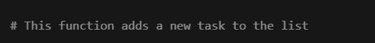

#### Docstrings:

These are placed inside triple quotes """ """ and written right below the function or class header. They explain what the method/class is for, what arguments it takes, and what it returns (if anything). For example:

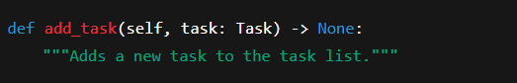

By adding docstrings and comments, my code became easier to read and work with. It also helped me stay organized and made it easier to review or debug things later.

## Portfolio Exercise 1: Adding Description Attribute to Task

### Understanding the Task

In this task, I was asked to improve the Task class by adding an optional **description** feature. This allows each task to have some extra details written about it, but it's not required.

I had to:

* Update the __init__ method so that the description can be passed when creating a task.
* Add a change_description() method to update the description later.
* Modify the __str__() method so that the description is included when printing the task.
* Lastly, I needed to update the main() function so that the user can change the task description through the menu (in the option where title and due date are already being updated).

### Explanation

* I started by updating the constructor like this:

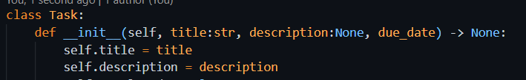

This made the description optional by setting its default value to None.

* Then I added a method:

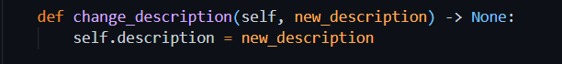

This allowed the user to change the description any time they want.

* In the __str__() method, I added the description to the return string so that whenever a task is displayed, its description shows up too.
* Finally, in main.py, I added an input option for the user to update the task’s description in the menu that also handles updating title and due date.

## Portfolio Exercise 2: View overdue tasks

### Understanding the Task

In this task, I had to add a feature that lets the user see all the **overdue tasks** — meaning tasks whose due date has already passed. For this, I needed to:

* Create a method called view_overdue_tasks() inside the TaskList class.
* Update the main() function and add a new menu option that calls this method.

This helps users easily track which tasks they’ve missed or need urgent attention.

### Explanation

In the TaskList class, I wrote a new method called view_overdue_tasks() which:

* Loops through all tasks.
* Checks if the due_date is **less than today’s date** using datetime.date.today().
* Prints those tasks as overdue.

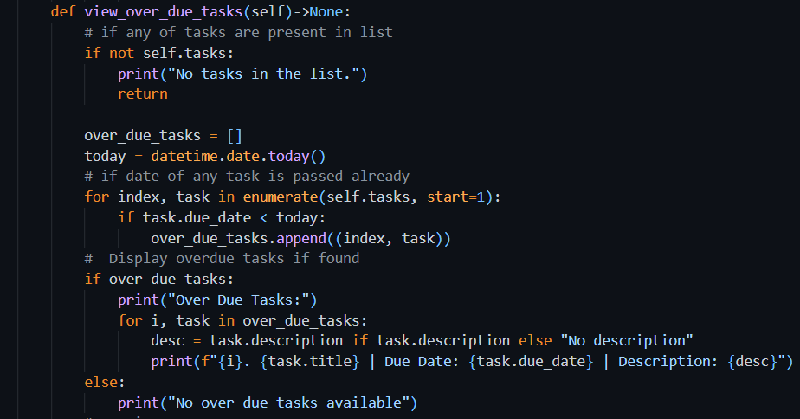

Then, in main.py, I added a new choice in the menu, that calls this method when selected.

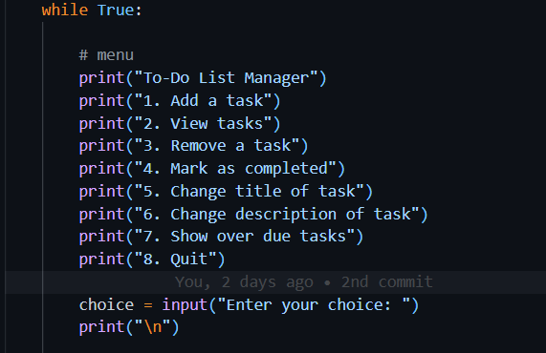

### Output

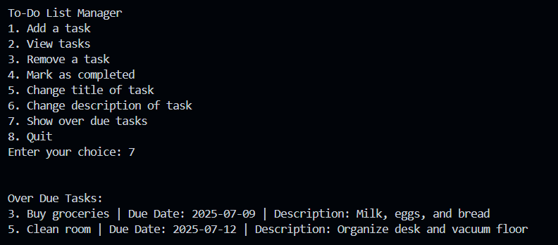

Week 5

# Section 1. Inheritance

## Exercise 1: Simple Inheritance

### Understanding the Task

In this exercise, I learned the concept of **inheritance** in object-oriented programming. The main goal was to understand how a child’s class can reuse and extend the features of a parent class. For example, since a **Car is a Vehicle**, we can create a Car class that inherits from a base Vehicle class.

The idea is to avoid repeating code. We define common features like colour, weight, and max_speed once in the parent (Vehicle) class and then let child classes like Plane or Car use those features directly. Each child can also have its own specific attributes (like wingspan for a plane).

### Explanation

* I started by creating a base class Vehicle with common properties.
* Then I made a child class (like Plane or Car) using inheritance like this:

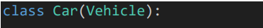

This means Car will automatically get everything from Vehicle.

* I also practiced **method overriding**, where I redefined the move() method inside the child class to change its output. For example:

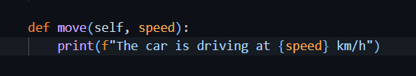

Even though the parent Vehicle class had its own move() method, this allowed me to customize it for each specific vehicle.

This exercise helped me understand how inheritance helps reduce code repetition, makes programs easier to organize, and supports flexible custom behavior in child classes.

#### Object Creation

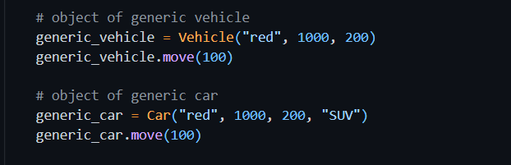

##### Output

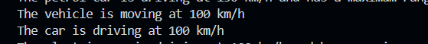

#### Adding more attributes to child class

Child class has all the attributes of parent class, but in some cases we need to add new attributes to child classes. For example, here in example of Car, the **form_factor** has to be added.

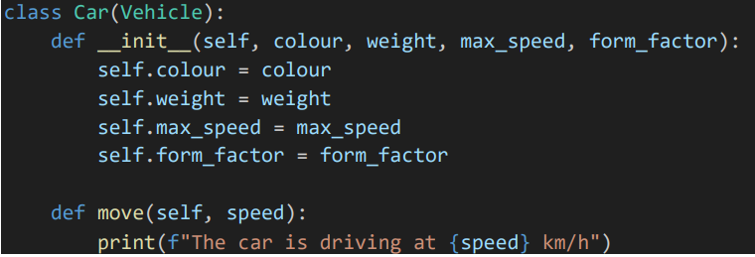

Creating the object with form factor:

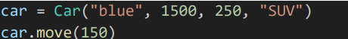

## Exercise 2: Super () function

super() is a special function used inside a **child class** to call a method from its **parent class**.

It's mostly used in **constructors (__init__)** to make sure the parent class is properly initialized before the child class adds more functionality.

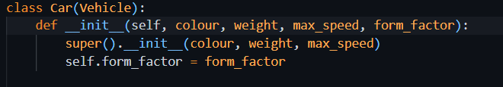

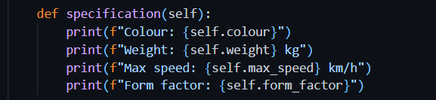

### Output

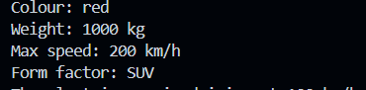

## Task: Create ElectricCar and the PetrolCar class.

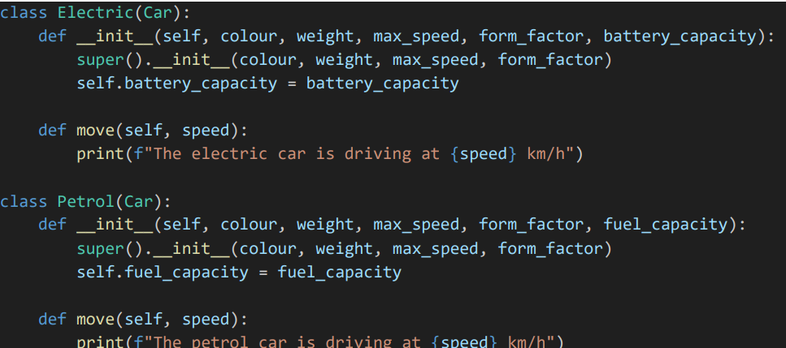

#### Test

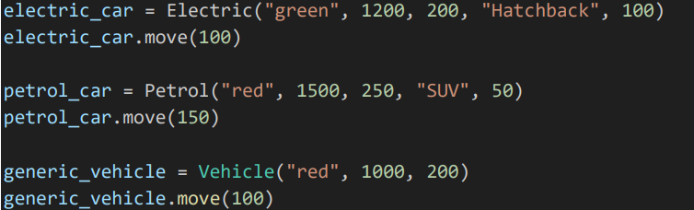

##### Output

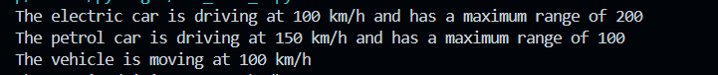

## Task: Adding max range parameter

Some vehicles have max range, but some do not have. That’s why max_range attribute is set to be None on default. If any vehicle has this value, it will be used.

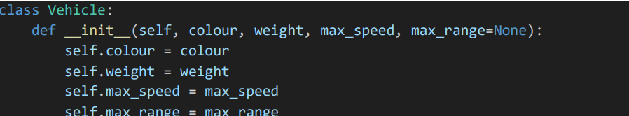

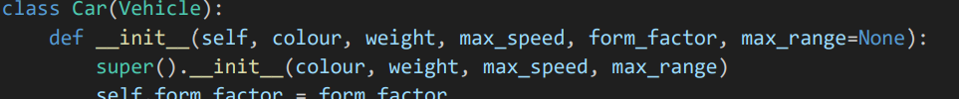

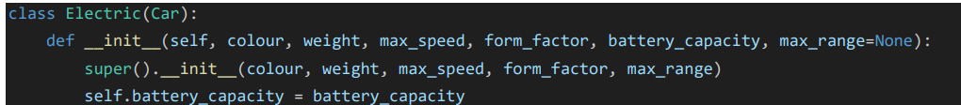

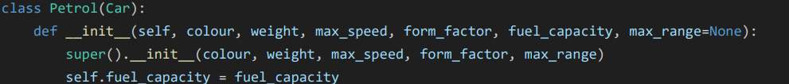

Using max range in electric car move method

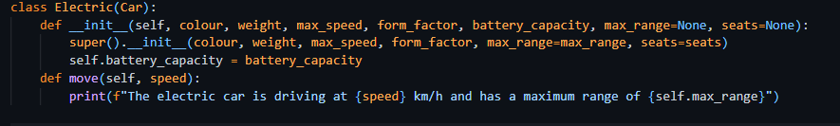

## Exercise 2: kwargs**

By using kwargs**, we can pass as many keyword arguments as possible. These are stored in dictionary data structure  
To use kwargs**, add this keyword as a parameter to any child class that is derived from Vehicle. Then pass this keyword to the parent class using super() function.

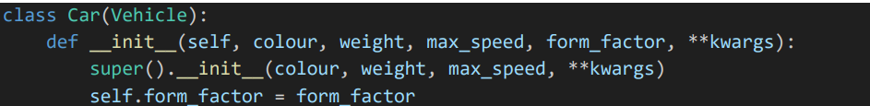

### Understanding the Task

In this task, I learned how to use **kwargs in a function or constructor.  
The purpose of **kwargs is to allow a function or method to accept **any number of keyword arguments** (like seats=4, max_range=200) even if they aren’t explicitly listed in the parameter list.

This is helpful when working with **inheritance** because sometimes a child’s class needs to pass extra arguments to the parent class without knowing exactly what those arguments are.

### Explanation

* **kwargs stands for **"keyword arguments"**
* It collects any extra named arguments as a dictionary

### Source Code

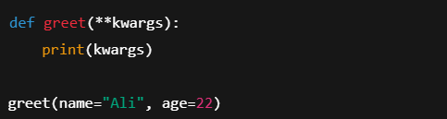

### Output

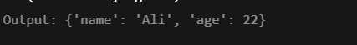

## Task: Adding seats attribute

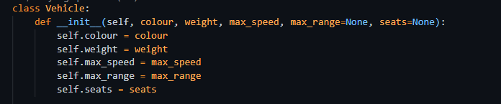

### Test

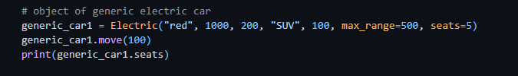

### Output



## Task: Creating Multilevel Inheritance

### Understanding the Task

In this task, I was asked to extend the Vehicle class by adding a new child class called Plane, and two more specific child classes from that, Propeller and Jet. This type of inheritance is called **multilevel inheritance.**

Each of these subclasses should:

* Inherit common vehicle features like colour, weight, and max_speed
* Add their own unique attribute:
  + Plane → wingspan
  + Propeller → propeller_diameter
  + Jet → engine_thrust

Also, each class should have its own version of the move() method, and since they are all flying machines, their output should say **"flying"** instead of "**driving**" or "**moving**".

### Explanation

* I started by creating a Plane class that **inherits from** Vehicle.
* Inside Plane, I added the extra attribute wingspan, and overrode the move() method to say respective text:

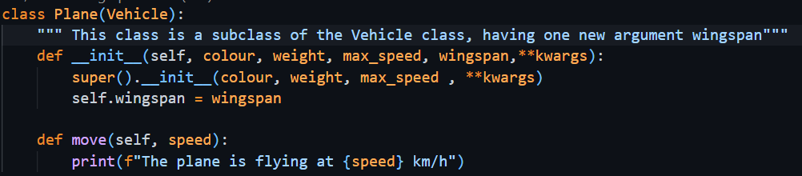

* Then, I created two more child classes:
  + Propeller(Plane) → adds propeller_diameter
  + Jet(Plane) → adds engine_thrust

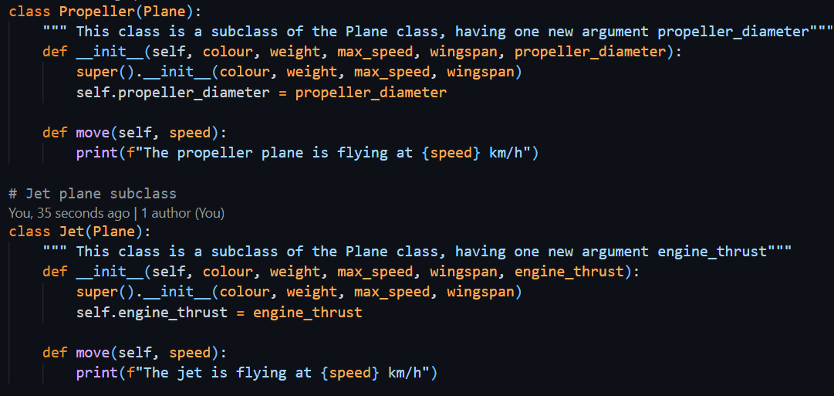

* Each subclass also had its own custom move() method to match its type.
* I tested each class by creating objects and printing their attributes to make sure everything worked as expected.

# Section 3. Multiple Inheritance

### Understanding the Task

In this task, I had to create a class called FlyingCar that inherits from **both** the Car class and the Plane class. This is a good example of **multiple inheritance**, where a child’s class gets features from more than one parent’s class.

Since a flying car has the properties of both a car (like wheels and form factors) and a plane (like wingspan), it makes sense to inherit from both.

### Explanation

* I created the FlyingCar class.

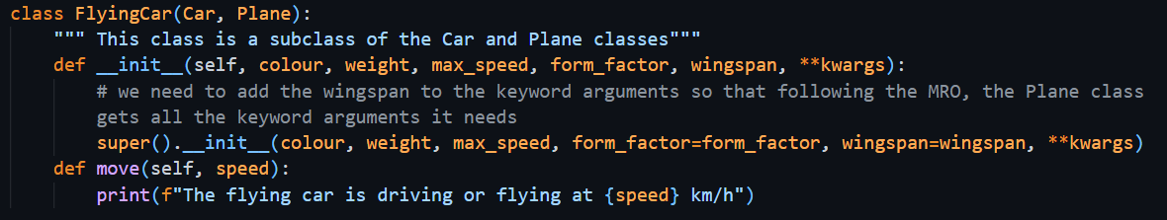

* In the constructor (__init__), I used super() to call the constructors of the parent classes and passed all necessary arguments like form_factor and wingspan.  
  Since Car and Plane both come from Vehicle, I made sure to use **kwargs to pass extra arguments smoothly.
* I also overrode the move()
* I created an object of **FlyingCar** to test whether all attributes (from both car and plane) were set correctly, like **form_factor,** wingspan and seats.

This task helped me understand how multiple inheritance works in Python, and how to combine behaviors from different classes into one.

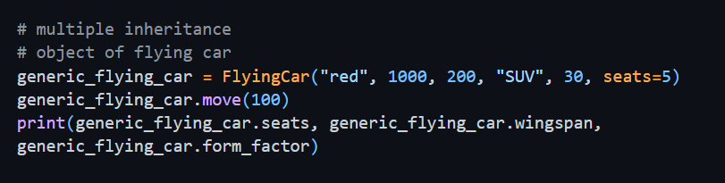

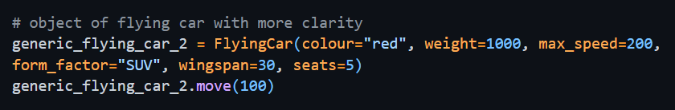

### Output

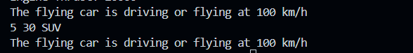

# Section 4. Polymorphism

Polymorphism allows different classes to have a **common method name** (like move()), but each class can perform **its own version** of that method.

### Understanding the Task

The idea is that we don’t need to know what kind of object we’re working with. If it has the method, we can just call it, and Python will run the correct version automatically. This is especially powerful when we’re looping over objects of different types.

### Explanation

The most common example of polymorphism is when a **parent class has a method**, and each **child class overrides** it with its own behavior. It means every child class also has the method with same name and same arguments but with different implementation

Let’s say we have:

* A Vehicle class → has a move() method
* Car, Plane, and FlyingCar subclasses → each with their own version of move()

Even though the method name move() is the same, the **output will depend on which object** is calling it. This is known as **method overriding**, and it’s a core part of polymorphism.

### Source Code

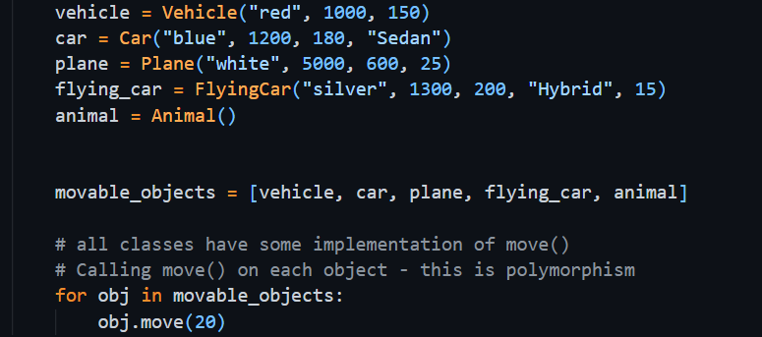

### Explanation

Creating objects of different classes with their respective arguments one by one. Saving all objects in a list and then calling move method of each object displaying the concept of polymorphism.

### Output

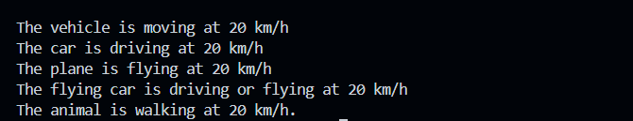

# Section 6. ToDo

## Task: Add Recurring Task functionality

### Understanding the Task

In this task, I had to extend the functionality of the ToDoApp by supporting **recurring tasks**, the kind of tasks that repeat over time (like doing laundry every week or cleaning every 2 weeks). Instead of manually adding these tasks repeatedly, the app should handle them smartly.

To do that, I had to:

* Create a new class called RecurringTask that **inherits from** Task.
* Add new features:
  + interval: a timedelta object that stores how often the task repeats.
  + completed_dates: a list to store **all dates** on which the task was marked as done.
  + _compute_next_due_date(): a method to **automatically calculate the next due date** based on the interval.
* Override the __str__() method to include the **interval** and **completed history**, so we can tell which tasks are recurring when we list them.
* Modify the logic in **option "1"** of the main() function to:
  + Ask the user if they want to add a recurring task or not.
  + If yes → ask for the interval in days, convert it using timedelta, and create a RecurringTask object.
  + If no → create a normal Task as before.

### Explanation

* I created the RecurringTask
* In the constructor, I added:
  + self.interval = interval
  + self.completed_dates = [] → to store completion history
* I added a private method _compute_next_due_date() which calculates the next deadline based on the last completion date or the current due date:
* I overrode the __str__() method to show:
  + Title, due date, status (completed/pending)
  + Interval (like "every 7 days")
  + Completed history

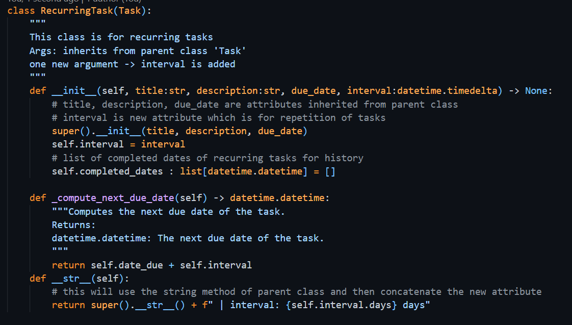

* Then in main.py, I updated the **task-adding flow**:
  + The user is asked: “Add a one time task or a recurring task?”
  + If recurring task, they enter an interval like "7"
  + I converted it using:

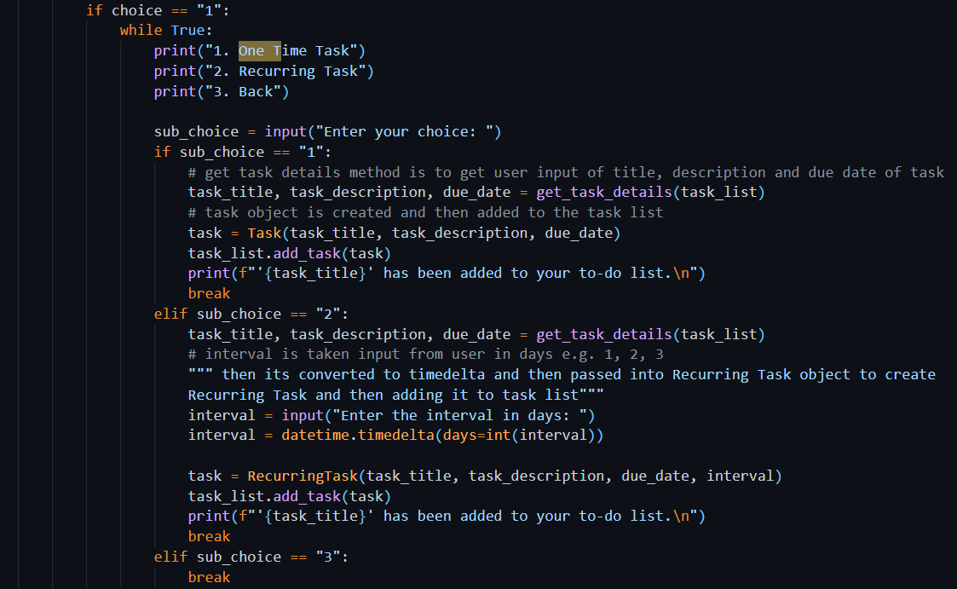

### Explanation

In this code, if user enters option 1 to add a task, it then asks him to enter the choice whether he wants to add a one-time task or a recurring one. In both cases, Program will ask the user to enter task details by get_task_details() method. If the option was to add a recurring task, then program will ask the user to enter number of days for interval. The program will then convert the string number of days into timedelta object using the datetime library. It will then create an object of Recurring Task by passing task details in it.   
Whether the Task created is a one-time task or a recurring task, it will be added into Task List.

### Output

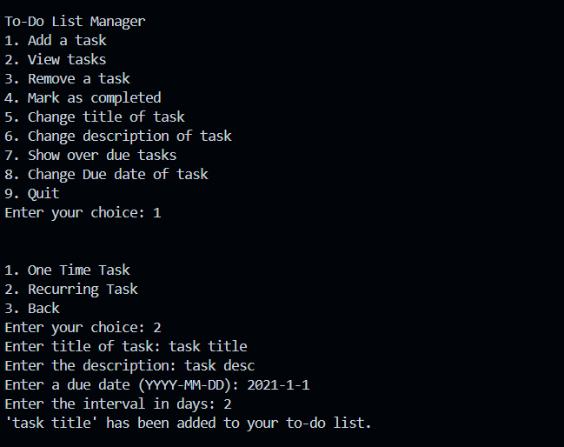

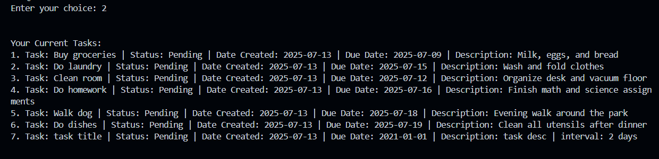

## Task: Add Recurring Task in Propagate Task List

### Understanding the Task

It is asked to add a recurring task in tasks list with all its required attributes, by using the method propagate_task_list

### Source Code

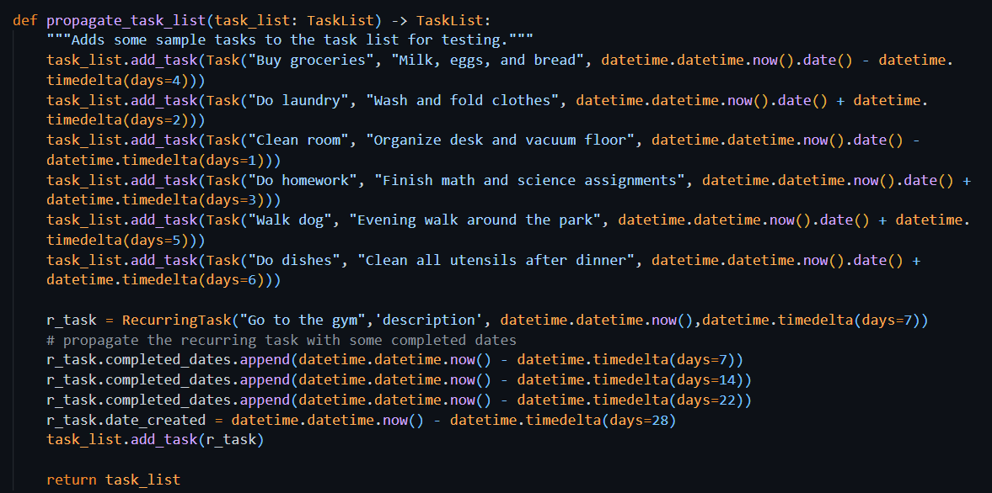

### Explanation

This code is getting a task list object. It then adds 6 objects of tasks into the task list. It also creates an object of Recurring task, then adding it to the task list with completed dates attribute. At the end it is returning a list back. The list returned is the one which we got empty in the start.

### Output

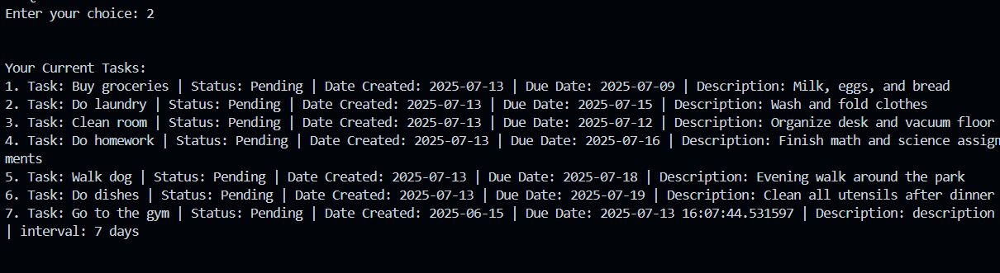

### Explanation

The first 6 tasks are normal one-time tasks and the ls tine is recurring task because of the interval attribute.

## Task: Mark Recurring Task Completed

### Understanding the Task

In the previous version of the ToDoApp, when we marked any task as completed (choice 5), it just updated the task's status to completed = True. But for **recurring tasks**, that's not enough.

This task asked me to improve the behavior of recurring tasks. Instead of just marking them as completed, the app should:

* Keep a **record** of the date when it was completed
* **Update the due date** for the next cycle automatically (e.g., next week)

To implement this, I had to override the mark_completed() method in the RecurringTask class using **polymorphism**.

### Source Code

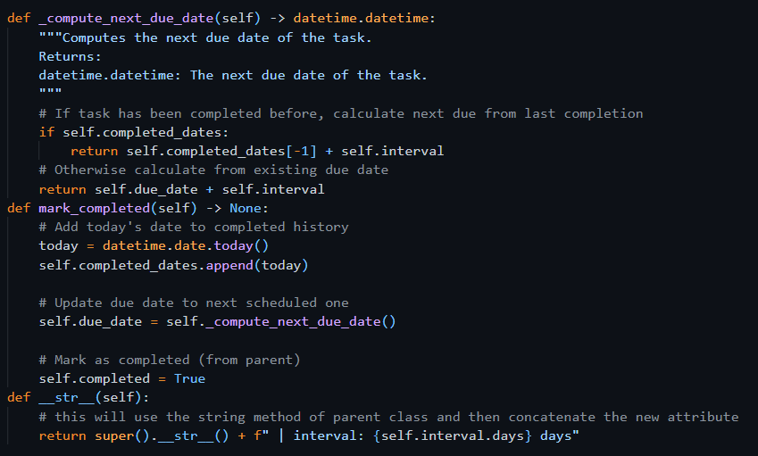

### Explanation

* I created a new version of mark_completed() inside the RecurringTask class.
* Inside that method:
  + I first added today’s date to the completed_dates list:
  + Then, I updated the due_date using the private method compute_next_due_date():
  + This calculates the next due date based on the task’s repeat interval.
  + Finally, I marked the task as completed using:

This shows the use of **polymorphism** — where both Task and RecurringTask have a method with the same name (mark_completed), but the behavior is different based on the object type.

### Output

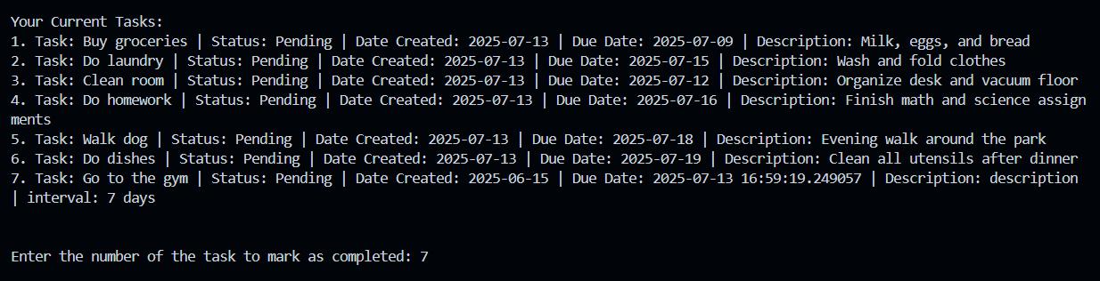

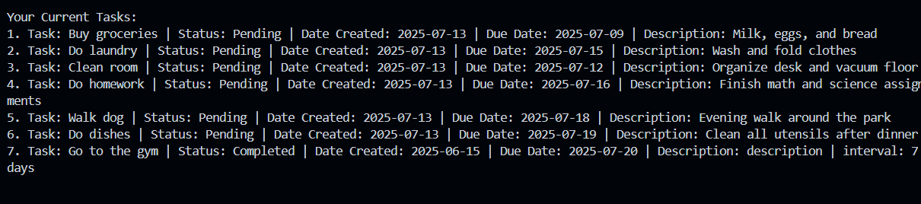

## Exercise 4 – Encapsulation

### Understanding the Task

In this task, I was asked to improve the way tasks are accessed from the TaskList class. Previously, the code directly accessed the task list using task_list.tasks[index]. This is not a good practice because it exposes the internal structure.

The goal was to apply the concept of **encapsulation**, which means hiding internal details and only exposing what’s necessary. I needed to:

* Create a method called get_task(index) inside the TaskList class.
* Replace direct access to task_list.tasks[...] in the main() function with this method.
* Make sure everything still works the same from a user’s point of view.

### Source Code

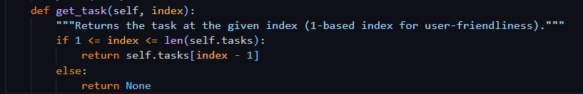

### Example Usage

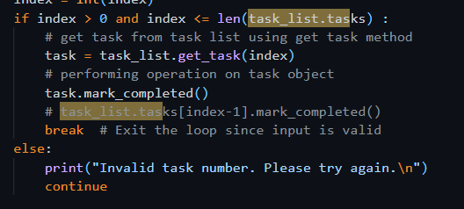

### Explanation

Encapsulation is about protecting the data and only allowing controlled access. So instead of letting other parts of the app directly access the task list, I created a method get_task() inside TaskList. This method checks if the index is valid and safely returns the task.   
By using this method

* The internal list (self.tasks) stays hidden and protected
* Any future changes in how tasks are stored won’t affect the rest of the app
* It keeps the code clean, safe, and easier to maintain

## Portfolio Exercise 3: Add User and Owner Functionalities

### Source Code

#### user.py

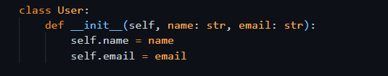

#### owner.py

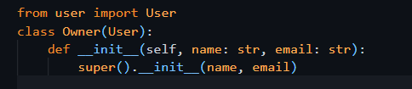

#### Accept owner object in TaskList class

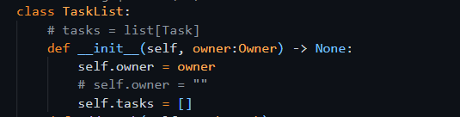

#### Usage in main function

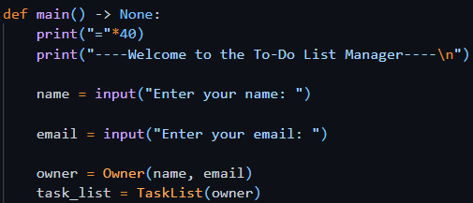

### Understanding the Task (UIT)

This task was about applying **inheritance** and **composition** together in the ToDoApp. I had to introduce a new user system by:

* Creating a User class with basic info like name and email
* Creating an Owner class that inherits from User
* Modifying the TaskList class to include an owner attribute, which should be of type Owner

This helps structure the app more professionally and adds a clear connection between a task list and its owner.

### Explanation

* I created a **base class User** that stores a person's name and email.
* Then I made an Owner class that **inherits from User**, meaning it automatically gets the name and email attributes.
* In the TaskList class, I added an attribute owner, which accepts an Owner object.
* This shows a **composition** relationship: a TaskList "has-an" Owner, while Owner "is-a" User.

This structure follows good OOP design and keeps responsibilities clear. If we want to expand later (e.g., add Admin or Guest users), this structure will make it much easier.

### Output

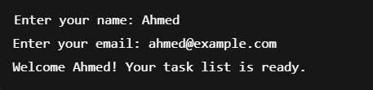

## Portfolio Exercise 4

### Understanding the Task (UIT)

This task was focused on structuring the code better by using **modularization** and **OOP concepts**:

* I had to create two new files users.py and owner.py that contains two classes: User and Owner respectively
* Each class has a __str__() method to print user details nicely
* Then, I updated the TaskList class to accept an Owner object when initializing
* Finally, in main.py, I asked the user for their name and email, created an Owner object, and used that to create a personalized TaskList

### Source Code

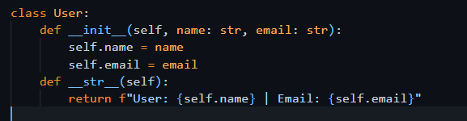

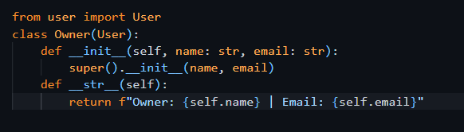

### Usage Example

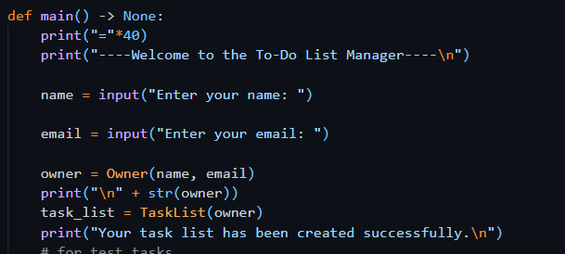

### Output

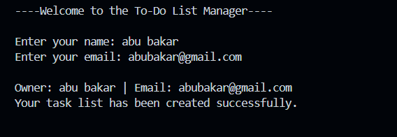

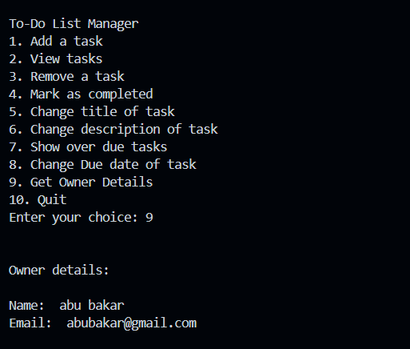

Week 6

# Section 1. Debugging

The debugging process is an important part of programming. It allows you to find and fix errors in your code. A debugger is a tool that allows you to step through your code and see what is happening at each step.

## Exercise 1: Finding the Problem

# Section 2. Properties using the @property decorator

In Python, the @property decorator is used to turn a method into an **attribute-like property**. This allows us to **call methods without parentheses** and treat them like variables — making code cleaner and more readable.

Instead of calling object.get_value(), you can just use object.value

### Understanding the Task

In this task, I was asked to use the @property decorator to filter and return **uncompleted tasks** from a to-do list.

The goal was:

* To define a method uncompleted_tasks() in the TaskList class.
* Use @property so that I can access task_list.uncompleted_tasks like a variable, even though it's a method behind the scenes.
* Update the view_tasks() method to use this property and only show tasks that are **not yet completed**.

### Source Code

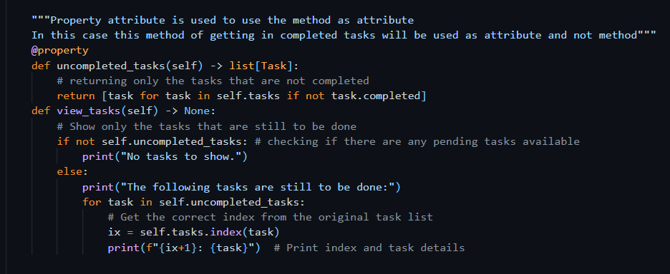

### Explanation

The uncompleted_tasks() method:

* Is now used like a variable (self.uncompleted_tasks) instead of self.uncompleted_tasks().
* This makes code inside view_tasks() cleaner and easier to read.

In the view_tasks() method, this property is used to:

* Check if there are any uncompleted tasks
* Loop through them and print only the tasks that are still pending

The index is retrieved from the original self.tasks list to keep numbering consistent.

### Why Is This Useful?

* It hides logic behind a simple interface
* Improves readability
* Maintains proper encapsulation
* Make code easier to maintain and extend later

### Output

Choosing 2 to view the tasks

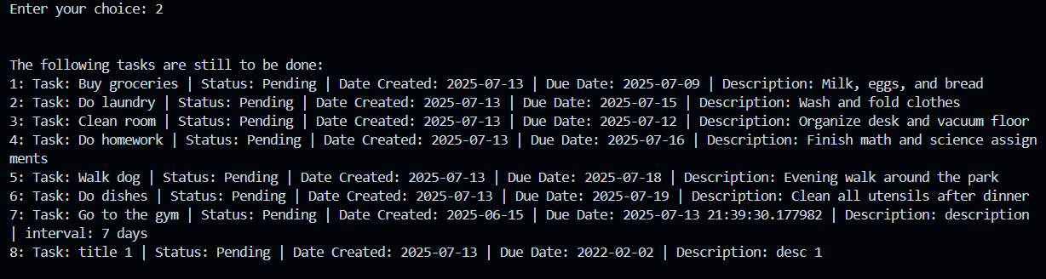

All pending tasks are shown only

# Section 3. Implementing Persistence

**Persistence** means **saving data** so that it remains available **even after the program ends**. In other words, the data stays alive (persistent) between runs of the program.

For example:  
If you create a task list and close the app, persistence allows that list to be saved and reloaded the next time you open it.

In Python, **persistence** can be achieved in several ways — it depends on how structured your data is and what your app needs. Here are the most common methods:

1. **Text Files (.txt)**  
   You can save plain text data in a file and read it later. This method is simple and useful for basic lists or logs.
2. **CSV Files (.csv)**  
   Ideal for tabular data — each row represents a record, and each column a field. It’s commonly used when storing structured data like tasks, scores, or tables.
3. **JSON Files (.json)**  
   This format allows you to store data in key-value pairs (dictionaries) or lists. It's perfect for saving complex objects like task lists with multiple fields (title, due date, completed status, etc.).
4. **Databases (e.g., SQLite, MySQL)**  
   For larger or more complex applications, using a database is a better approach. Databases provide advanced features like search, filtering, sorting, and relations between different data types.

## Exercise 1: DAO

### Understanding the Task

In this task, I had to **modularize** the part of the code responsible for creating sample tasks by moving it into a separate class, following the **DAO design pattern**. This helps separate the **data management logic** from the rest of the application.

Instead of keeping the propagate_task_list() function in the main.py, I removed it and created a new class called TaskTestDAO. This class is responsible for **pretending to load tasks from a file**, even though no real file-saving is happening yet.

Then, I updated the main function to:

* Let the user **choose when to load/save tasks**
* Ask for a file path (just for simulation)
* Create an object of TaskTestDAO
* Use get_all_tasks() to load predefined tasks and add them to the current task list

### Source Code

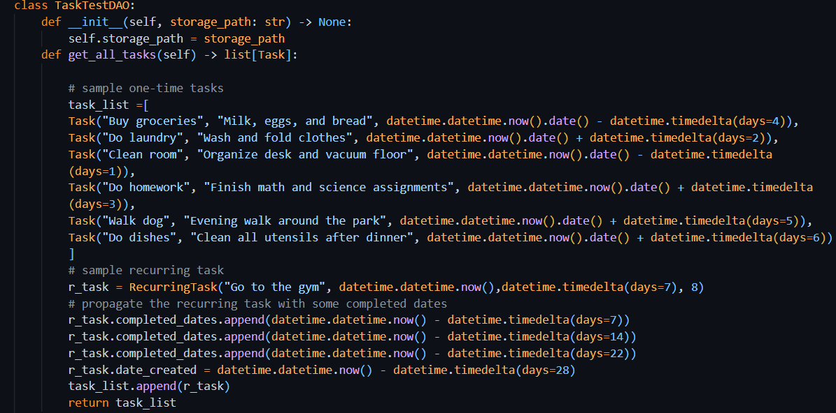

### Explanation

The DAO design pattern separates **data access** logic (like loading and saving) from the rest of the application. This helps in:

* Keeping the main.py file clean
* Making future updates easier (e.g., connecting to a real database or CSV file)
* Improving **code maintainability** and **testability**

In the TaskTestDAO class:

* The get_all_tasks() method simulates loading data by returning a list of sample Task and RecurringTask objects.
* The save_all_tasks() method is empty for now — just a placeholder for future saving functionality.

By moving task-loading logic here, I made the application more **organized** and **realistic**, like how professional apps are built.

## Exercise 2: CSV Persistence

### Serialization

Serialization is the process of converting an object into a stream of bytes to store the object or transmit it to memory, a database, or a file. The main purpose of serializing an object is to be able to recreate it when needed.

In my case, I am going to serialize the tasks to a CSV file.

For this reason, I have created a file TaskCsvDAO.py. The __init__ method sets up the CSV file path by combining the folder of the current Python file with the provided file name, ensuring the file is saved or accessed in the correct location. It also initializes the expected column headers (fieldnames) that define the structure of the task data, including fields like title, type, due date, and completion status. This setup prepares the class to read from or write to the CSV file properly.

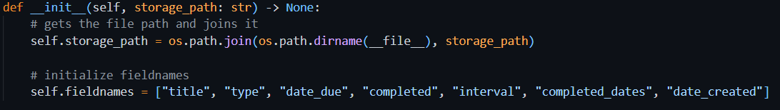

## Task A: Complete get_all_tasks() functionality

### Understanding the Task

In this task, I was required to **load all saved tasks from a CSV file** and convert them back into proper Task or RecurringTask objects. This simulates real **file persistence**, where tasks previously saved to a file are reloaded into the program.

Instead of hardcoding tasks (like in TaskTestDAO), now I'm using TaskCsvDAO to:

* Open the .csv file,
* Read each row
  + Get the type of the task
  + Get the title, due date, date created, interval (if present)
  + Convert the string format of the date into datetime object to be used further
* Check if the row is a normal task or a recurring one,
* Rebuild the appropriate object using the row's data (like title, due date, etc.),
* Do the same processing for all the rows present in file
* And finally, return a list of all such tasks.

### Source Code

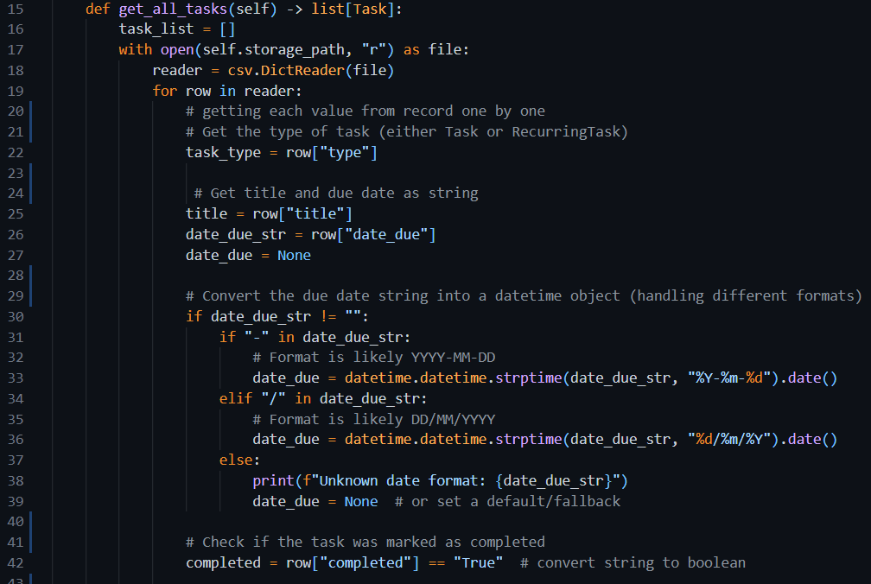

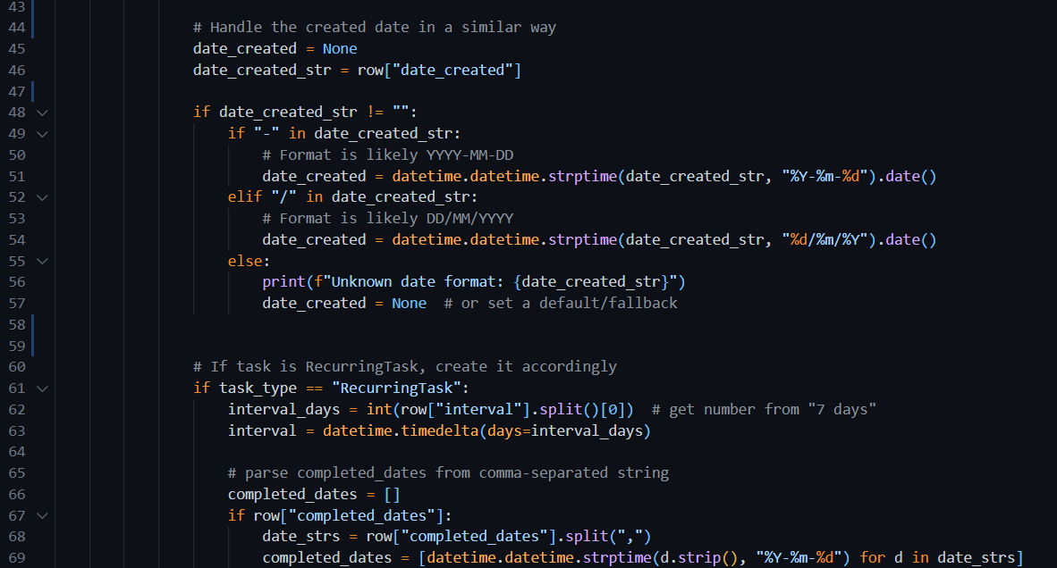

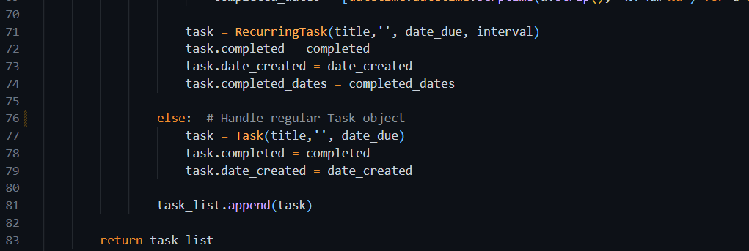

### Explanation

The get_all_tasks() method does the following:

* Opens the CSV file and reads it using csv.DictReader, so each row becomes a dictionary.
* Check the type column to decide if it's a regular Task or a RecurringTask.
* Parses important values like:
  + date_due and date_created using two possible formats (YYYY-MM-DD or DD/MM/YYYY).
  + Converts the completed value from string to Boolean.
  + Extracts and parses the interval (for recurring tasks).
  + Splits and parses multiple completed_dates into a list of datetime objects.
* Build the task object (Task or RecurringTask) and adds it to a list.

This way, all task data from the CSV file is restored exactly as it was, making the program **persistent and usable across sessions.**

### CSV file

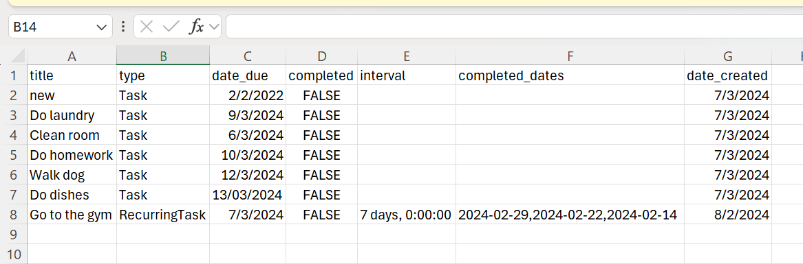

First, there are no tasks present in the program

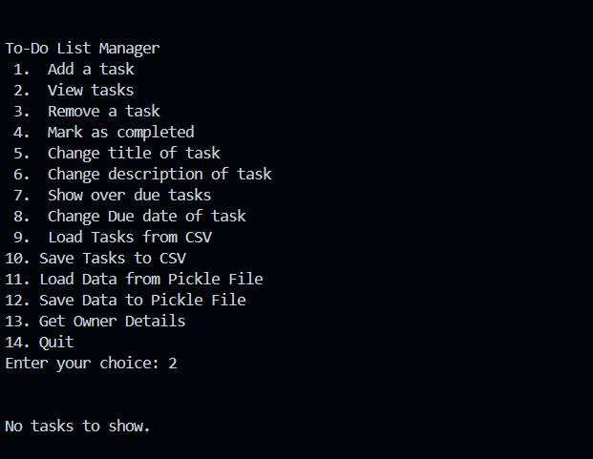

Choosing 9 to load data from csv file. Then entering the path of the file e.g. tasks.csv

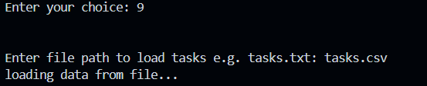

Choosing 2 to view tasks which are loaded from the file

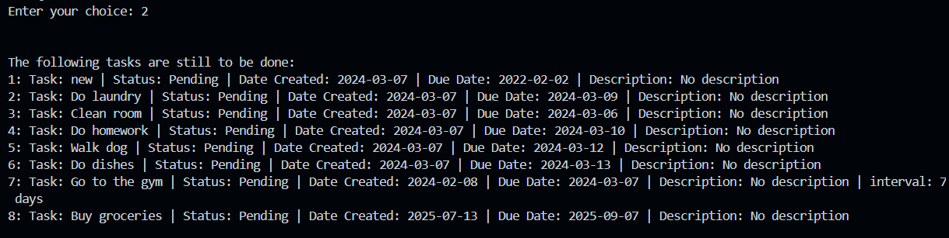

## Task B: Complete save_all_tasks() functionality

### Understanding the Task

In this task, we were asked to implement the functionality to **save tasks to a CSV file**. The goal is to persist user data so that the list of tasks (both regular and recurring) can be stored and accessed later. The function should also:

* Write each task's details to the CSV properly formatted.
* Check and **avoid duplicate entries** using a unique identifier (in this case, the task title).
* Distinguish between regular Task and RecurringTask using the type column.
* Properly handle different task attributes, especially converting date fields and lists (like completed_dates) into strings.

### Source Code

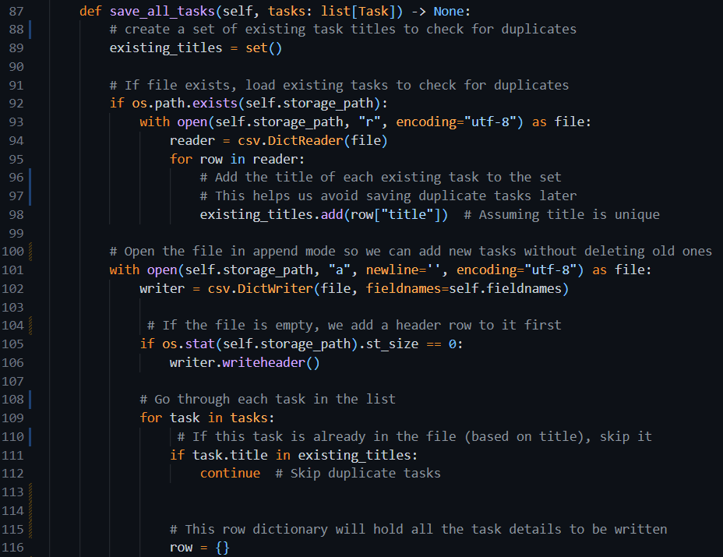

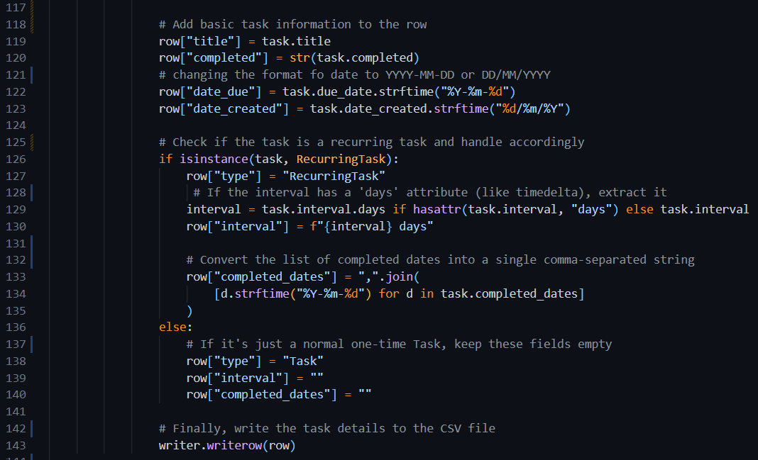

### Explanation

This save_all_tasks method is designed to store all tasks in a CSV file while avoiding duplicates. It first checks if the file already exists and reads any existing task titles to prevent writing the same task multiple times. It then opens the file in append mode and writes a header if the file is empty. For each task in the list, it skips saving if the task title is already present in the file. It then prepares the task's data for storage, converting relevant attributes like due_date and date_created into string format using strftime. If the task is a RecurringTask, it also includes additional fields such as the interval and a comma-separated list of completed dates. If it’s a normal task, those extra fields are left blank. Finally, each prepared task is written as a row in the CSV file, ensuring a clean and structured representation of the task data. This method makes the application’s task data persistent and reusable.

### Output

#### CSV

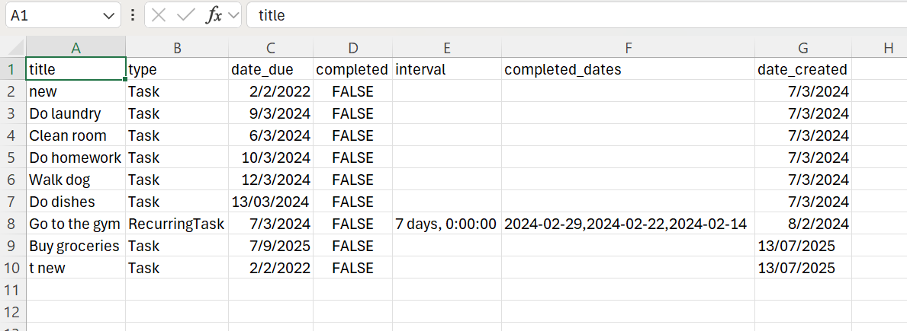

Choosing opt 1 to add a task, then choosing 1 to add a one time task.

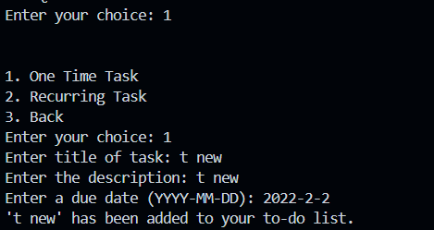

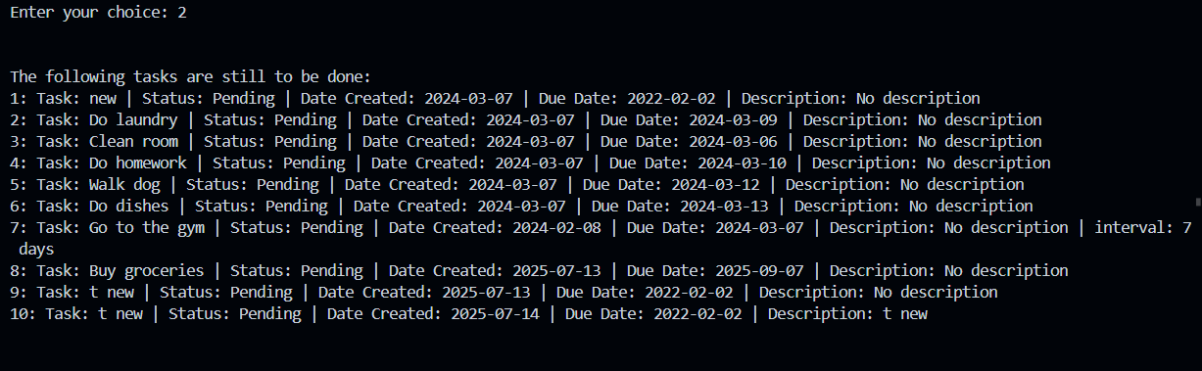

We can see the duplicate of task with title ‘t new’. This output is from the tasks saved in program, not the file.

Choose 10 to save data to file. After that the tasks in the csv are:

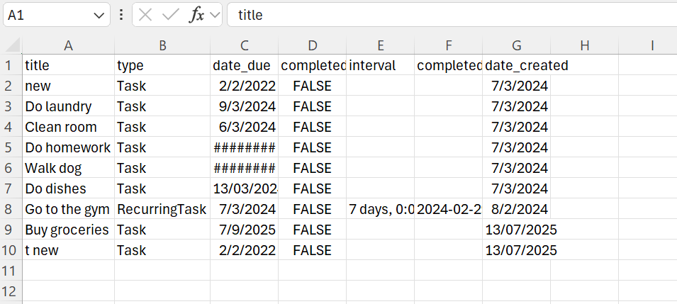

Which shows that duplicate is not saved.

#### Example 2

Choosing 1 and then 1 to add a one time task.

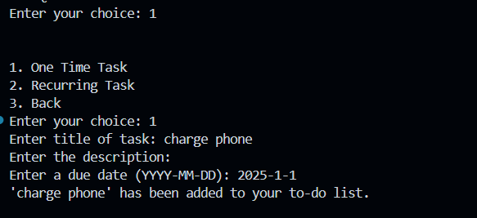

Choosing 10 to save data to file

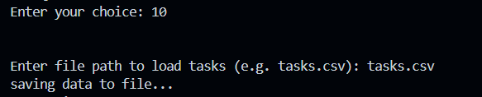

Output in csv

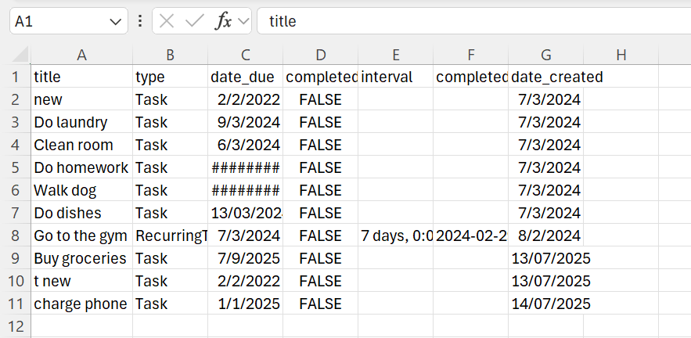

We can see that the task ‘charge phone’ is saved in the file

### Summary

This method ensures that:

* Tasks are written to a file in a clean, structured way.
* Duplicates are avoided.
* Both Task and RecurringTask objects are properly handled.
* Dates and lists are converted into formats suitable for CSV storage.

## Task C: Update single record in the file

### Understanding the Task

The goal of this task is to enable updating a single task record in the CSV file. When a user modifies a task (like marking it as completed, changing the title, updating the description, or editing the due date), these changes should be saved persistently. The update must correctly overwrite only the specific record in the file without affecting the others. This ensures that the CSV file always reflects the most current state of all tasks.

### Source Code

### Explanation

* The method takes two arguments:
  + updated_task: the modified task object (with new values)
  + old_title: the title used to find the original task in the CSV
* First, it opens the CSV file and reads all rows.
* It checks each row’s title to find the task that matches old_title.
* When found:
  + It builds a new row with the updated task data (including type, dates, etc.).
  + Adds this new row to a temporary list.
* All other rows are added to the list unchanged.
* After looping, it writes the entire list back to the CSV file — replacing the original file with the updated content.
* A success message is printed if the update is completed; otherwise, it alerts the user that the task wasn’t found.

The method also properly handles different task types:

* Regular Task
* RecurringTask

#### Usage

##### Marking a Task as Completed (Choice 4)

* Displays all tasks
* Takes task number from user
* Marks the task as completed
* Calls update_task() to save the updated task status in the CSV

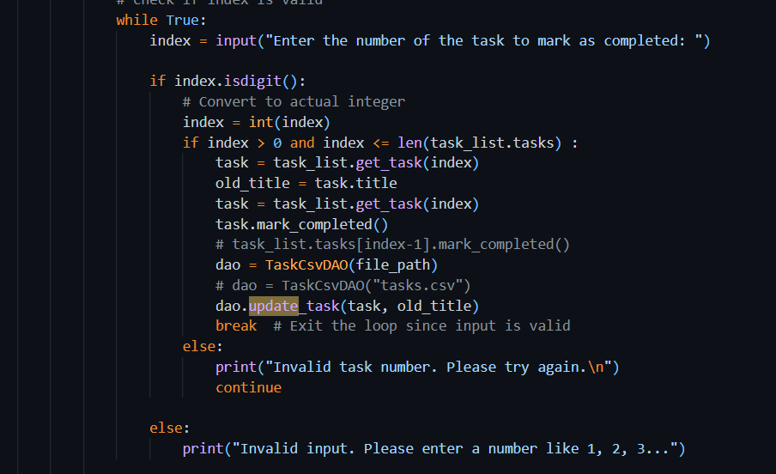

##### Changing Task Title (Choice 5)

* Displays all tasks
* Asks user to enter a task number and a new title
* Updates the task's title
* Calls update_task() to save the new title to the CSV

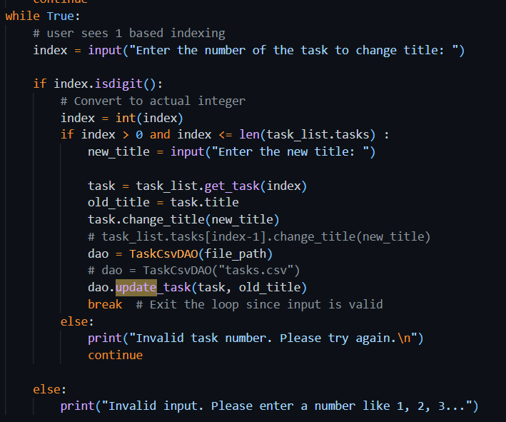

##### Changing Description

* Prompts for task number and new description
* Updates the description
* Calls update_task() with the changed task

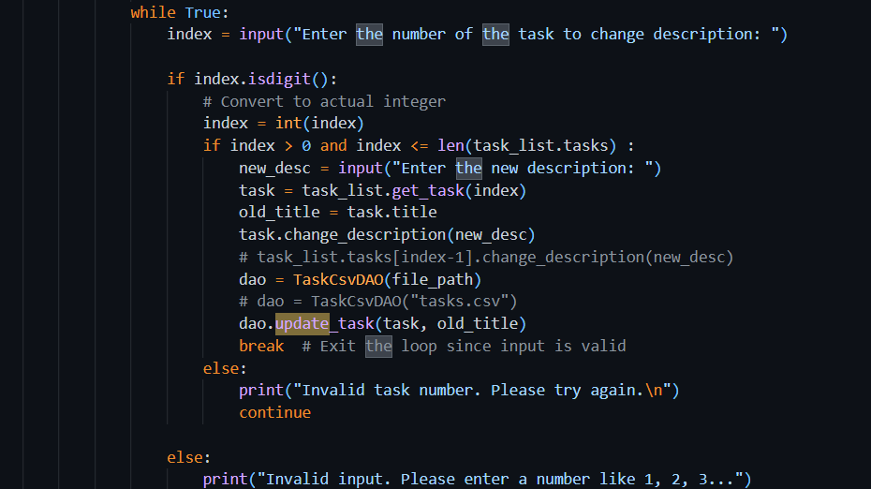

##### Changing Due Date

* Prompts for task number and new due date
* Updates the due date
* Calls update_task() to persist changes

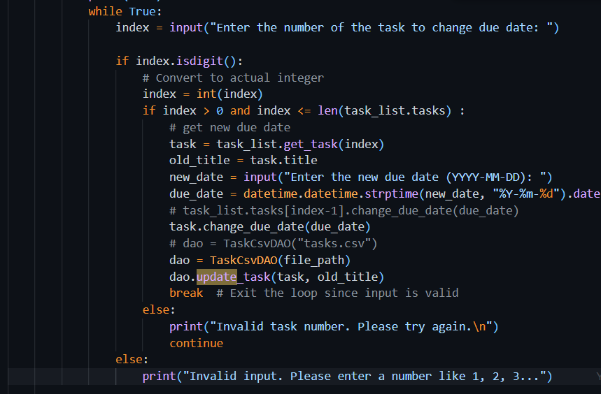

### Explanation

## Exercise 3: Serialization using Pickle

Pickle is a built-in Python module that allows you to **serialize** (convert Python objects into a byte stream) and **deserialize** (load them back into Python objects). It’s helpful when you want to save complex objects (like custom classes or lists of objects) to a file so they can be reused later. Unlike CSV or JSON, which require you to manually handle each attribute, Pickle handles the entire object, preserving its structure, type, and values.

The format of pickle file looks like this:

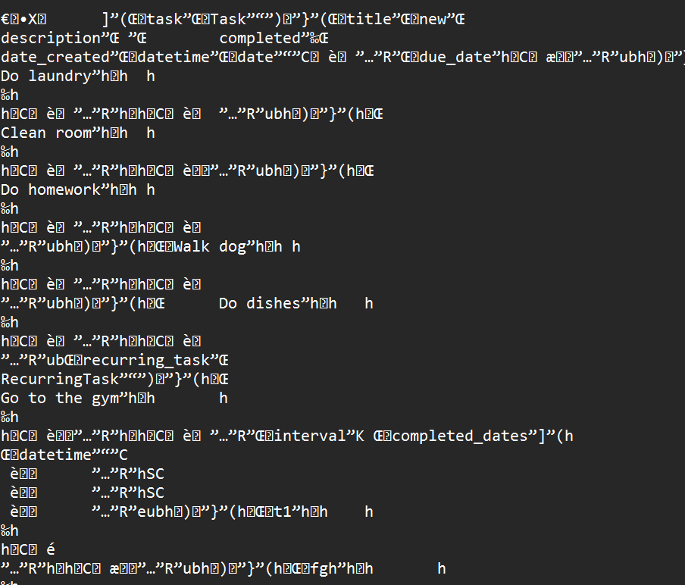

In a **pickle file**, data is saved in **binary format**, specifically, as a stream of bytes that represents Python objects.

### Understanding the Task

The goal of this exercise is to implement a new way of saving and loading tasks using the pickle module instead of CSV. You're asked to create a new class called TaskPickleDAO that reads from and writes to a pickle file. This approach makes it easier to handle complex objects (like tasks with nested attributes or classes), especially as your code grows and changes. This task aims to improve data persistence in a more flexible and Pythonic way.

### Source Code

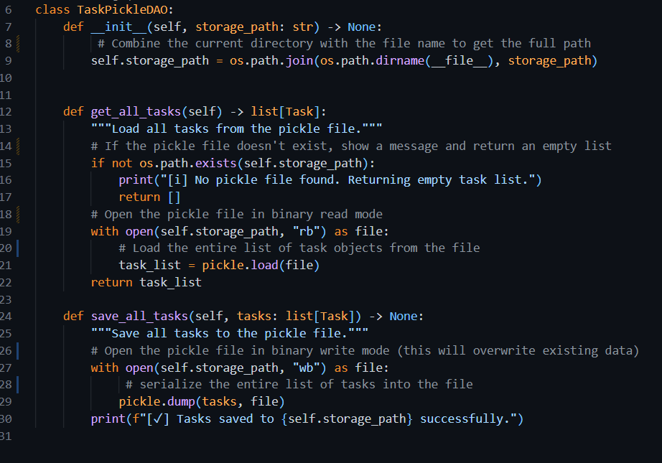

### Explanation

The TaskPickleDAO class is built to handle saving and loading of task data using the pickle module. In the constructor, it sets the path where the pickle file will be saved, ensuring it's relative to the file location for better file organization. The get_all_tasks method checks whether the pickle file exists; if it doesn't, it returns an empty list, otherwise it loads and returns the saved tasks using pickle.load(). The save_all_tasks method takes a list of tasks and writes it to the specified file using pickle.dump(). This approach ensures that all task information — including objects like RecurringTask — are stored and restored accurately, without having to manually write or read each attribute. It's especially useful as the structure of tasks grows more complex.

### Output

Choosing 11 to load data from pickle file

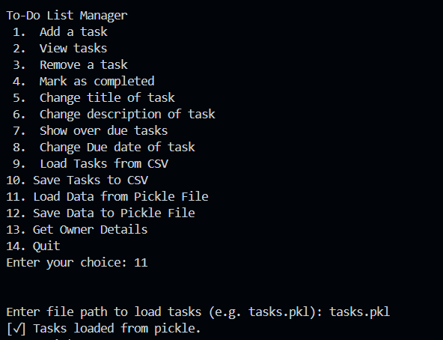

Choosing 2 to view tasks

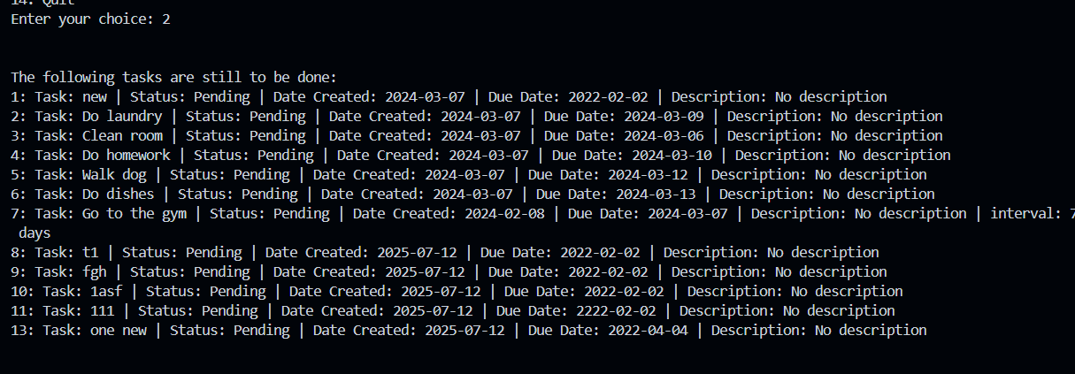

Choosing 1 and 2 to add a recurring task

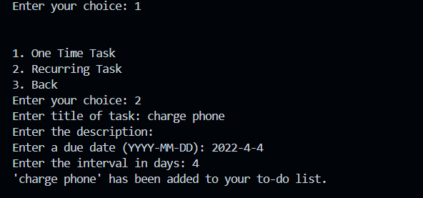

Choosing 12 to save data to pickle file 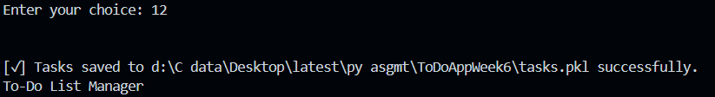

Choosing 2 to see whether the task is saved in pickle file or not

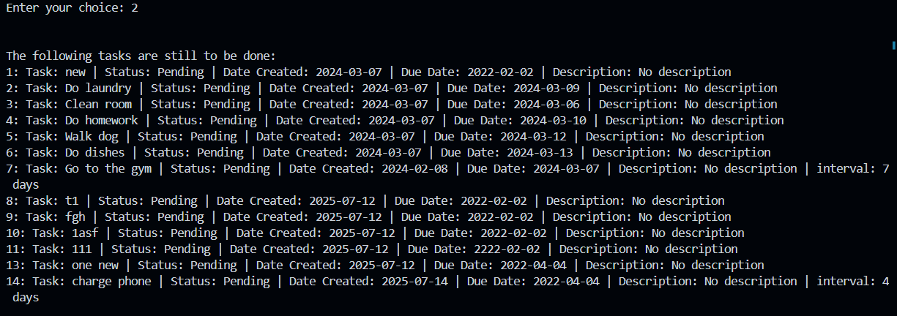

It is saved in the file

Week 7

# Section 1. SOLID Principles

There are several OOP principles that, if followed, can help you to write better OO code. A commonly used set of principles follows the SOLID acronym. These principles are:

* S: Single Responsibility Principle. Ensures classes have a single responsibility, enhancing modularity.
* O: Open/Closed Principle. Allows for extension of classes without modifying existing code.
* L: Leskov Substitution Principle. Subclasses can substitute super classes without altering functionality.
* I: Interface Segregation Principle. Clients only depend on the interfaces they use, promoting modularity.
* D: Dependency Inversion Principle. High-level modules depend on abstractions, not low-level details

## Exercise 1. Single Responsibility Principle

### Understanding the Task

In this exercise, I was introduced to the concept of the **Single Responsibility Principle** (SRP), which basically means that **every class should do one job only**. The idea is that if a class has too many responsibilities, it becomes harder to maintain, reuse, or extend. So, I had to think about whether each part of my ToDoApp was respecting SRP. I reviewed classes like Task, TaskList, TaskCsvDAO, and main.py to check if they were handling only one responsibility or doing too much. I noticed that while most classes followed SRP, the **main.py file was mixing user interface logic and business logic**, which breaks the rule.

### Source Code

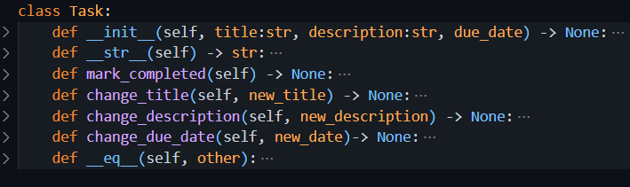

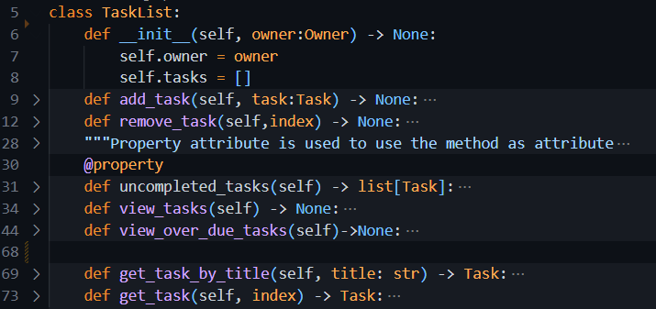

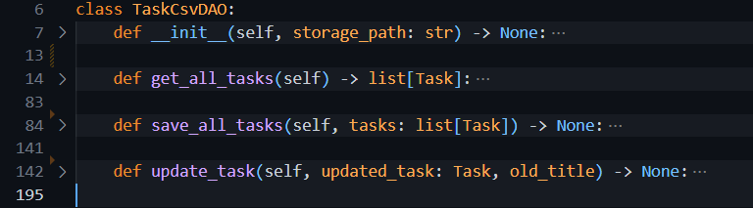

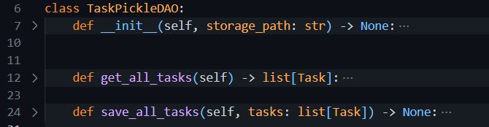

In the source code, it is seen that every class is serving one purpose only using its methods.

### Explanation

The Single Responsibility Principle is part of clean code and good software design. In the context of my ToDoApp, each class mostly follows SRP:

* **Task and RecurringTask** handle storing task data of respective types.
* **TaskList** is responsible for managing the list of tasks (like adding, removing, or viewing them).
* **DAO classes** (TaskCsvDAO, TaskPickleDAO, etc.) deal only with saving and loading tasks from files.

But the main.py file is where SRP is clearly broken. It’s doing multiple things: asking user input, displaying menus, processing logic, and calling other classes. This makes it harder to manage or update in the future. So, to follow SRP properly, we should **move the input and print-related stuff to a separate class**, like CommandLineUI, and keep the business logic in the controller or model classes.

### Benefits of SRP in My ToDoApp

* Make the code **cleaner and easier to understand**.
* If I want to update one feature (like how tasks are saved), I don’t have to dig through unrelated code.
* Make **testing** easier since each class can be tested in isolation.
* Help reduce **bugs** and confusion when the codebase grows.
* **Improves reusability** – I can reuse the same Task logic in other apps, without copying extra unrelated stuff.

## Exercise 2. Open/Closed Principle

### Understanding the Task

In this task, I had to understand how to apply the **Open/Closed Principle (OCP)** in my ToDoApp. The principle says that classes should be **open for extension but closed for modification**. This means instead of changing an existing class when adding new features, I should extend it by creating a new class. I realized that I’ve already been applying this idea when I created the RecurringTask class, which extends the base Task class by adding extra attributes and functionality like interval and completed_dates — all without changing the original Task class. Similarly, the exercise asks me to think about how I could improve other parts of my code (like the DAO classes) by using inheritance and abstraction to make future updates easier.

### Explanation

The Open/Closed Principle helps make code more maintainable by encouraging extensions instead of changes. In my ToDoApp:

* The **Task class** is the base for all task-related functionality.
* The **RecurringTask class** extends Task and adds features like automatic due date updates and recurring intervals. I didn’t touch the Task class while adding this — which means I followed OCP.

The same can be applied to the DAO layer. Instead of editing TaskCsvDAO or TaskPickleDAO every time I want to add a new storage type, I can create an abstract BaseTaskDAO class and make each DAO subclass inherit from it. This ensures consistent structure (interface) and allows me to add new behavior without touching the old code.

### Benefits of Using OCP

* Avoid **breaking existing functionality** while adding new features.
* Keeps the original class **stable and reliable**.
* Supports **scalable** design — new features can be plugged in easily.
* Promotes **reuse of existing code** and reduces duplication.
* Encourages use of **polymorphism**, making the design more flexible and cleaner.

## Exercise 3: Liskov Substitution Principle (LSP)

### Understanding the Task

The goal was to make sure that wherever a Task object is used in the app, it should be replaceable with a RecurringTask object without breaking the app. This aligns with LSP, which says that subclasses should be able to stand in for their parent classes seamlessly.

### Explanation:

In our ToDoApp, RecurringTask inherits from Task and shares the same structure — attributes like title, due_date, and methods like mark_completed(). Although RecurringTask overrides some functionality (e.g. updating due dates automatically), it still behaves as expected in every context where a regular task is used. This shows our app is correctly following LSP — we can substitute Task with RecurringTask and everything still works fine.

### Benefits:

* Enables **flexible code reusability** with safe subclassing
* Reduces the chance of **bugs due to substitution**
* Keeps the **interface consistent** across the app

## Exercise 4: Interface Segregation Principle (ISP)

### Understanding the Task

The focus was to avoid writing large, all-purpose classes with too many unrelated methods. Instead, we aim to keep our class interfaces minimal — each class should only have methods that are relevant to its role.

### Explanation

Even though Python doesn’t use formal interfaces like Java or C#, we follow ISP by keeping our Task and RecurringTask classes clean and focused. Task has only necessary methods like change_title() or mark_completed(). RecurringTask builds on that by adding specific logic for recurrence. There are no unrelated or unused methods in either class. This helps ensure that each class is lightweight, specific, and easier to maintain.

### Benefits

* Keeps each class **easier to understand**
* Prevents **overloading classes with unnecessary responsibilities**
* Makes future **testing and extension cleaner and faster**

## Exercise 5: Dependency Inversion Principle (DIP)

### Understanding the Task

This exercise was about ensuring that higher-level modules (like TaskList) don’t depend on the concrete details of file formats or storage logic (like CSV or Pickle). Instead, they should rely on abstract interactions through a DAO.

### Explanation

In the ToDoApp, the TaskList class doesn't directly save to a file — instead, it delegates that to a DAO (like TaskCsvDAO or TaskPickleDAO). This means if we ever change how tasks are saved (e.g. using a database or an API), the TaskList logic won’t break — because it's not tightly coupled to any specific implementation. While Python doesn’t have built-in interfaces, we can still achieve DIP by writing code that communicates through well-structured, abstract method contracts (e.g. get_all_tasks(), save_all_tasks()).

### Benefits

* Improves **maintainability and testability**
* Allows for **easy swapping of data sources** (e.g. CSV to Pickle)
* Keeps higher-level logic **clean and isolated from low-level details**

# Section 2. Exception Handling

## Task: ToDoApp Modification by adding exception handling

### Understanding the Task

In this task, we are improving the user experience by making our app more robust and error-tolerant. When a user tries to remove or modify a task using an invalid index (like a number that doesn't exist in the task list), the app currently crashes. Our goal is to **add exception handling** using Python’s try, except, and raise keywords to prevent these crashes and instead provide helpful error messages to the user.

#### Example 1

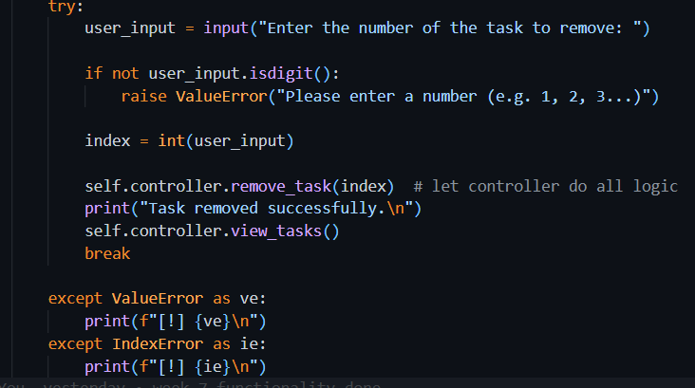

##### Explanation

The provided code uses a try-except block around user input and task manipulation logic. Here’s what happens:

* The app first **asks the user for a task number** to remove.
* If the input is **not a digit**, a ValueError is manually raised using raise ValueError(...).
* The input is then converted to an integer and passed to self.controller.remove_task(index).
* If this index is **not valid** (e.g., it's out of range), the controller will raise an IndexError.
* Both exceptions are caught, and a **friendly error message** is shown instead of crashing.
* If everything goes well, the task is removed, and the updated task list is shown.

This structure allows the app to **continue running smoothly**, even if the user makes a mistake.

#### Example 2

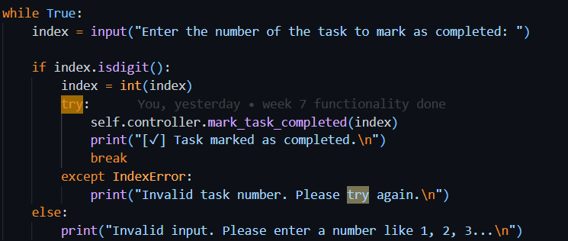

##### Explanation

* The user is asked to enter a number that refers to the task they want to mark as completed.
* isdigit() checks if the input is a number. If not, a clear error message is shown.
* If the input is a valid number, the program tries to mark the task as completed using the controller.
* If the task number is **out of range or invalid**, the program catches the IndexError and informs the user that the task number is incorrect.
* If the task is marked successfully, a success message is shown.

This logic ensures that the app doesn’t crash when the user enters invalid task numbers or text.

#### Example 3

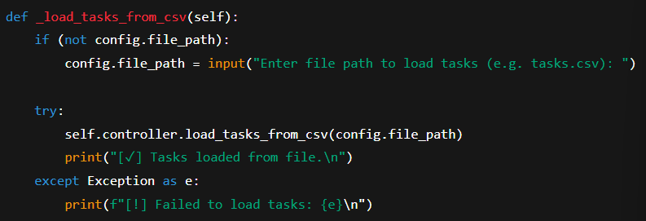

##### Explanation

* This function checks whether the CSV file path (config.file_path) is already stored. If not, it asks the user to provide it.
* Then it tries to load tasks from the file using the controller’s load_tasks_from_csv() method.
* If something goes wrong (like the file doesn’t exist or is incorrectly formatted), it catches the error and prints a clear message.
* The use of Exception as e helps catch **any kind of error**, not just specific ones like FileNotFoundError.

### Benefits of Exception Handling

* Prevents the program from crashing unexpectedly.
* Provides better user experience by giving clear instructions when input is incorrect.
* Makes the code more maintainable and easier to debug.
* Helps isolate bugs and ensures the app behaves reliably under edge cases.

# Section 3. Improving ToDoApp according to SOLID Principles

## Task: Modification of main module to separate the user interface from the business logic

### Understanding the Task

In this task, I was required to **restructure my ToDoApp** to improve its design by clearly separating **user interface logic from business logic**. The idea was to make the code more modular, easier to maintain, and better aligned with **Object-Oriented Programming principles** like **Separation of Concerns**, **Single Responsibility Principle**, and **Low Coupling**.

I had to:

* Create a new class CommandLineUI in a separate ui module. This class is responsible for everything the user sees or interacts with: menus, inputs, and printed messages.
* Create another class TaskManagerController in a controllers module. This class handles the logic of how the app behaves—adding tasks, marking them complete, checking valid indexes, loading/saving data, etc.
* Introduce and use the TaskFactory class whenever a new task is created. This pattern helps me avoid hardcoding logic in the UI or controller and makes task creation more flexible.
* Optionally, if I had portfolio tasks (like user login or overdue filtering), I could plug them in as well without disrupting existing logic.

### Explanation

The idea behind this task is to **fully separate concerns** in the app. The main.py file is now very lightweight and simply acts as an entry point that runs CommandLineUI.

The **CommandLineUI** class handles:

* Showing the menu
* Taking input from the user
* Deciding what action to take based on the input
* Sending user requests to the controller class (TaskManagerController)

The **TaskManagerController** class handles:

* Adding, deleting, editing, completing tasks
* Saving or loading data via the appropriate DAO (CSV or Pickle)
* Validating task indexes
* Communicating with the TaskFactory and TaskList

The **TaskFactory** decides what kind of task to create (normal or recurring) based on the given data. It acts like a helper tool to keep that logic out of both UI and controller.

This design pattern makes the app easier to extend in the future e.g., adding a GUI interface later won't require changing the task logic.

### Benefits of This Restructure

* **Easier to maintain and modify**: UI changes don’t affect task logic, and vice versa.
* **Modular structure**: Each class has a clear responsibility, following **SRP** (Single Responsibility Principle).
* **No code duplication**: By centralizing task creation in TaskFactory, and task validation in TaskList, we follow the **DRY** (Don't Repeat Yourself) principle.
* **Easier to test**: Business logic and UI are separate, so we can write unit tests for the controller and tasks without dealing with print/input.
* **Extensible**: Adding features like login, filtering, exporting can be done without touching all parts of the app.

### Source Code

Main.py

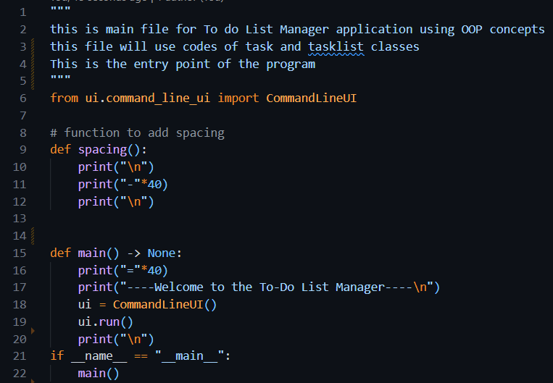

command_line_ui.py

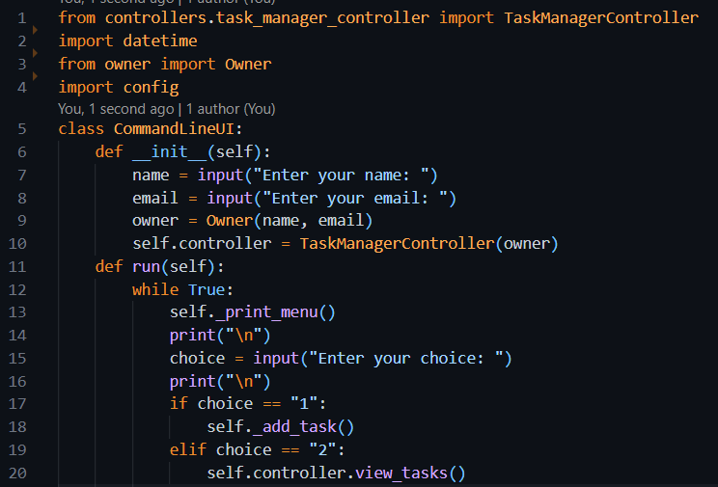

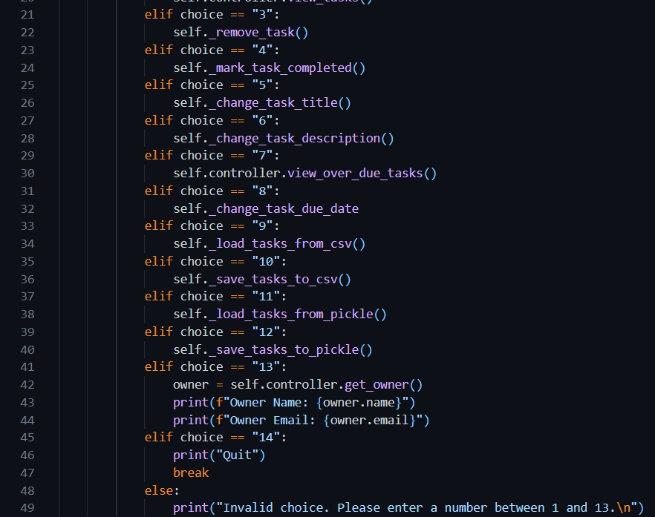

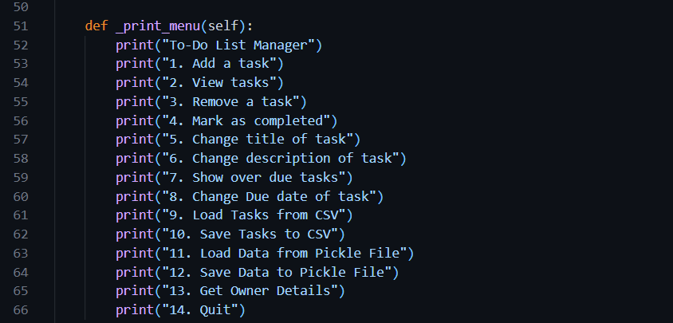

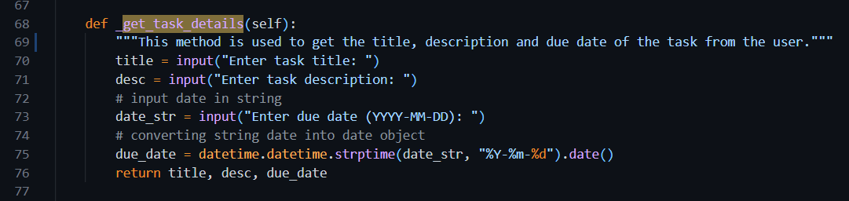

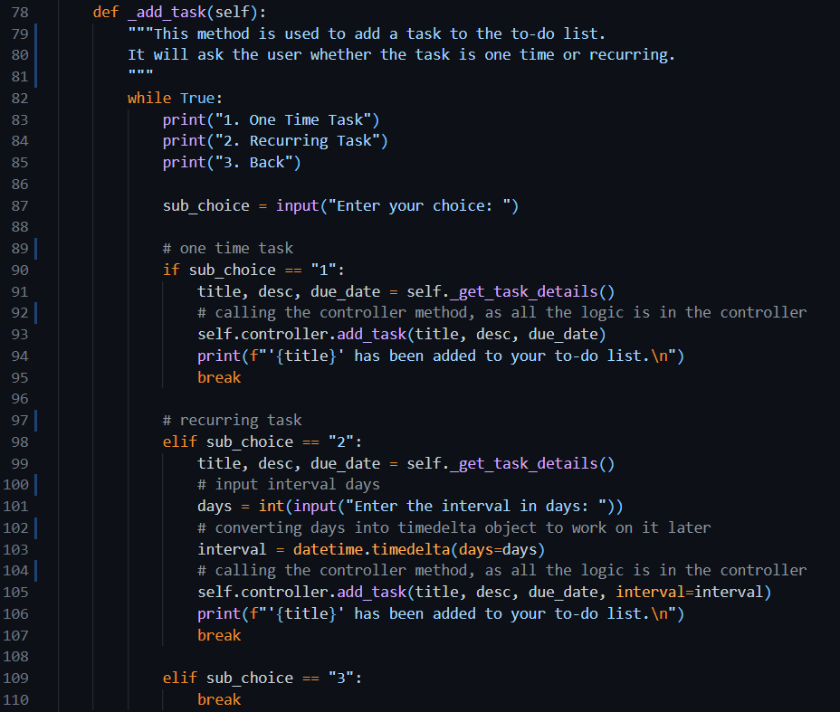

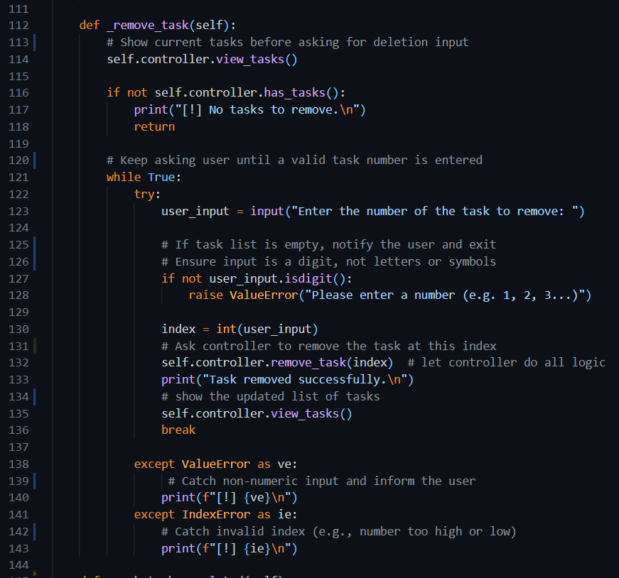

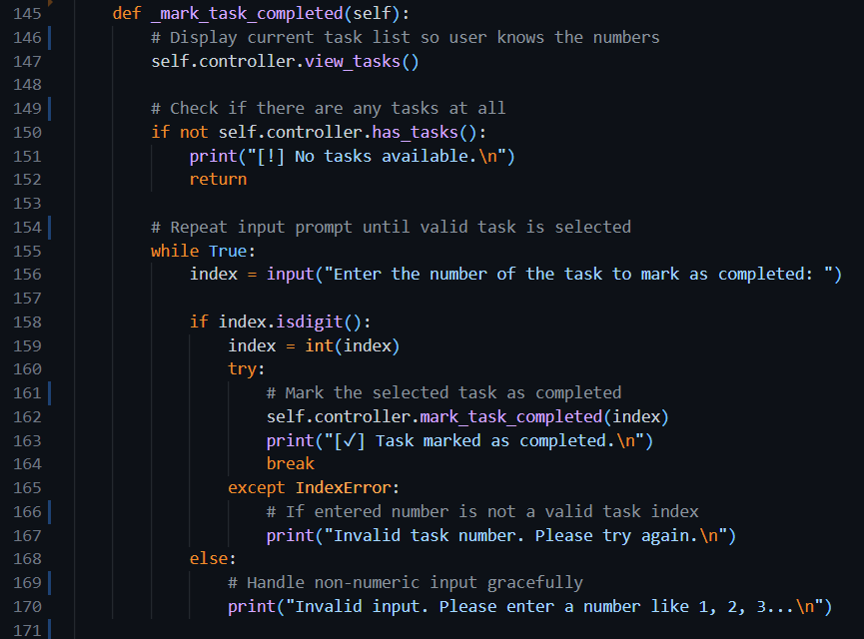

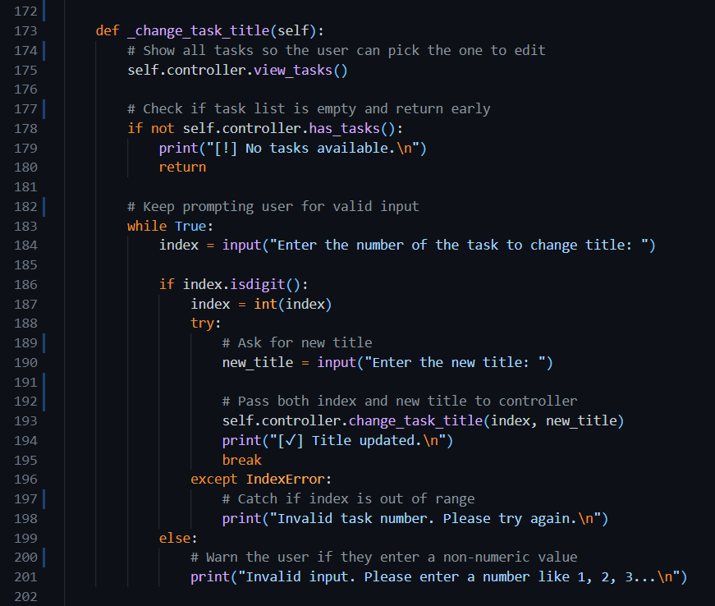

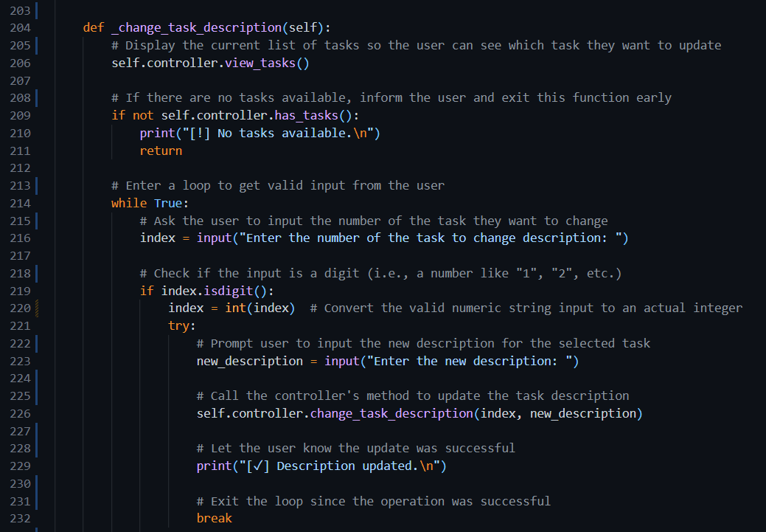

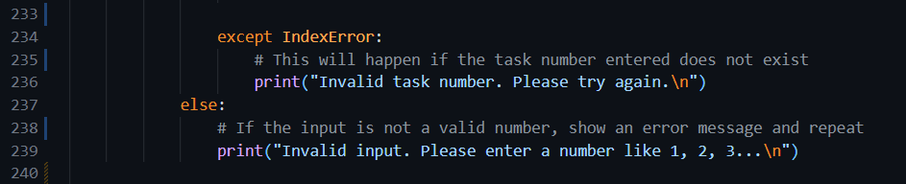

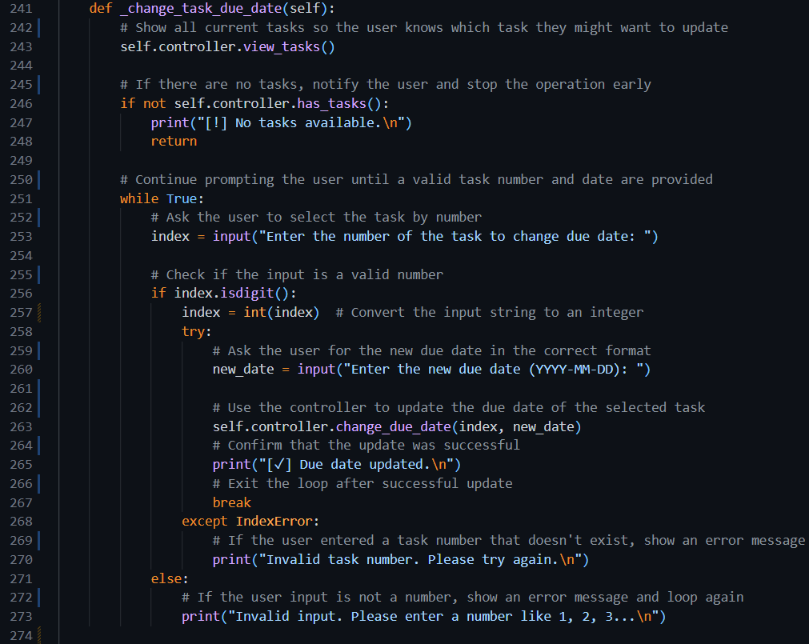

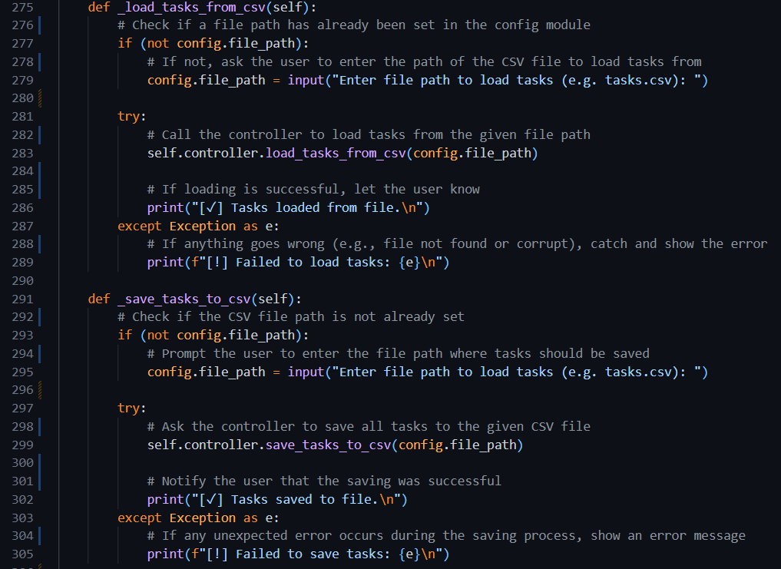

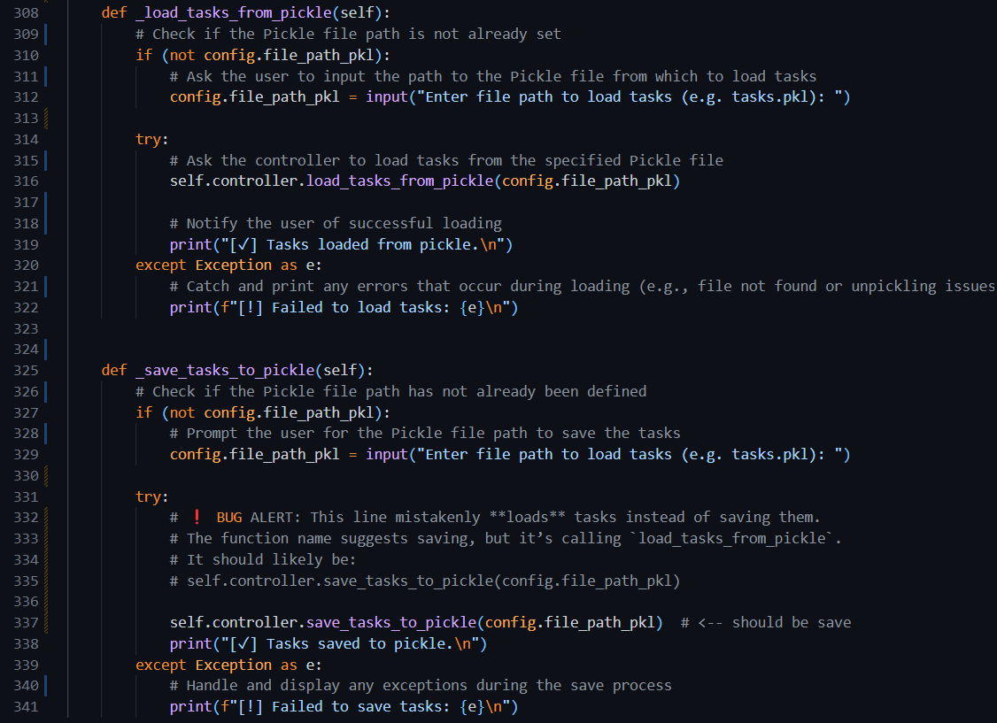

#### task_list.py

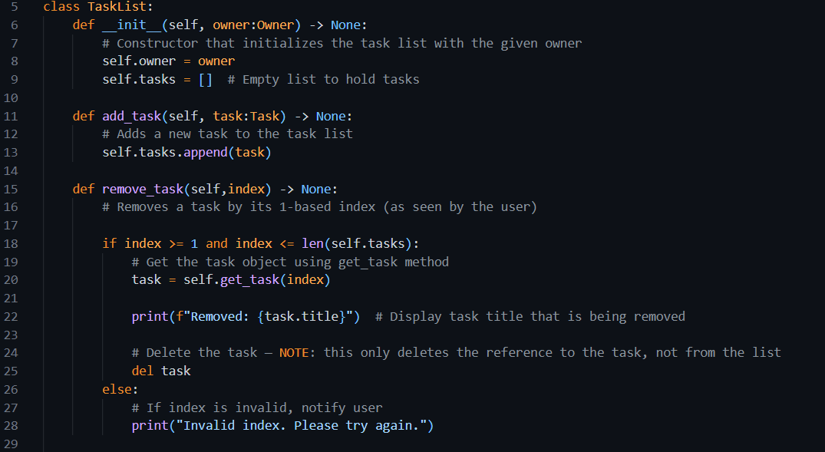

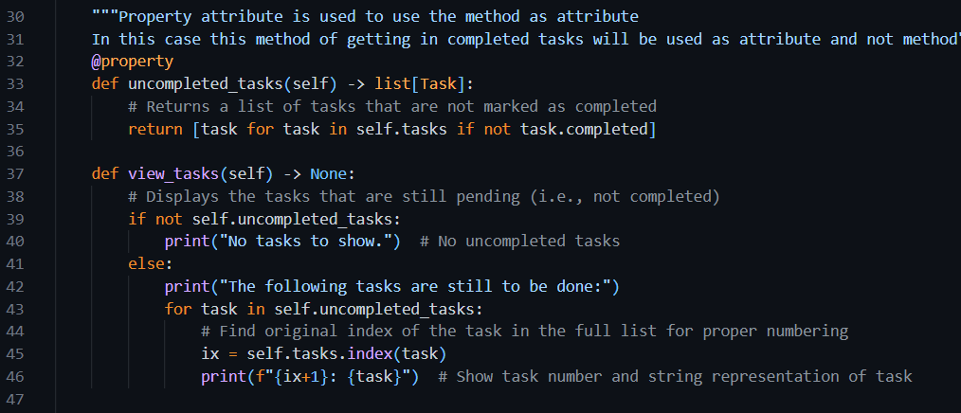

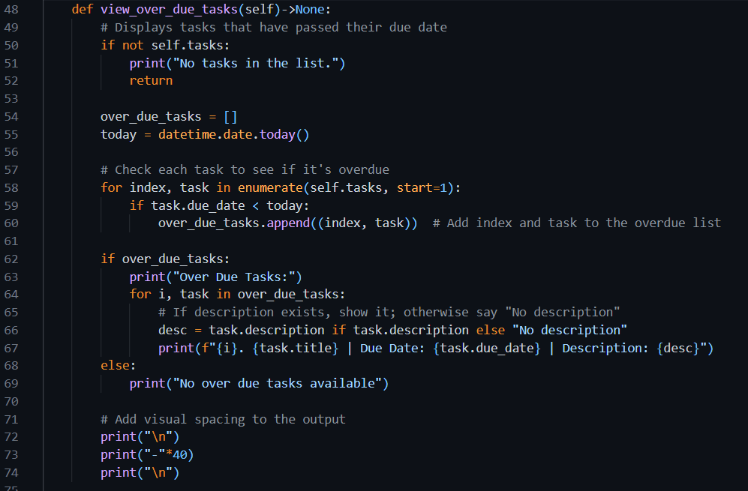

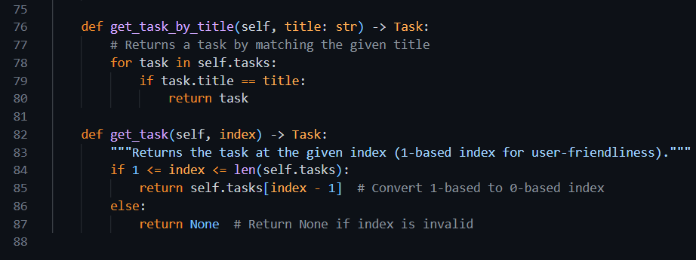

#### task_factory.py

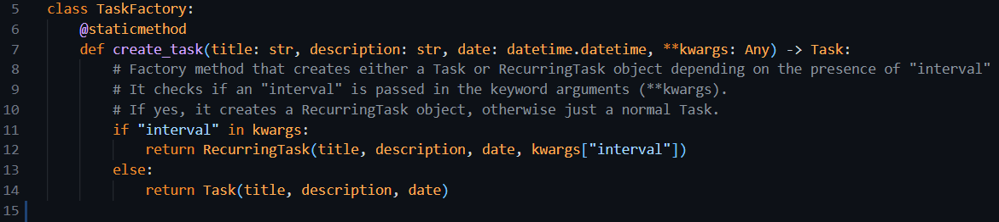

#### task.py

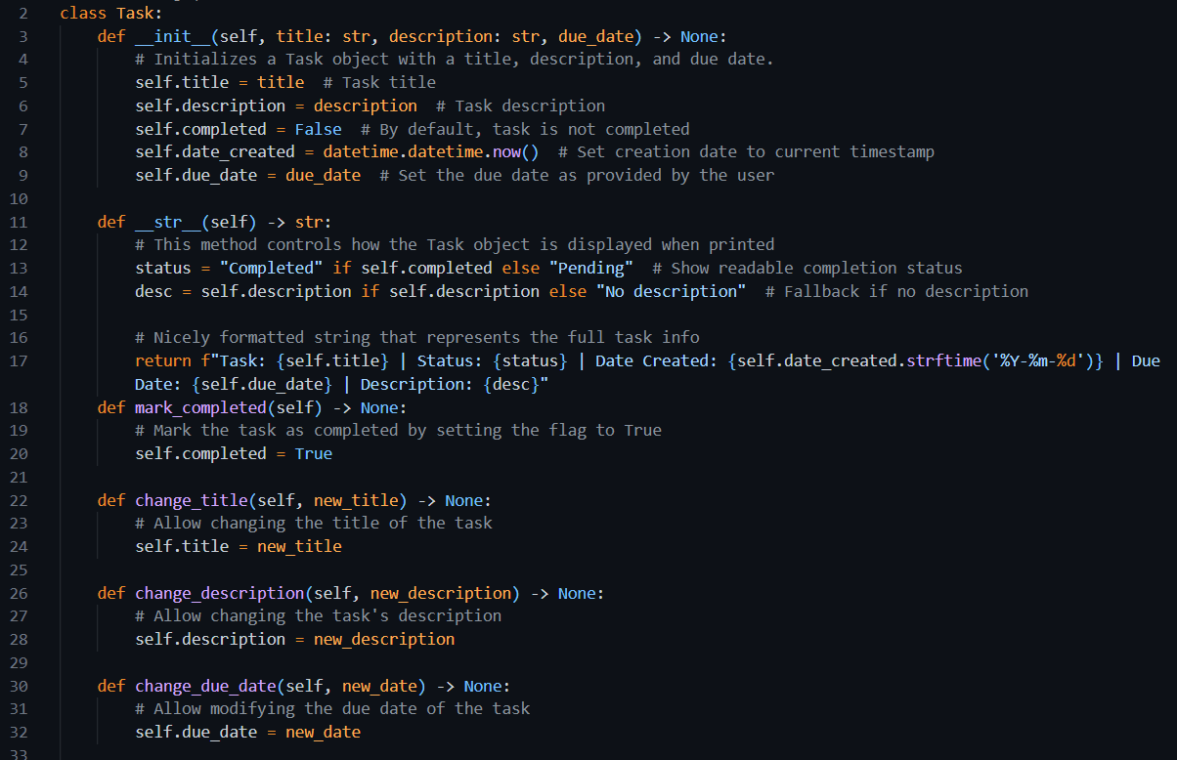

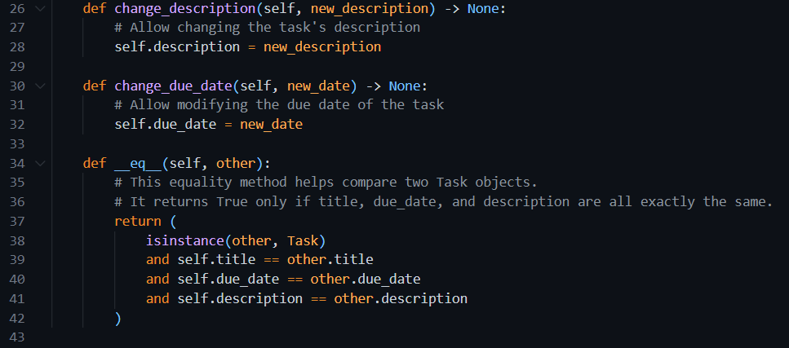

#### task_manager_controller.py

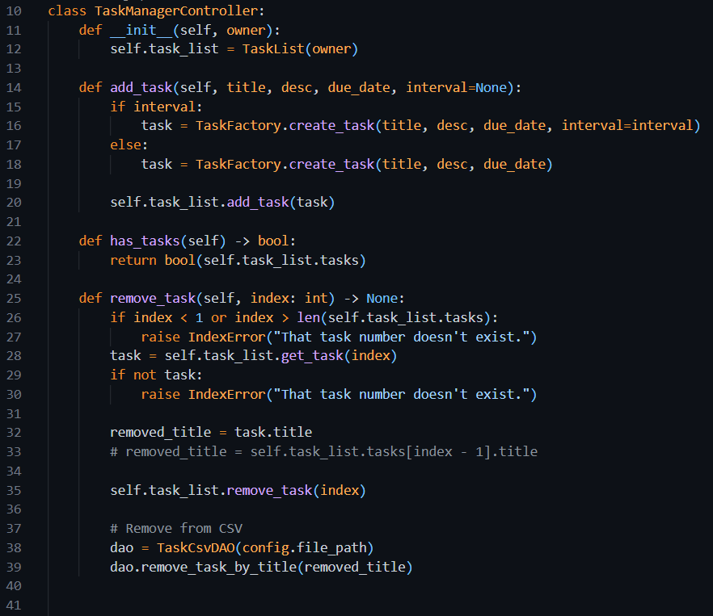

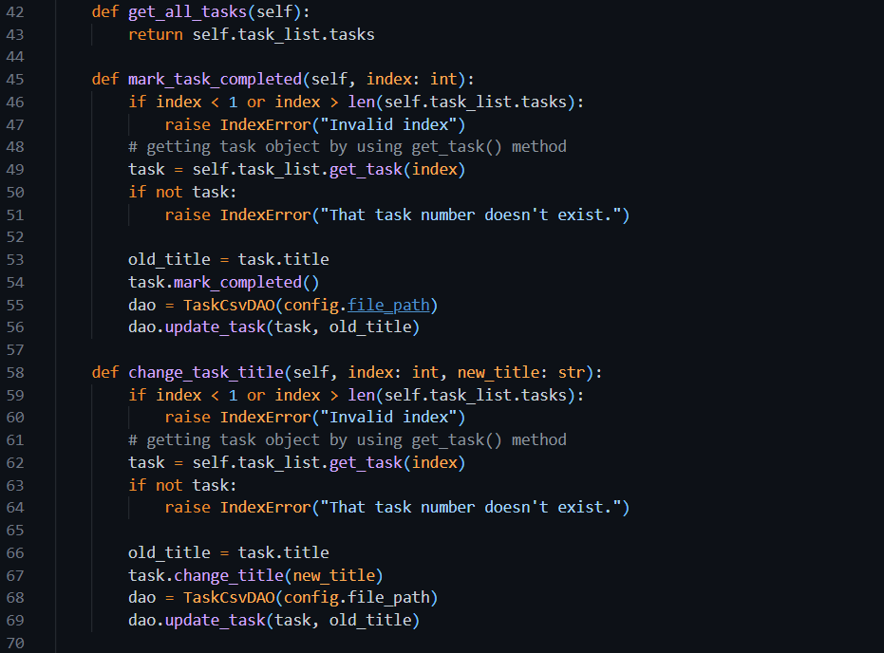

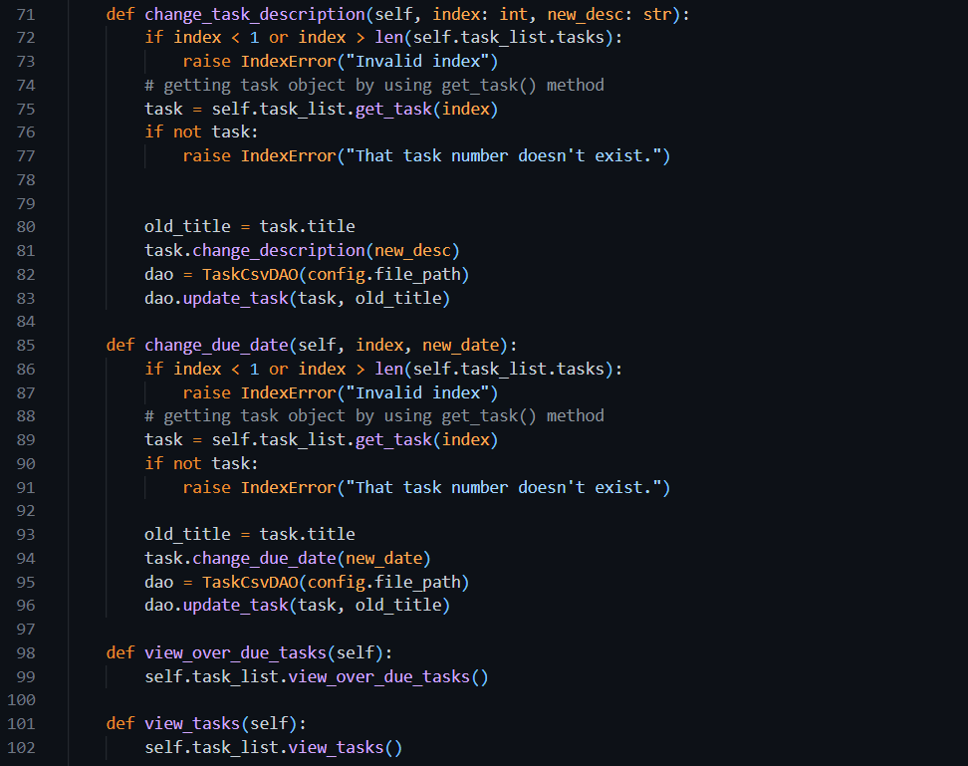

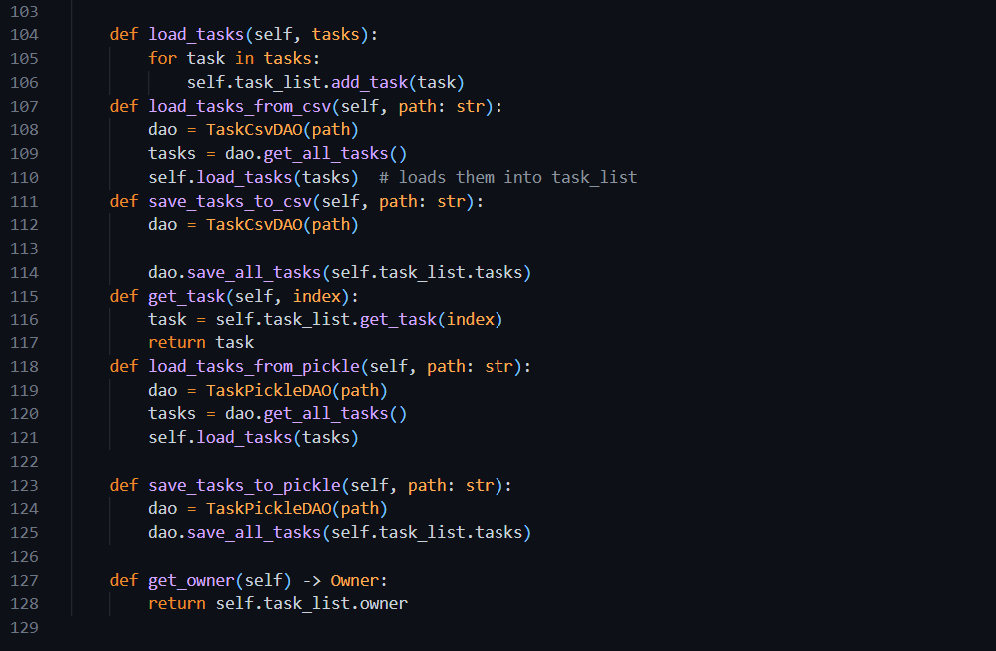

Week 8

# Section 1. Data Structures

In programming, **data structures** are different ways of organizing and storing data so it can be used efficiently. Python offers several built-in data structures like **lists**, **tuples**, **sets**, and **dictionaries**, each with unique behaviors and use cases.

In this exercise, we’ll focus on:

1. Tuples
2. Sets
3. Dictionaries

## **Exercise 1: Tuples**

### Understanding the Task:

A **tuple** is a collection of items that are **ordered and immutable**, meaning once you create it, you cannot change its values. It's great for storing data that shouldn’t be modified, like coordinates or RGB color values.

### Source Code

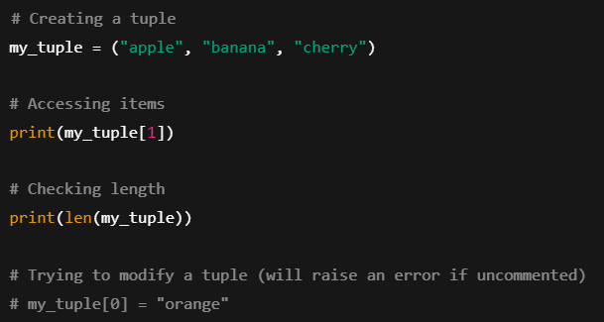

### Explanation:

* my_tuple is created with three fruits.
* We access the second item using indexing (my_tuple[1]).
* We check the total number of items using len().
* Tuples are **immutable**, so trying to modify an item will raise an error.

### Output

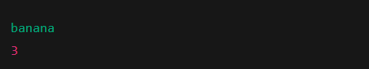

## Exercise 2: Sets

### Understanding the Task:

A **set** is an **unordered collection** of **unique elements**. It’s useful when you want to remove duplicates or perform operations like union or intersection.

### Source Code

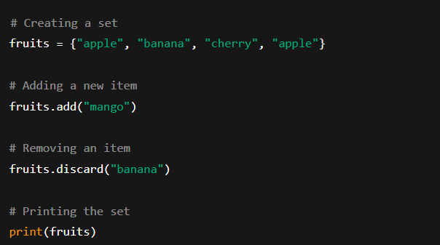

### Explanation:

* The set removes the **duplicate "apple"** automatically.
* We add "mango" and remove "banana" using add() and discard() respectively.
* Sets do not maintain any order, so the printed result can appear in any sequence.

### Output

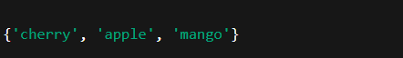

## Exercise 3: Dictionaries

### Understanding the Task:

A **dictionary** is a collection of **key-value pairs**. It’s used when you want to map a value to a specific label or key — like storing student names with their grades.

### Source Code

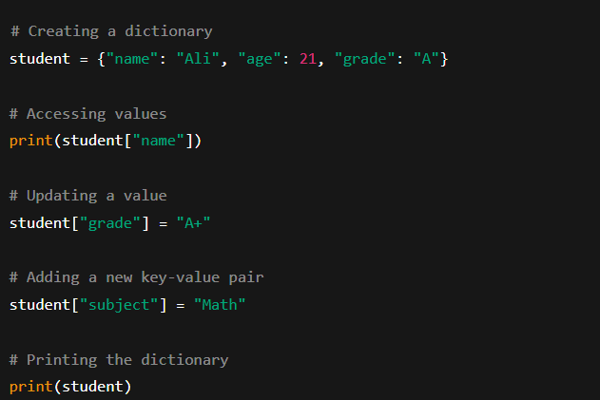

### Explanation:

* A dictionary student is created with keys: "name", "age", and "grade".
* We access and update values using square brackets.
* New key-value pairs can be added anytime.
* Dictionaries are **unordered** in Python versions before 3.7, but now they preserve insertion order.

### Output

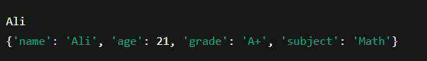

## Task: Swap a and b using tuple

### Source Code

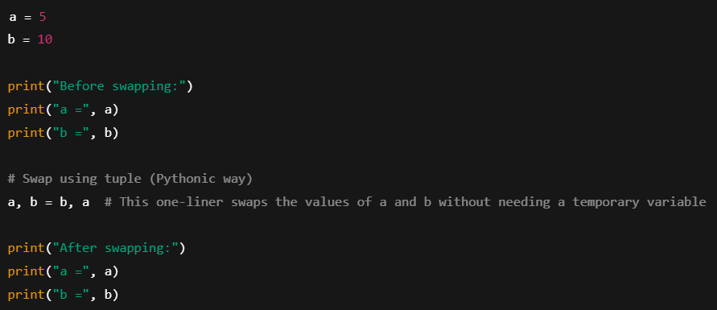

### Explanation

* We first define two variables a and b with values 5 and 10.
* Python allows us to **swap** values in a very clean way using tuple unpacking: a, b = b, a.
* No need for a temporary variable (like in other languages).
* The values are now swapped.

### Output

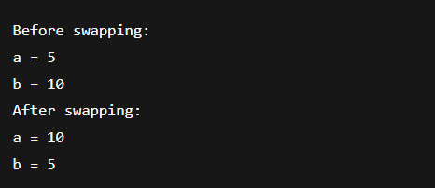

## Task: Comparing two sets to find common values

### Source Code

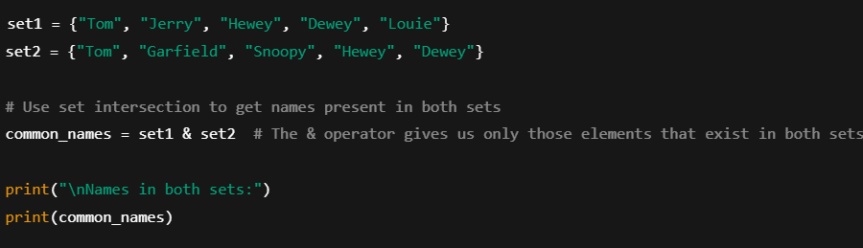

### Explanation:

* We define two sets with cartoon character names.
* The & operator performs a **set intersection**, returning only elements found in both sets.
* This helps us quickly compare and find common entries.
* The result is printed as a Python set.

### Output

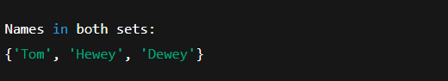

## Task: Histogram

### Source Code

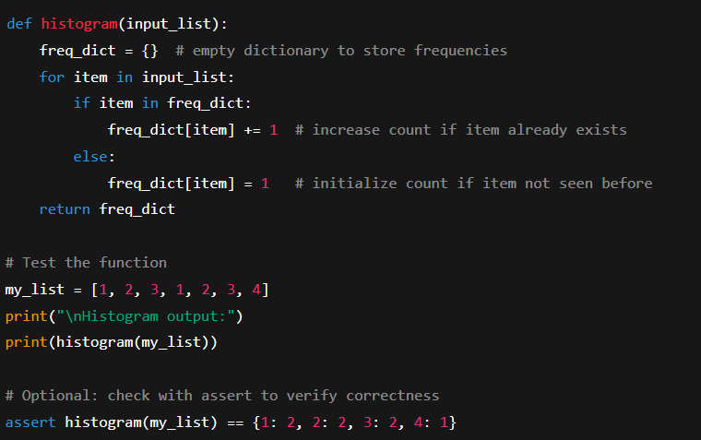

### Explanation:

* A function histogram is defined to count how many times each number appears in a list.
* It uses a **dictionary** to store numbers as keys and their count as values.
* For each item in the list:
  + If the number is already in the dictionary, we increase its count.
  + If not, we add it with a count of 1.
* We then test the function with a sample list: [1, 2, 3, 1, 2, 3, 4].
* The assert statement is used for **automated verification**, ensuring the result matches the expected dictionary.

### Output

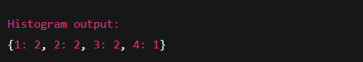

# Section 2. Abstract Classes

It is the concept of hiding the complex implementation of an object and only showing the necessary features of the object. Abstract classes enable this as all we do is define the methods that must be implemented by the child classes. Once those child classes have been created, we can use them without needing to know the details of their implementation but can be sure that those methods (and attributes) will be available.

To use abstract classes in python, it is required to import the **ABC** and **abstractmethod** modules from the **abc** **package**. Then you can create an abstract class by inheriting from the ABC class and using the **@abstractmethod** decorator to define the abstract methods.



## Task: Dice class and abstract method in it

### Source Code

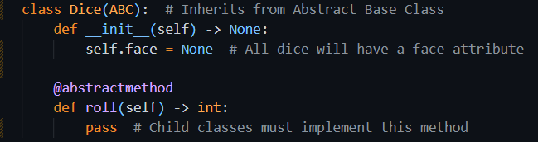

### Explanation

In this task, we are introduced to **abstract classes** in Python using a simple and relatable example — a dice. The main goal here is to design a **base class** that defines the **essential structure** and **common interface** for all dice, without actually implementing how the dice rolls. That behavior will be defined by the **child classes**.

The Dice class is created as an **abstract class** using Python’s ABC module. This class sets a foundation that all dice must follow. It includes:

* A face attribute, which will hold the current value shown on the dice after a roll.
* An abstract method roll(), which is meant to be implemented by any class that inherits from Dice. This method will define how the dice is rolled (e.g., random number generation for 6-sided dice).

The key takeaway is that the Dice class **cannot be used directly to create objects** because it lacks a working implementation of roll(). It’s just a **blueprint** meant to be extended.

## Task: Six Sided Dice

### Understanding the Task

Now that we have an abstract base class Dice, the next step is to **implement a specific type of dice** — in this case, a standard **six-sided dice** (like the one used in most board games). The idea is to **inherit** from the Dice class and provide the missing roll() method.

### Source Code

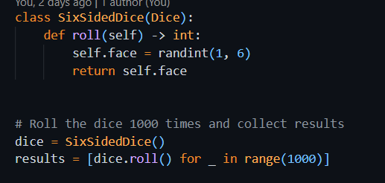

### Explanation

* This class SixSidedDice **inherits** from the abstract Dice class.
* It **implements** the roll() method that was declared as abstract in Dice.
* Inside roll(), it uses randint(1, 6) to simulate rolling a real dice — generating a random number between 1 and 6.
* The result is stored in the face attribute (inherited from Dice) and returned.

The class is now **concrete** and can be instantiated since all abstract methods are implemented.

### Rolling the Dice 1000 Times:

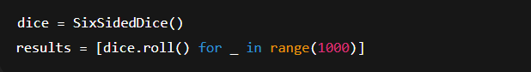

* An instance of SixSidedDice is created.
* The roll() method is called **1000 times** using a list comprehension.
* Each result is stored in the results list, so we can analyze frequencies, simulate outcomes, or plot distributions.

## Task: Ten-Sided Dice

### Understanding the Task

This task focuses on building a **concrete subclass** of an abstract Dice class. Specifically, we are implementing a TenSidedDice that simulates the behavior of a dice with 10 faces. The core idea is to show how inheritance and abstraction work together, and then simulate the dice to see how random values are distributed. Finally, we visualize the outcome using a histogram to check how balanced the results are.

### Source Code and Explanation

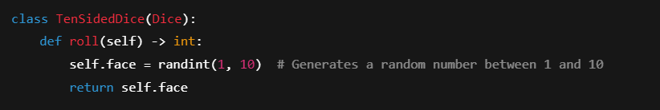

* This class **inherits from** the abstract Dice class.
* It **implements** the required roll() method.
* Each roll gives a value from **1 to 10**, and the result is stored in the face attribute.

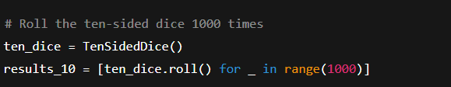

* An instance of TenSidedDice is created.
* A list comprehension is used to **simulate 1000 rolls** and collect the outcomes.

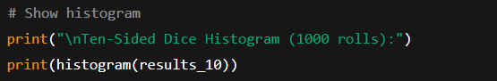

* he histogram() function counts how many times each number (1–10) appeared.
* This is used to **visually inspect randomness** — ideally, each number should appear around 100 times.

### Output

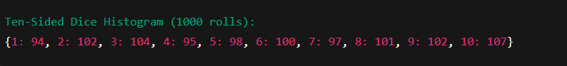

## Task: Implement Abstraction in ToDoApp

### Understanding the Task

This task is about **applying abstraction** in your ToDo application by introducing **abstract base classes** (ABCs) using Python’s abc module. The main goal is to enforce **a common structure** for classes that are similar in purpose but differ in implementation — such as the DAO classes and Task-related classes. This makes the application more **scalable, maintainable, and robust**.

### Source Code

#### TaskDAO.py – Abstract class for DAO classes

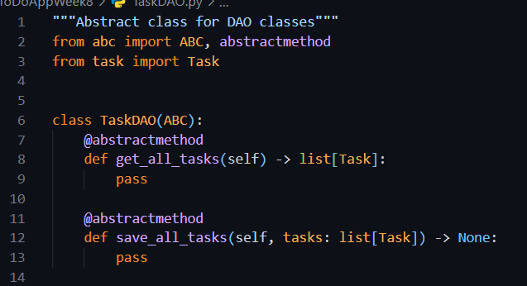

### Using Abstract class

#### TaskCsvDAO.py

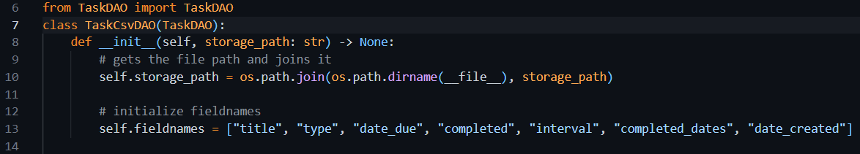

#### TaskPickleDAO.py

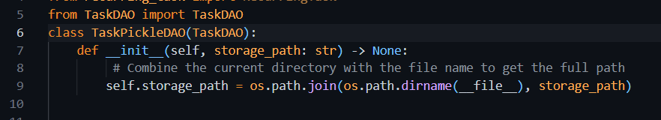

#### AbstractTask.py – Abstract class for Task classes

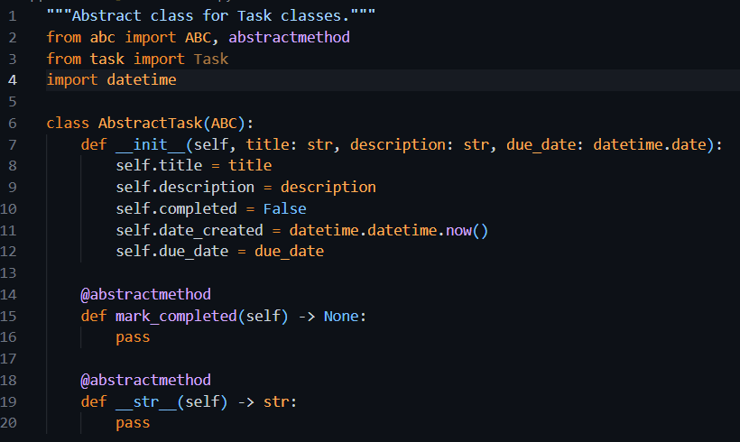

### Using Abstract class

#### task.py

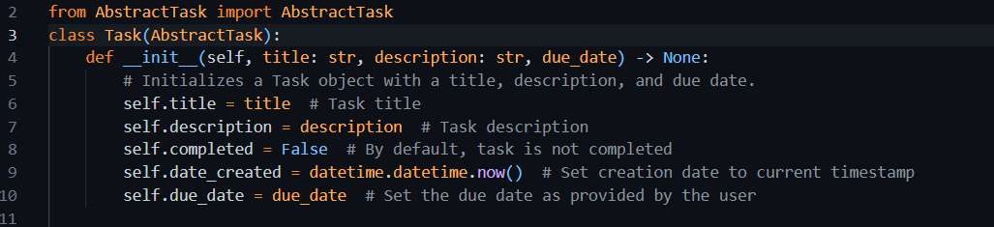

#### recurring_task.py

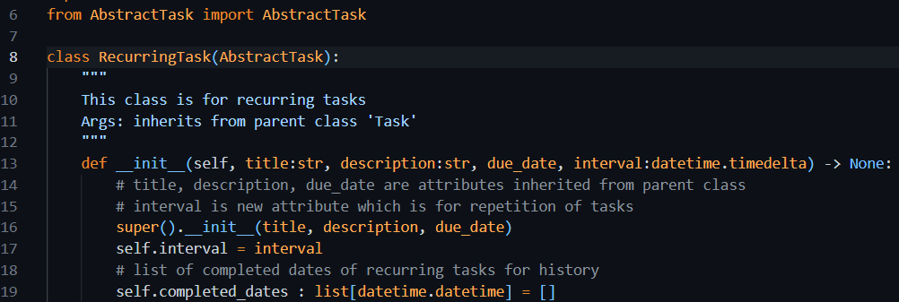

## Portfolio Exercise 5: Priority Task

### Understanding the Task

This exercise expands the ToDo app's functionality by introducing a new task type called **PriorityTask**. Just like we have Task and RecurringTask, the PriorityTask adds an extra layer of importance by associating tasks with a **priority level** (1 to 3).

* Priority will be stored as an **integer** (1, 2, 3) representing **low**, **medium**, and **high**.
* A **mapping dictionary** will convert those numeric values into user-friendly strings ("low", "medium", "high").
* The class should include:
  + type hints,
  + validation (to restrict values outside 1–3),
  + and a readable string representation via __str__.

### Source Code

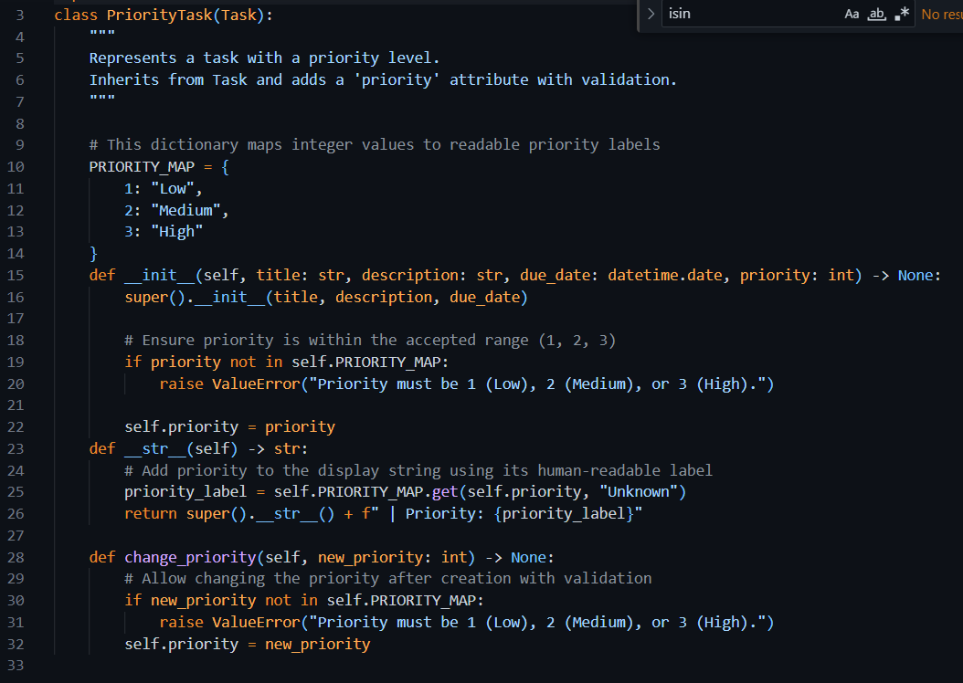

### Explanation

* PriorityTask is a specialized type of task that builds on the regular task features.
* It includes a priority level to show how important the task is.
* The priority is stored as a number: 1 (Low), 2 (Medium), or 3 (High).
* When creating a task, the program checks that the priority is valid (only 1, 2, or 3 are allowed).
* If an invalid number is given, the task won't be created, and an error is shown.
* The task can display priority in words using a built-in mapping from numbers to labels.
* When printed or displayed, the task shows its usual details plus the priority label.
* The priority can be changed later, and the new value is also validated to be one of the allowed numbers.

## Portfolio Exercise: Integrate Priority Task in ToDoApp

### Understanding the Task

In this exercise, I was asked to fully integrate the PriorityTask class into the existing To-Do application. The goal was to make sure that all parts of the application are aware of and can handle this new type of task that includes a priority level (Low, Medium, High).

Specifically, I was required to update three main components:

* **TaskFactory**: So it can create PriorityTask objects when a priority is provided.
* **CommandLineUI**: So the user can interactively create a PriorityTask through the terminal.
* **DAO (Data Access Objects)**: So PriorityTask can be saved and loaded correctly from files (especially CSV), including the priority value.

What I understood from the question is that this is not just about creating a new class—it’s about making sure it works throughout the whole system just like other task types (e.g., standard and recurring tasks). This includes making sure it can be added, saved, loaded, and displayed properly within the existing app structure.

### Source Code

#### Task_factory

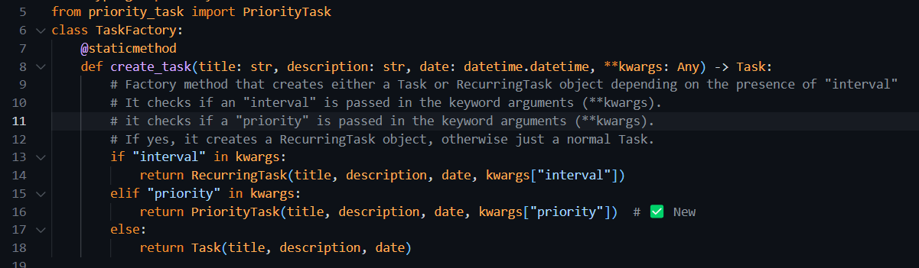

#### Comman_line_ui.py

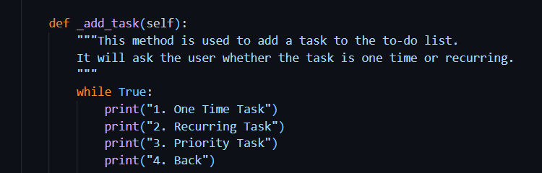

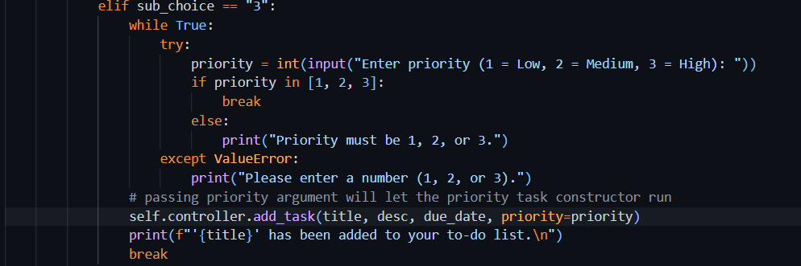

#### TaskCsvDAO.py

#### Init function

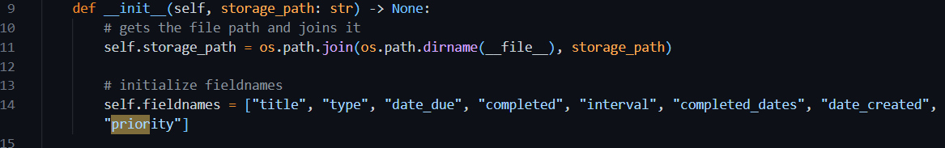

#### Get_all_tasks()



#### save_all_tasks()



### Output

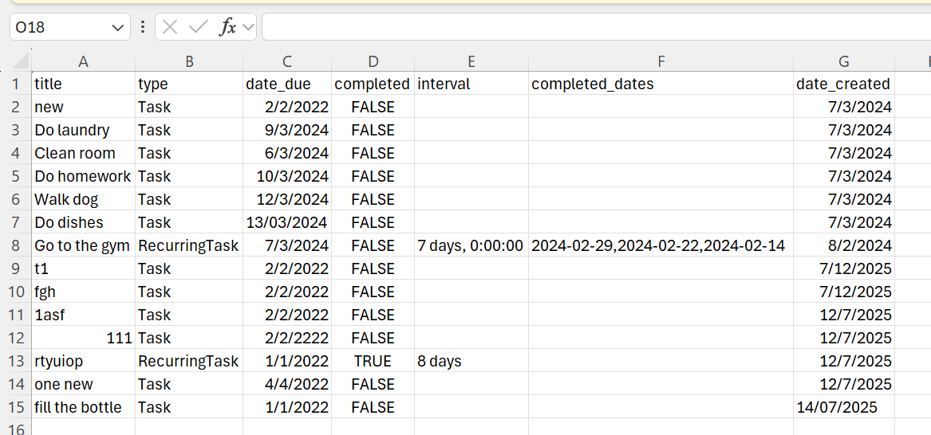

Choosing 1 and then 3 to add a priority task to the list

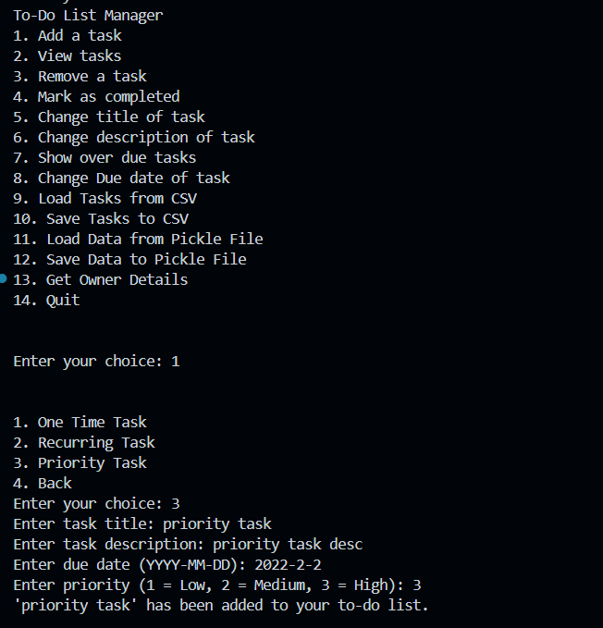

Choosing 10 to save data to file

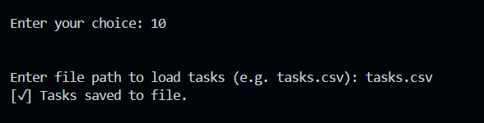

### CSV

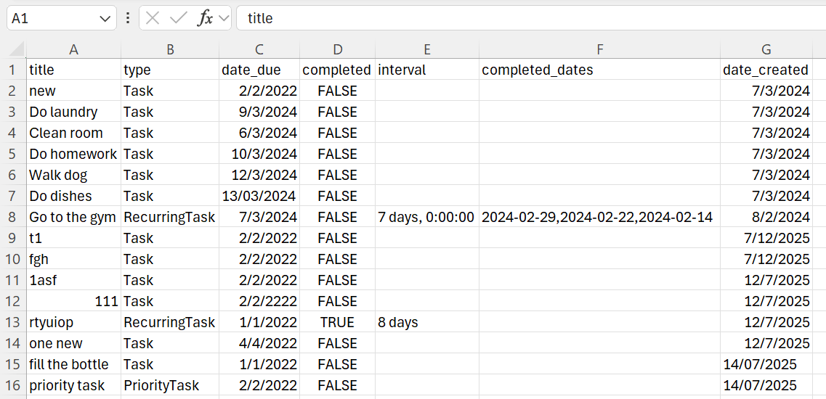

We can see from this picture that the priority task is added to the file